# 

# 

# Bed Management Solution (BMS)

### Technical Manual



**April, 2016**

### Revision History

| **Creation Date** | **Version No.** | **Description/Comments** | **Author(s)** | **Reviewer(s)** | **Review Type** | **Issue Date** |
| --- | --- | --- | --- | --- | --- | --- |
| 3/4/2016 | 0.6 | Removed real URL and server addresses and replaced them with generic address names throughout the document | H. Gau |  |  | 3/4/2016 |
| 7/15/2015 | 0.5 | Final team review | P. O’Reilly, N. Morrison, H. Gau, A. Ray, B. Welkder, L. Harth |  |  | 7/15/15 |
| 06/05/2015 | 0.5 | Technical edit. Fix issues with table of tables and table of figures. | R. Wilder |  |  | 06/30/2015 |
| 6/05/2015 | 0.5 | Updated the following sections:  2.2 System Requirements  2.3 Configuration Parameters  2.4 Scheduled Windows and SQL Jobs Configuration  2.4.1 BMS Reports Full  2.4.2 BMS Incremental  2.4.3 BMS Reports WMI  2.5 Ward Whiteboard Kiosk Setup  2.6 Whiteboard Snapshot Configuration  2.7 EMS Mobile Defice Configuration  2.9 NUMI Integration  3.3 Database Architecture  3.4 Component Files  7 Software Security | P. O’Reilly, N. Morrison, H. Gau, A. Ray, B. Welkder, L. Harth |  |  | 6/30/2015 |
| 07/17/2013 | 0.4 | Updated section 2.3 Configuration Parameters, updated section 2.5 Whiteboard Kiosk Mode, updated section 2.7 EMS Mobile Device Configuration, added Appendix 9.5, | S. Greenacre |  |  | 07/19/2013 |
| 07/29/2013 | 0.3 | Updated section 2.8.1.1 to include the MDWS Endpoint. | S. Greenacre |  |  | 08/06/2013 |
| 10/07/2013 | 0.2 | Updated section 2.2 with service account information, Renamed and Updated section 2.6.3, Added a note to section 2.6.4, added log files to section 8. | S. Greenacre |  |  | 10/15/2013 |
| 06/12/2013 | 0.1 | Initial baseline. | S. Greenacre |  |  | 07/09/2013 |

### 

### Table of Contents

Bed Management Solution (BMS) 1

Technical Manual 1

Revision History 2

Table of Contents 4

List of Figures 9

1 Introduction 11

1.1 Purpose 11

1.2 BMS Overview 11

1.3 References 11

2 Implementation and Maintenance 12

2.1 BMS Infrastructure Diagram 12

2.2 System Requirements (Hardware and Software) 13

2.3 Configuration Parameters 15

2.4 Scheduled Windows and SQL Jobs Configuration 102

2.4.1 BMS Reports Full 102

2.4.2 BMS Incremental 112

2.4.3 BMS Reports Windows Management Instrumentation (WMI) 119

2.5 Ward Whiteboard Kiosk Mode Display Configuration (BMS Whiteboard Kiosk Setup) 120

2.5.1 Create the Ward Whiteboard Kiosk URL 122

2.5.2 Set up a default user for the BMS Kiosk 123

2.5.3 Set up the Workstation / Kiosk Machine 125

2.6 Whiteboard Snapshot Configuration 136

2.6.1 Create Snapshot Folder 136

2.6.2 Define Network Share 137

2.6.3 Assign Rights to Master BMS Service Account User 139

2.6.4 Assign Snapshot Folder Path to Ward Group 145

2.6.5 Associate Scheduler with Whiteboard Report 146

2.7 EMS Mobile Device Configuration 147

2.7.1 Configure EMS Mobile Device Default Login User 147

2.7.2 Configure EMS Mobile Device URL 149

2.8 VistA Integration 149

2.8.1 Choose VistA Site 150

2.8.2 Define Schedulers 151

2.8.3 Run Scheduler 152

2.8.4 View Audit Results 153

2.9 NUMI Integration 154

Integration Settings 155

2.9.1 Choose VistA Site 155

2.9.2 Define Schedulers 155

2.9.3 Select Scheduler 155

3 Application structure 156

3.1 Application Components 156

3.2 Application Directory Structure 157

3.3 Database Architecture 158

3.4 Component Files 158

4 Archiving 183

5 External Relationships 184

6 External Interfaces 185

7 Software Security 186

7.1 Policy Manager 188

7.2 Operation Definitions 188

7.3 Task Definitions 199

7.4 Role Definitions 209

7.5 Assigning a Role to a User 210

7.6 Adding a New Role 211

7.7 Adding a New Task 213

7.8 Adding a New Operation 215

7.9 Business scenarios and use cases 216

8 Detailed Functional Model on Each Interface 218

8.1 Service contracts 218

Data contracts 222

8.2 BMS Roles 222

9 Troubleshooting 223

10 Appendix A – BMS Diagrams 229

10.1 Business Process Diagrams 229

10.2 Activity Diagram 234

10.3 Functional Flow Diagram 234

1.1 10 Appendix B - Terms, Acronyms, and Abbreviations 237

**List of Tables**

Table 1: Server for Web Applications 11

Table 2:Application Sever 12

Table 3: Database Server 12

Table 4: BMS ServiceHost Configuration Parameters 13

Table 5: EIS Service Configuration Parameters 78

Table 6 - EVS Service Configuration Parameters 81

Table 7 - PAP Service Configuration Parameters 85

Table 8 - PDP Service Configuration Parameters 88

Table 9 - RS Service Configuration Parameters 89

Table 10 - STS Service Configuration Parameters 90

Table 11 - Win ServiceHost Configuration Parameters 93

Table 12 - WMI User Group Configuration Parameters 94

Table 13 - Policy Manager Configuration Parameters 94

Table 14 - BMS Web Configuration Parameters 95

Table 1 - Ward Whiteboard URL Configuration Parameters 120

Table 16: Facility Settings Page Parameters 146

Table 17:BMS Admin Page Parameters 146

Table 18: Description and Configuration for EMS Mobile Device URL parameters 147

Table 19:New VistA Site Parameters 149

Table 20:New Scheduler Parameters 150

Table 21:View Audit Results Columns Report 152

Table 22: BMS Database Files 156

Table 23: BMS Service Files 158

Table 24: Win Service Host Files 162

Table 25:BMS Web Site Files 171

Table 26:PolicyManager Files 180

Table 29: Terms, Acronyms, and Abbreviations 235

### 

### List of Figures

Figure 1: BMS Infrastructure Diagram 10

Figure 17 - BMS Ward Whiteboard Screen 118

Figure 18 - Facility Settings 122

Figure 19 - Whiteboard Kiosk User Role Assignment Fields Filled in on the BMS Admin Section Add/Edit BMS User Page 123

Figure 20 - Screen Saver Option 124

Figure 21 - Screen Saver Settings Window 125

Figure 22 - Power Options 126

Figure 23 - Change Plan Settings Option 126

Figure 24 - Power Options Settings 127

Figure 25 - Run Window 128

Figure 26 - Run Window with Command Entered 128

Figure 27 - User Accounts Window 129

Figure 28 - User must enter a user name and password to use this computer option 130

Figure 29 - Tools Menu of Internet Explorer 131

Figure 30 - General Tab of Internet Options 132

Figure 31 - Open Option 132

Figure 32 - Internet Explorer Shortcut 133

Figure 33 - Windows Registry Editor 134

Figure 34: Whiteboard Snapshot Folder 135

Figure 35: Whiteboard Snapshot Folder Properties 136

Figure 36: Advanced Sharing Option 136

Figure 37:Share this folder Option 137

Figure 38: Permissions for Whiteboard Snapshot 138

Figure 39:Select Users or Groups Window 138

Figure 40: Advanced Section of Select Users or Groups Window 139

Figure 41:Search Result Section 140

Figure 42:Object Names Section 140

Figure 43:Permissions Window 141

Figure 44:User Permissions 142

Figure 45:Advanced Sharing Window 143

Figure 46: WardGroup1-PC Path 143

Figure 47:Contingency Settings Page 144

Figure 48:Whiteboard Report Scheduler Association 145

Figure 49: EMS Fields Filled on the Facility Settings Page 145

Figure 50:EMS Fields Filled on the BMS Admin Page 146

Figure 51:EMS Staff Page for Mobile Devices 147

Figure 52: Adding a VistA Site 148

Figure 53: Schedulers Tab 149

Figure 54: VistA Integration Tab 150

Figure 55:Audit Tab 151

Figure 56:View Audit Results 152

Figure 57: NUMI Tab 154

Figure 58: Selecting the VistA Site for Which to Gather NUMI Data 154

Figure 59: Database Architecture 156

Figure 60: Backup Maintenance Plan 182

Figure 61:BMS External Interfaces 183

Figure 62 – Security services architecture 185

Figure 63 *- New Operation Definition* 214

Figure 64– Authentication use cases 214

Figure 65 – Authorization use cases 214

Figure 66 – Authorization administration use cases 215

Figure 67 – Class diagram for data contracts in PAP and PDP 220

Figure 68: 500 Internal Server Error 222

Figure 69: There are no Facilities 223

Figure 70: Unhandled Exception 224

Figure 71: Login Unsuccessful 225

Figure 72: EMS Bed Status Report is Missing 226

Figure 73: Report Cannot be Found 227

Figure 74: Admit Patient to Patients Pending Bed Placement Business Process 228

Figure 75: Transfer Patients Pending Bed Placement Business Process 228

Figure 76: Display and Update Patients Pending Bed Placement Business Process 228

Figure 77: Display and Update Bed Status Business Process 229

Figure 78: Manage Bed Cleaning Business Process 229

Figure 79: Create Notification Business Process 230

Figure 80: Create Facility Diversion Business Process 231

Figure 81: Manage Whiteboard Business Process 231

Figure 82: Reports Business Process 231

Figure 83: BMS Overview Activity Diagram 232

Figure 84: BMS Overview Functional Flow Diagram 233

Figure 85: BMS Overview Data Flow Diagram 234

# 

# Introduction

## Purpose

This document is designed to provide sufficient technical information about the Bed Management Solution (BMS) application to the developers and Information Resources Management (IRM) technical personnel to operate and maintain the software.

## BMS Overview

BMS is a real-time, user-friendly Web-based Veterans Health Information Systems and Technology Architecture (VistA) interface for tracking patient movement, bed status and bed availability. It provides performance information that can be used to improve patient flow within, and between, VA Medical Centers (VAMCs).

BMS allows administrative and clinical staff to record, manage and report on the planning, patient- movement, patient occupancy, and other activities related to management of beds. All patient admission, discharge, and transfer movements are sent directly from VistA to BMS.

BMS offers the following features:

* + - Tracks patient movement through the system;
    - Displays patient and bed occupancy status for all beds in the facility and/or Veterans Integrated Service Networks (VISN);
    - Provides visibility of bed availability within VAMC’s to support emergency management;
    - Automates request and assignment of beds;
    - Displays and facilitates timely discharge appointments;
    - Supports and facilitates efficient flow operations and is a catalyst to process improvement and best practices;
    - Provides reports on performance measures associated with bed management and patient flow. BMS provides answers to the following questions:
    - How many beds do we have?
    - How many empty beds do we have?
    - How many available female beds do we have?
    - How many beds are out of service and why?
    - How long does it take to clean a bed?
    - How many patients are waiting for beds in community hospitals?
    - How many admissions, transfers, and discharges did my unit have yesterday?
    - How many discharges will we have tomorrow?
    - How many scheduled admissions do we have for today?

## References

Requirements Specification Document (CLIN: 0002AA; title: Requirements Specification Document; file: Init8_BMS_RSD)

System Design Document; file: BMS_SDD)

# Implementation and Maintenance

## BMS Infrastructure Diagram

The BMS application has a list of physical components that can be divided on more physical servers according with their roles.

The following diagram represents a possible schema of physical deployment.

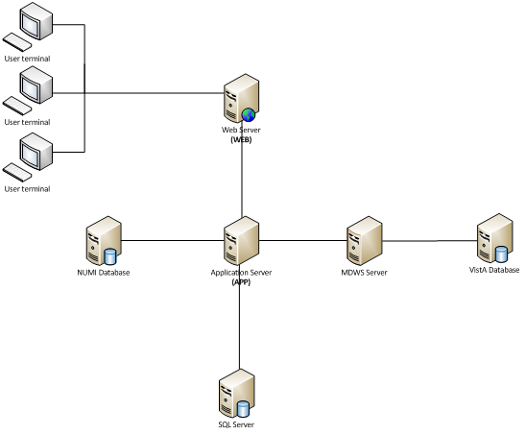

Figure 1: BMS Infrastructure Diagram

BMS is divided into specific components:

1. Persistence layer: SQL Server 2008 R2 database
2. Application server layer: Windows Communication Foundation (WCF) Web Services installed as Windows Services
3. Web server layer: Active Server Pages (ASP) .NET Model-View-Controller (MVC) Web application hosted in Internet Information Services (IIS)
4. Data Exchange Servers:
   1. National Utilization Management Integration (NUMI) SQL Server Database
   2. VistA integration servers (servers that have access to VistA)
      1. Medical Domain Web Services (MDWS): Web Service installed in IIS
5. Client Layer: Web Application client launched from browsers

## System Requirements (Hardware and Software)

BMS requires the creation of a Master Windows Service Account User and numerous facility/Site Service Account Users for execution and operations.

All the BMS Application Services run under a service account.

* + - AITC has created the Windows User (acc\bms_svc_prod) as the master service account that the four BMS Services runs under. This can be referred to as the Master BMS Service Account.
    - The <SERVERADDRESS>25 server hosts the four application services:
      * BMS.BedManagerService
      * BMS.SecurityHost
      * BMS.ServiceHost
    - The <ServerAddress>26 server hosts the four application services:
      * BMS.VI.ServiceHost.
      * BMS.ServiceHost

All BMS Facilities/Sites require at least one service account for certain site functionality.

* + - This service account will run the EMS Mobile Page and Whiteboard Kiosk Page functions.
    - Under BMS version 1.xx a single service account can be used for both functions.
    - The service account that runs the EMS Mobile Page and Whiteboard Kiosk Page functions must not have any Policies assigned that restrict its use to specific computers.

BMS minimum hardware and software requirements are presented below:

Table 1: Server for Web Applications

|  |  |
| --- | --- |
| Basic software: | Microsoft Windows Server 2008 64 bit R2 Standard Microsoft Clustering Services 2008  IIS 7.5 ASP.NET MVC3  .NET Framework 4.5.2 |
| Application software: | Dashboards web application |
| Processor(s): | 16 x Intel Xeon E5520 or equivalent |
| Memory: | 32 GB |
| Hard disks: | 190 GB |
| Network controller: | Broadcom NetXtreme Gigabit Ethernet, or equivalent |

Table 2:Application Sever

|  |  |
| --- | --- |
| **Server 1** | |
| **Basic software:** | Microsoft Windows Server 2008 64 bit R2 Standard  .NET Framework 4.5.2 |
| **Application software:** | EIS, EVS, DS, BMS InFlow |
| **Processor(s):** | 14 x Intel Xeon E5520 or equivalent |
| **Memory:** | 65 GB |
| **Hard disks:** | 190 GB |
| **Network controller:** | Broadcom NetXtreme Gigabit Ethernet, or equivalent |
| **Server 2** | |
| **Basic software:** | Microsoft Windows Server 2008 64 bit R2 Standard  .NET Framework 4.5.2 |
| **Application software:** | EIS, EVS, DS, BMS InFlow |
| **Processor(s):** | 12 x Intel Xeon E5520 or equivalent |
| **Memory:** | 65 GB |
| **Hard disks:** | 210 GB |
| **Network controller:** | Broadcom NetXtreme Gigabit Ethernet, or equivalent |

Table 3: Database Server

|  |  |
| --- | --- |
| **Basic software:** | Microsoft Windows Server 2008 64 bit R2 Standard Microsoft SQL Server 2008 R2 Standard  .NET Framework 4.5.2 |
| **Application software:** | Databases used by the services installed on APP |
| **Processor(s):** | 32 x Intel Xeon E5520 or equivalent |
| **Memory:** | 136 GB |
| **Hard disks:** | 1500 GB |
| **Network controller:** | Broadcom NetXtreme Gigabit Ethernet, or equivalent |

## 

## Configuration Parameters

This section describes configuration parameters of the BMS application.

Table 4: BMS ServiceHost Configuration Parameters

| **Section** | **Configuration Key/Name** | **Configuration values (ex.)** | | |  | **Description** |
| --- | --- | --- | --- | --- | --- | --- |
|  |  | Split Service | | | Combine Service |  |
|  |  | BMS.ServiceHost.config | | BMS.VI.ServiceHost.exe.config | BMS.ServiceHost.config |  |
| **configSections** | mtmodules | type="ePractice.MiddleTier.MTModuleSectionHandler, MiddleTier" | | | |  |
| enterpriselibrary.configurationSettings | type="ePractice.Configuration.ConfigurationManagerSectionHandler, MS.Configuration" | | | |  |
| pagingSortGroup | type="BMS.Utils.PagingSortSection, BMS.Utils" allowDefinition="Everywhere" allowExeDefinition="MachineToApplication" restartOnExternalChanges="true" | | | |  |
| log4net | type="log4net.Config.Log4NetConfigurationSectionHandler,log4net" | | | |  |
| **connectionStrings** | Authorization | connectionString="Data Source=<DatabaseAddress>;Network Library=DBMSSOCN;Initial Catalog=BMS;Persist Security Info=False;Integrated Security=SSPI;Pooling=true;Min Pool Size=0;Max Pool Size=250;" | connectionString="Data Source=<DatabaseAddress>;Network Library=DBMSSOCN;Initial Catalog=BMS;Persist Security Info=False;Integrated Security=SSPI;Pooling=true;Min Pool Size=0;Max Pool Size=250;" | | connectionString="Data Source=<DatabaseAddress>;Initial Catalog=BMS;Persist Security Info=False;Integrated Security=SSPI;Pooling=true;Min Pool Size=0;Max Pool Size=100;" | Connection string for the connection to the BMS database. |
| **appSettings** | DatasetPath | value="DBRepository" | | | |  |
| LocalServer | value="yes" | | | |  |
| UseSecurityContext | value="1" | | | | Security - Authorization |
| ePractice.MiddleTier.Transaction | value="MiddleTier.dll" | | | |  |
| ConnectionRef | value="1" | | | |  |
| TransactionProvider | value="ePractice.MiddleTier.CustomTransactionProvider" | | | |  |
| VistaWorker.WorkerDelayTimeSpan | value="0:0:0:30" | | | | Delay time from service start to first processing |
| VistaWorker.WorkerPeriodTimeSpan | value="0:0:0:15" | | | | Period between worker processing steps |
| VistaWorker.BulkSize | value="100" | | | | Maximum number of processed entities in one step |
| VistaWorker.Enabled | N/A (No longer used) | | | | Whether vista worker is enabled or not (true or false) |
| VistaIntegration.Enabled | value="false" | value="true" | | value="true" | Whether vista integration is enabled or not (true or false) |
| VistaIntegration.SchedulerSecondsLate | value="30" | | | | The time delay of schedulers |
| VistaIntegration.UpdateBmsPatients | value="true" | | | | Whether update bms patients is enabled or not (true or false) |
| SmtpHost | value="smtp.va.gov" | value="smtp.va.gov" | | value="localhost" | smtp host |
| VistaWorker.VistASitesFilePath | value="VistASites.xml" | | | | The vista sites configuration file name |
| VistasBedHoldSupported | N/A | | | | List of vista sites that support bed hold. |
| visitorAppPwd | value="UM" | | | | Password used by MDWS to connect to VistA. |
| visitorUserSiteCode | value="523" | | | | User Site Code used by MDWS to connect to VistA. |
| visitorUserName | < visitorUserName > | | | | User Name used by MDWS to connect to VistA. |
| visitorUserDuz | value="<visitorUserDuz >" | | | | User Duz used by MDWS to connect to VistA. |
| visitorUserSsn | value="<visitorUserSsn >" | | | | User SSN used by MDWS to connect to VistA. |
| visitorContext | value="<visitorContext >" | | | | Context used by MDWS to connect to VistA. |
| UsingNewMdwsMethods | value="true" | | | | Whether use new mdws methods for vista integration (true or false) |
| BMS_EIS_GET_ENTITY_FILTR_PAGE_SIZE | value="1000" | | | | Number of records queried that are brought from EIS in one page. |
| BMS_EVS_GET_CONCEPT_PAGE_SIZE | value="1000" | | | | Number of records queried that are brought from EVS in one page. |
| Changeset | value="72898" | | | | Changeset of the installed build. |
| NumiSvcAuthenticationKey | value="<NumiSvcAuthenticationKey > " | | | | NUMI service authentication key. |
| NumiMaxNumberOfSitesPerCall | value="5" | | | | Maximum number of sites that NUMI processes in one call. |
| Is_IIS_Single_Instance | value="true" | | | | Whether use SSL endpoint from configuration file. (true or false) |
| UseCacheEndpointFromConfigWithSsl | value="true" | | | | Whether use SSL endpoint from configuration file. |
| ProxyPoolMaxCount | value="1000" | value="50" | | value="1000" | The maximum number of proxies in the pool. |
| MdwsEndpointUrl_1 | N/A | <add key="MdwsEndpointUrl_DFLT" value="http://vaausbmsweb26:87/QuerySvc.asmx"/>  <add key="MdwsEndpointUrl_R1" value="http://vaausbmsweb26:88/QuerySvc.asmx"/>  <add key="MdwsEndpointUrl_R2" value="http://vaausbmsweb26:89/QuerySvc.asmx"/>  <add key="MdwsEndpointUrl_R3" value="http://vaausbmsweb26:90/QuerySvc.asmx"/>  <add key="MdwsEndpointUrl_R4" value="http://vaausbmsweb26:91/QuerySvc.asmx"/>  <add key="MdwsEndpointUrl_V1" value="http://vaausbmsweb26:92/QuerySvc.asmx"/>  <add key="MdwsEndpointUrl_V2" value="http://vaausbmsweb26:93/QuerySvc.asmx"/>  <add key="MdwsEndpointUrl_V3" value="http://vaausbmsweb26:94/QuerySvc.asmx"/>  <add key="MdwsEndpointUrl_V4" value="http://vaausbmsweb26:95/QuerySvc.asmx"/>  <add key="MdwsEndpointUrl_V5" value="http://vaausbmsweb26:96/QuerySvc.asmx"/>  <add key="MdwsEndpointUrl_V6" value="http://vaausbmsweb26:97/QuerySvc.asmx"/>  <add key="MdwsEndpointUrl_V7" value="http://vaausbmsweb26:98/QuerySvc.asmx"/>  <add key="MdwsEndpointUrl_V8" value="http://vaausbmsweb26:99/QuerySvc.asmx"/>  <add key="MdwsEndpointUrl_V9" value="http://vaausbmsweb26:100/QuerySvc.asmx"/>  <add key="MdwsEndpointUrl_V10" value="http://vaausbmsweb26:101/QuerySvc.asmx"/>  <add key="MdwsEndpointUrl_V11" value="http://vaausbmsweb26:102/QuerySvc.asmx"/>  <add key="MdwsEndpointUrl_V12" value="http://vaausbmsweb26:103/QuerySvc.asmx"/>  <add key="MdwsEndpointUrl_V13" value="http://vaausbmsweb26:104/QuerySvc.asmx"/>  <add key="MdwsEndpointUrl_V14" value="http://vaausbmsweb26:105/QuerySvc.asmx"/>  <add key="MdwsEndpointUrl_V15" value="http://vaausbmsweb26:106/QuerySvc.asmx"/>  <add key="MdwsEndpointUrl_V16" value="http://vaausbmsweb26:107/QuerySvc.asmx"/>  <add key="MdwsEndpointUrl_V17" value="http://vaausbmsweb26:108/QuerySvc.asmx"/>  <add key="MdwsEndpointUrl_V18" value="http://vaausbmsweb26:109/QuerySvc.asmx"/>  <add key="MdwsEndpointUrl_V19" value="http://vaausbmsweb26:110/QuerySvc.asmx"/>  <add key="MdwsEndpointUrl_V20" value="http://vaausbmsweb26:111/QuerySvc.asmx"/>  <add key="MdwsEndpointUrl_V21" value="http://vaausbmsweb26:112/QuerySvc.asmx"/>  <add key="MdwsEndpointUrl_V22" value="http://vaausbmsweb26:113/QuerySvc.asmx"/>  <add key="MdwsEndpointUrl_V23" value="http://vaausbmsweb26:114/QuerySvc.asmx"/>  <add key="MdwsEndpointUrl_GLA" value="http://vaausbmsweb26:115/QuerySvc.asmx"/>  <add key="MdwsEndpointUrl_LAS" value="http://vaausbmsweb26:116/QuerySvc.asmx"/>  <add key="MdwsEndpointUrl_LOM" value="http://vaausbmsweb26:117/QuerySvc.asmx"/>  <add key="MdwsEndpointUrl_LON" value="http://vaausbmsweb26:118/QuerySvc.asmx"/>  <add key="MdwsEndpointUrl_SDC" value="http://vaausbmsweb26:119/QuerySvc.asmx"/>  <add key="MdwsEndpointUrl_KAN" value="http://vaausbmsweb26:120/QuerySvc.asmx"/>  <add key="MdwsEndpointUrl_STL" value="http://vaausbmsweb26:121/QuerySvc.asmx"/>  <add key="MdwsEndpointUrl_NFL" value="http://vaausbmsweb26:122/QuerySvc.asmx"/>  <add key="MdwsEndpointUrl_WPB" value="http://vaausbmsweb26:123/QuerySvc.asmx"/>  <add key="MdwsEndpointUrl_BAY" value="http://vaausbmsweb26:124/QuerySvc.asmx"/>   <add key="MdwsEndpointUrl_MIA" value="http://vaausbmsweb26:125/QuerySvc.asmx"/>  <add key="MdwsEndpointUrl_ORL" value="http://vaausbmsweb26:126/QuerySvc.asmx"/>  <add key="MdwsEndpointUrl_SAJ" value="http://vaausbmsweb26:127/QuerySvc.asmx"/>  <add key="MdwsEndpointUrl_TAM" value="http://vaausbmsweb26:128/QuerySvc.asmx"/>   <add key="MdwsEndpointUrl_RSV1" value="http://vaausbmsweb27:87/QuerySvc.asmx"/>  <add key="MdwsEndpointUrl_RSV2" value="http://vaausbmsweb27:88/QuerySvc.asmx"/>  <add key="MdwsEndpointUrl_RSV3" value="http://vaausbmsweb27:89/QuerySvc.asmx"/>  <add key="MdwsEndpointUrl_RSV4" value="http://vaausbmsweb27:90/QuerySvc.asmx"/>  <add key="MdwsEndpointUrl_RSV5" value="http://vaausbmsweb27:91/QuerySvc.asmx"/>  <add key="MdwsEndpointUrl_RSV6" value="http://vaausbmsweb27:92/QuerySvc.asmx"/>  <add key="MdwsEndpointUrl_RSV7" value="http://vaausbmsweb27:93/QuerySvc.asmx"/>  <add key="MdwsEndpointUrl_RSV8" value="http://vaausbmsweb27:94/QuerySvc.asmx"/>  <add key="MdwsEndpointUrl_RSV9" value="http://vaausbmsweb27:95/QuerySvc.asmx"/>  <add key="MdwsEndpointUrl_RSV10" value="http://vaausbmsweb27:96/QuerySvc.asmx"/>  <add key="MdwsEndpointUrl_RSV11" value="http://vaausbmsweb27:97/QuerySvc.asmx"/>  <add key="MdwsEndpointUrl_RSV12" value="http://vaausbmsweb27:98/QuerySvc.asmx"/>  <add key="MdwsEndpointUrl_RSV13" value="http://vaausbmsweb27:99/QuerySvc.asmx"/>  <add key="MdwsEndpointUrl_RSV14" value="http://vaausbmsweb27:100/QuerySvc.asmx"/>  <add key="MdwsEndpointUrl_RSV14" value="http://vaausbmsweb27:101/QuerySvc.asmx"/>  <add key="MdwsEndpointUrl_RSV15" value="http://vaausbmsweb27:102/QuerySvc.asmx"/>  <add key="MdwsEndpointUrl_RSV16" value="http://vaausbmsweb27:103/QuerySvc.asmx"/>  <add key="MdwsEndpointUrl_RSV17" value="http://vaausbmsweb27:104/QuerySvc.asmx"/>  <add key="MdwsEndpointUrl_RSV18" value="http://vaausbmsweb27:105/QuerySvc.asmx"/>  <add key="MdwsEndpointUrl_RSV19" value="http://vaausbmsweb27:106/QuerySvc.asmx"/>  <add key="MdwsEndpointUrl_RSV20" value="http://vaausbmsweb27:107/QuerySvc.asmx"/>  <add key="MdwsEndpointUrl_RSV21" value="http://vaausbmsweb27:108/QuerySvc.asmx"/>  <add key="MdwsEndpointUrl_RSV22" value="http://vaausbmsweb27:109/QuerySvc.asmx"/>  <add key="MdwsEndpointUrl_RSV23" value="http://vaausbmsweb27:110/QuerySvc.asmx"/>  <add key="MdwsEndpointUrl_RSV24" value="http://vaausbmsweb27:111/QuerySvc.asmx"/>  <add key="MdwsEndpointUrl_RSV25" value="http://vaausbmsweb27:112/QuerySvc.asmx"/>  <add key="MdwsEndpointUrl_RSV26" value="http://vaausbmsweb27:113/QuerySvc.asmx"/>  <add key="MdwsEndpointUrl_RSV27" value="http://vaausbmsweb27:114/QuerySvc.asmx"/>  <add key="MdwsEndpointUrl_GLA27" value="http://vaausbmsweb27:115/QuerySvc.asmx"/>  <add key="MdwsEndpointUrl_LAS27" value="http://vaausbmsweb27:116/QuerySvc.asmx"/>  <add key="MdwsEndpointUrl_LOM27" value="http://vaausbmsweb27:117/QuerySvc.asmx"/>  <add key="MdwsEndpointUrl_LON27" value="http://vaausbmsweb27:118/QuerySvc.asmx"/>  <add key="MdwsEndpointUrl_SDC27" value="http://vaausbmsweb27:119/QuerySvc.asmx"/>  <add key="MdwsEndpointUrl_KAN27" value="http://vaausbmsweb27:120/QuerySvc.asmx"/>  <add key="MdwsEndpointUrl_STL27" value="http://vaausbmsweb27:121/QuerySvc.asmx"/>  <add key="MdwsEndpointUrl_NFL27" value="http://vaausbmsweb27:122/QuerySvc.asmx"/>  <add key="MdwsEndpointUrl_WPB27" value="http://vaausbmsweb27:123/QuerySvc.asmx"/>  <add key="MdwsEndpointUrl_BAY27" value="http://vaausbmsweb27:124/QuerySvc.asmx"/>   <add key="MdwsEndpointUrl_MIA27" value="http://vaausbmsweb27:125/QuerySvc.asmx"/>  <add key="MdwsEndpointUrl_ORL27" value="http://vaausbmsweb27:126/QuerySvc.asmx"/>  <add key="MdwsEndpointUrl_SAJ27" value="http://vaausbmsweb27:127/QuerySvc.asmx"/>  <add key="MdwsEndpointUrl_TAM27" value="http://vaausbmsweb27:128/QuerySvc.asmx"/> | | value="http://localhost:82/QuerySvc.asmx" value="http://localhost:82/QuerySvc.asmx" | MDWS instance URL address. |
| VistaIntegrationJobFailedMaxCount | value="25" | | | | The maximum number of job failures until the system decides to retry. |
| VistaIntegrationJobFailedIncrementDateMinutes | value="10" | | | | The time span (minutes) that the system decides to increment job’s start date when the threshold of job failures is reached. |
| VistaIntegrationJobFailedNotificationEmailTo |  |  | |  | Recipient’s email used when a job fails. (va_person@va.gov) |
| VistaIntegrationJobFailedNotificationEmailFrom | value="BMSBackgroundProcessorAgent@va.gov" | | | | Sender’s email used when a job fails. |
| BMS_EIS_LongRunningMethodsMaxConcurrentCalls | value="100" | value="75" | | value="75" |  |
| BMS_EVS_LongRunningMethodsMaxConcurrentCalls | value="100" | value="100" | | value="50" |  |
| BMSServiceHostStartType | value="BMS" | value="BMS.VI" | | value="ALL" | Identifies how BMS is ran and the the asscoiate configuration file. (possible values: ALL, BMS, BMS.VI) |
| VistaIntegration.TaskSchedulerDelayMin | value="0" | value="0" | | value="0" |  |
| VistaIntegration.TaskSchedulerDelayMax | value="10" | value="10" | | value="10" |  |
| VistaIntegration.TaskSchedulerDelayStep | value="5" | value="5" | | value="5" |  |
| ThreadPoolMaxWorkerThreads |  |  | | value="200" |  |
| VistaIntegration.PatientMovementIenDays |  | value="60" | | value="60" |  |
| **pagingSortGroup\pagingSort** | sortColumnCode="entered" | sortColumnName="[A].[CREATION_DATE]" | | | |  |
| sortColumnCode="patient" | sortColumnName="[PAT].[LAST_NAME], [PAT].[FIRST_NAME]" | | | |  |
| sortColumnCode="facility" | sortColumnName="[F].[NAME]" | | | |  |
| sortColumnCode="requestdt" | sortColumnName="[A].[CREATION_DATE]" | | | |  |
| sortColumnCode="specialty" | sortColumnName="[REQSP].[DISPLAY_NAME]" | | | |  |
| sortColumnCode="visn" | sortColumnName="[TR].[FACILITY_VISN] | | | |  |
| sortColumnCode="region" | sortColumnName="[TR].[FACILITY_REGION]" | | | |  |
| sortColumnCode="eventdt" | sortColumnName="[AEVN].[CREATION_DATE]" | | | |  |
| sortColumnCode="VacatedDate" | sortColumnCode="VacatedDate" | | | |  |
| sortColumnCode="transfereventdt" | sortColumnName="[A].[CREATION_DATE]" | | | |  |
| sortColumnCode="transferrequestdt" | sortColumnName="[TR].[REQUESTED_DATE]" | | | |  |
| **mtmodules [defaultserver=""]** | assembly="General.MT.dll" | servername="" | | | |  |
| assembly="BMS.MT.dll" | servername="" | | | |  |
| **enterpriselibrary.configurationSettings xmlns:xsd="http://www.w3.org/2001/XMLSchema" xmlns:xsi="http://www.w3.org/2001/XMLSchema-instance" applicationName="HMSI" xmlns="http://www.microsoft.com/practices/enterpriselibrary/08-31-2004/configuration"** | configurationSections\configurationSection xsi:type="ReadOnlyConfigurationSectionData" name="securityConfiguration" encrypt="false" | storageProvider xsi:type="XmlFileStorageProviderData" name="XML File Storage Provider" path="securityConfiguration.config" | | | |  |
| <dataTransformer xsi:type="XmlSerializerTransformerData" name="Xml Serializer Transformer">  <includeTypes>  <includeType name="HMUserAccessAuthenticationProviderData" type="ePractice.Security.HMUserAccess.Configuration.HMUserAccessAuthenticationProviderData, Security.HMUserAccess"/>  <includeType name="HMUserAccessAuthorizationProviderData" type="ePractice.Security.HMUserAccess.Configuration.HMUserAccessAuthorizationProviderData, Security.HMUserAccess"/>  <includeType name="HMUserAccessRolesProviderData" type="ePractice.Security.HMUserAccess.Configuration.HMUserAccessRolesProviderData, Security.HMUserAccess"/>  <includeType name="NullAuthenticationProviderData" type="ePractice.Security.Null.Configuration.NullAuthenticationProviderData, Security.Null"/>  <includeType name="NullAuthorizationProviderData" type="ePractice.Security.Null.Configuration.NullAuthorizationProviderData, Security.Null"/>  </includeTypes>  </dataTransformer> | | | |  |
| configurationSections\configurationSection xsi:type="ReadOnlyConfigurationSectionData" name="cachingConfiguration" encrypt="false" | storageProvider xsi:type="XmlFileStorageProviderData" name="XML File Storage Provider" path="cachingConfiguration.config" | | | | Caching configuration is for CLIENT |
| <dataTransformer xsi:type="XmlSerializerTransformerData" name="Xml Serializer Transformer">  <includeTypes/>  </dataTransformer> | | | |
| configurationSections\configurationSection xsi:type="ReadOnlyConfigurationSectionData" name="connectionConfiguration" encrypt="false" | storageProvider xsi:type="XmlFileStorageProviderData" name="XML File Storage Provider" path="connectionConfiguration.config" | | | | Connection configuration is for SERVER |
| <dataTransformer xsi:type="XmlSerializerTransformerData" name="Xml Serializer Transformer">  <includeTypes>  <includeType name="ServicesDatabaseConnectionProviderData" type="ePractice.Connection.SingleDatabase.Configuration.ServicesDatabaseConnectionProviderData, Connections.SingleDatabase, Version=1.0.0.0, Culture=neutral, PublicKeyToken=null"/>  </includeTypes>  </dataTransformer> | | | |
| keyAlgorithmStorageProvider | xsi:nil="true" | | | |  |
| **system.runtime.remoting** | application\channels\channel | type="System.Runtime.Remoting.Channels.Tcp.TcpChannel, System.Runtime.Remoting, Version=1.0.5000.0, Culture=neutral, PublicKeyToken=b77a5c561934e089" name="RegularChannel" | | | |  |
| **system.net** | connectionManagement\add | address="*" maxconnection="1000" | | | |  |
| **system.serviceModel\services** | service | name="BMS.ServiceImplementation.BedManagerOperationsCore" behaviorConfiguration="ServiceBehavior" | | | |  |
|  | host\base\baseAddresses\add | baseAddress="http://<ServerAddress>25:16050/BMSOperations" | baseAddress="http://<ServerAddress>26:16050/BMSOperations" | | baseAddress="http://localhost:16050/BMSOperations" |  |
|  | endpoint | address="" bindingConfiguration="ServiceBinding" binding="wsFederationHttpBinding" contract="BMS.ServiceContracts.IBedManagerOperations" | | | |  |
|  | endpoint | address="win" bindingConfiguration="WinBinding" binding="wsFederationHttpBinding" contract="BMS.ServiceContracts.IBedManagerOperations" | | | |  |
|  | endpoint | contract="IMetadataExchange" binding="mexHttpBinding" address="mex" | | | |  |
|  | endpoint | address="unsec" binding="basicHttpBinding" contract="BMS.ServiceContracts.IBedManagerOperations" | | | |  |
|  | service | name="BMS.ServiceImplementation.BedManagerQueryCore" behaviorConfiguration="ServiceBehavior" | | | |  |
|  | host\base\baseAddresses\add | baseAddress="http://<ServerAddress>25:16050/BMSQuery" | baseAddress="http://<ServerAddress>26:16050/BMSQuery" | | baseAddress="http://localhost:16050/BMSQuery" |  |
|  | endpoint | address="" bindingConfiguration="ServiceBinding" binding="wsFederationHttpBinding" contract="BMS.ServiceContracts.IBedManagerQuery" | | | |  |
|  | endpoint | address="win" bindingConfiguration="WinBinding" binding="wsFederationHttpBinding" contract="BMS.ServiceContracts.IBedManagerQuery" | | | |  |
|  | endpoint | contract="IMetadataExchange" binding="mexHttpBinding" address="mex" | | | |  |
|  | endpoint | address="unsec" binding="basicHttpBinding" contract="BMS.ServiceContracts.IBedManagerQuery" | | | |  |
|  | service | name="BMS.ServiceImplementation.BedManagerCacheCore" behaviorConfiguration="ServiceBehavior" | | | |  |
|  | host\base\baseAddresses\add |  | baseAddress="http://<ServerAddress>26:16050/BMSCache" | | baseAddress="http://localhost:16050/BMSCache" |  |
|  | endpoint |  | address="" bindingConfiguration="ServiceBinding" binding="wsFederationHttpBinding" contract="BMS.ServiceContracts.IBedManagerCache" | | address="" bindingConfiguration="ServiceBinding" binding="wsFederationHttpBinding" contract="BMS.ServiceContracts.IBedManagerCache" |  |
|  | endpoint |  | address="win" bindingConfiguration="WinBinding" binding="wsFederationHttpBinding" contract="BMS.ServiceContracts.IBedManagerCache" | | address="win" bindingConfiguration="WinBinding" binding="wsFederationHttpBinding" contract="BMS.ServiceContracts.IBedManagerCache" |  |
|  | endpoint |  | contract="IMetadataExchange" binding="mexHttpBinding" address="mex" | | contract="IMetadataExchange" binding="mexHttpBinding" address="mex" |  |
|  | endpoint |  | address="unsec" binding="basicHttpBinding" contract="BMS.ServiceContracts.IBedManagerCache" | | address="unsec" binding="basicHttpBinding" contract="BMS.ServiceContracts.IBedManagerCache" |  |
|  | service | name="BMS.ServiceImplementation.ConfigurationOperationsCore" behaviorConfiguration="ServiceBehavior" |  | | name="BMS.ServiceImplementation.ConfigurationOperationsCore" behaviorConfiguration="ServiceBehavior" |  |
|  | host\base\baseAddresses\add | baseAddress="http://<ServerAddress>25:16050/BMSConfigurationOperations" |  | | baseAddress="http://localhost:16050/BMSConfigurationOperations" |  |
|  | endpoint | address="" bindingConfiguration="ServiceBinding" binding="wsFederationHttpBinding" contract="BMS.ServiceContracts.IConfigurationOperations" |  | | address="" bindingConfiguration="ServiceBinding" binding="wsFederationHttpBinding" contract="BMS.ServiceContracts.IConfigurationOperations" |  |
|  | endpoint | address="win" bindingConfiguration="WinBinding" binding="wsFederationHttpBinding" contract="BMS.ServiceContracts.IConfigurationOperations" |  | | address="win" bindingConfiguration="WinBinding" binding="wsFederationHttpBinding" contract="BMS.ServiceContracts.IConfigurationOperations" |  |
|  | endpoint | contract="IMetadataExchange" binding="mexHttpBinding" address="mex" |  | | contract="IMetadataExchange" binding="mexHttpBinding" address="mex" |  |
|  | endpoint | address="unsec" binding="basicHttpBinding" contract="BMS.ServiceContracts.IConfigurationOperations" |  | | address="unsec" binding="basicHttpBinding" contract="BMS.ServiceContracts.IConfigurationOperations" |  |
|  | service | name="InfoWorld.Security.Authorization.AuthorizationSubscriber.AuthorizationSubscriber" behaviorConfiguration="ServiceBehavior" |  | | name="InfoWorld.Security.Authorization.AuthorizationSubscriber.AuthorizationSubscriber" behaviorConfiguration="ServiceBehavior" |  |
|  | host\base\baseAddresses\add | baseAddress="http://<ServerAddress>25:16050/BMS/AuthorizationSubscriber" |  | | baseAddress="http://localhost:16050/BMS/AuthorizationSubscriber" |  |
|  | endpoint | address="" binding="wsFederationHttpBinding" bindingConfiguration="WinBinding" contract="InfoWorld.Security.Authorization.AuthorizationSubscriber.IAuthorizationSubscriber" |  | | address="" binding="wsFederationHttpBinding" bindingConfiguration="WinBinding" contract="InfoWorld.Security.Authorization.AuthorizationSubscriber.IAuthorizationSubscriber" |  |
|  | service |  | name="TransferFlow" behaviorConfiguration="WorkflowService" | | name="TransferFlow" behaviorConfiguration="WorkflowService" |  |
|  | host\base\baseAddresses\add |  | baseAddress="http://<ServerAddress>26:16050/TransferWF" | | baseAddress="http://localhost:16050/TransferWF" |  |
|  | endpoint |  | address="" bindingConfiguration="ServiceBinding" binding="wsFederationHttpBinding" contract="BMS.Workflows.WF.ITransferFlow" | | address="" bindingConfiguration="ServiceBinding" binding="wsFederationHttpBinding" contract="BMS.Workflows.WF.ITransferFlow" |  |
|  | endpoint |  | address="win" bindingConfiguration="WinBinding" binding="wsFederationHttpBinding" contract="BMS.Workflows.WF.ITransferFlow" | | address="win" bindingConfiguration="WinBinding" binding="wsFederationHttpBinding" contract="BMS.Workflows.WF.ITransferFlow" |  |
|  | endpoint |  | contract="IMetadataExchange" binding="mexHttpBinding" address="mex" | | contract="IMetadataExchange" binding="mexHttpBinding" address="mex" |  |
|  | endpoint |  | address="unsec" binding="basicHttpBinding" contract="BMS.Workflows.WF.ITransferFlow" | | address="unsec" binding="basicHttpBinding" contract="BMS.Workflows.WF.ITransferFlow" |  |
|  | service |  | name="WaitingListFlow" behaviorConfiguration="WorkflowService" | | name="WaitingListFlow" behaviorConfiguration="WorkflowService" |  |
|  | host\base\baseAddresses\add |  | baseAddress="http://<ServerAddress>26:16050/WaitingListWF" | | baseAddress="http://localhost:16050/WaitingListWF" |  |
|  | endpoint |  | address="" bindingConfiguration="ServiceBinding" binding="wsFederationHttpBinding" contract="BMS.Workflows.WF.IWaitingListFlow" | | address="" bindingConfiguration="ServiceBinding" binding="wsFederationHttpBinding" contract="BMS.Workflows.WF.IWaitingListFlow" |  |
|  | endpoint |  | address="win" bindingConfiguration="WinBinding" binding="wsFederationHttpBinding" contract="BMS.Workflows.WF.IWaitingListFlow" | | address="win" bindingConfiguration="WinBinding" binding="wsFederationHttpBinding" contract="BMS.Workflows.WF.IWaitingListFlow" |  |
|  | endpoint |  | contract="IMetadataExchange" binding="mexHttpBinding" address="mex" | | contract="IMetadataExchange" binding="mexHttpBinding" address="mex" |  |
|  | endpoint |  | address="unsec" binding="basicHttpBinding" contract="BMS.Workflows.WF.IWaitingListFlow" | | address="unsec" binding="basicHttpBinding" contract="BMS.Workflows.WF.IWaitingListFlow" |  |
|  | service |  | name="BedUnavailableFlow" behaviorConfiguration="WorkflowService" | | name="BedUnavailableFlow" behaviorConfiguration="WorkflowService" |  |
|  | host\base\baseAddresses\add |  | baseAddress="http://<ServerAddress>26:16050/BedUnavailableWF" | | name="BedUnavailableFlow" behaviorConfiguration="WorkflowService" |  |
|  | endpoint |  | address="" bindingConfiguration="ServiceBinding" binding="wsFederationHttpBinding" contract="BMS.Workflows.WF.IBedUnavailableFlow" | | address="" bindingConfiguration="ServiceBinding" binding="wsFederationHttpBinding" contract="BMS.Workflows.WF.IBedUnavailableFlow" |  |
|  | endpoint |  | address="win" bindingConfiguration="WinBinding" binding="wsFederationHttpBinding" contract="BMS.Workflows.WF.IBedUnavailableFlow" | | address="win" bindingConfiguration="WinBinding" binding="wsFederationHttpBinding" contract="BMS.Workflows.WF.IBedUnavailableFlow" |  |
|  | endpoint |  | contract="IMetadataExchange" binding="mexHttpBinding" address="mex" | | contract="IMetadataExchange" binding="mexHttpBinding" address="mex" |  |
|  | endpoint |  | address="unsec" binding="basicHttpBinding" contract="BMS.Workflows.WF.IBedUnavailableFlow" | | address="unsec" binding="basicHttpBinding" contract="BMS.Workflows.WF.IBedUnavailableFlow" |  |
|  | service |  | name="BMS.ServiceImplementation.VistaQueryCore" behaviorConfiguration="ServiceBehavior" | | name="BMS.ServiceImplementation.VistaQueryCore" behaviorConfiguration="ServiceBehavior" |  |
|  | host\base\baseAddresses\add |  | baseAddress="http://<ServerAddress>26:16050/VistaQuery" | | baseAddress="http://localhost:16050/VistaQuery" |  |
|  | endpoint |  | address="" bindingConfiguration="ServiceBinding" binding="wsFederationHttpBinding" contract="BMS.ServiceContracts.IVistaWorkerQuery" | | address="" bindingConfiguration="ServiceBinding" binding="wsFederationHttpBinding" contract="BMS.ServiceContracts.IVistaWorkerQuery" |  |
|  | endpoint |  | address="win" bindingConfiguration="WinBinding" binding="wsFederationHttpBinding" contract="BMS.ServiceContracts.IVistaWorkerQuery" | | address="win" bindingConfiguration="WinBinding" binding="wsFederationHttpBinding" contract="BMS.ServiceContracts.IVistaWorkerQuery" |  |
|  | endpoint |  | contract="IMetadataExchange" binding="mexHttpBinding" address="mex" | | contract="IMetadataExchange" binding="mexHttpBinding" address="mex" |  |
|  | endpoint |  | address="unsec" binding="basicHttpBinding" contract="BMS.ServiceContracts.IVistaWorkerQuery" | | address="unsec" binding="basicHttpBinding" contract="BMS.ServiceContracts.IVistaWorkerQuery" |  |
|  | service |  | name="BMS.VistaIntegration.HL7.ServiceImplementation.HL7OperationsCore" behaviorConfiguration="BasicBindingBehavior" | | name="BMS.VistaIntegration.HL7.ServiceImplementation.HL7OperationsCore" behaviorConfiguration="BasicBindingBehavior" |  |
|  | host\base\baseAddresses\add |  | baseAddress="http://<ServerAddress>26:16050/HL7Operations" | | baseAddress="http://localhost:16050/HL7Operations" |  |
|  | endpoint |  | address="" bindingConfiguration="messagingBinding" binding="basicHttpBinding" contract="BMS.VistaIntegration.HL7.ServiceContracts.IHL7Operations" | | address="" bindingConfiguration="messagingBinding" binding="basicHttpBinding" contract="BMS.VistaIntegration.HL7.ServiceContracts.IHL7Operations" |  |
|  | bindings\basicHttpBinding |  |  | |  |  |
|  | binding |  | name="EVSBinding" maxReceivedMessageSize="2147483647" closeTimeout="00:10:00" openTimeout="00:10:00" receiveTimeout="00:15:00" sendTimeout="00:10:00" | | name="EVSBinding" maxReceivedMessageSize="2147483647" closeTimeout="00:10:00" openTimeout="00:10:00" receiveTimeout="00:15:00" sendTimeout="00:10:00" |  |
|  | binding |  | name="subscriptionBinding" maxBufferSize="2147483647" maxReceivedMessageSize="2147483647" closeTimeout="00:10:00" openTimeout="00:10:00" receiveTimeout="00:15:00" sendTimeout="00:10:00" | | name="subscriptionBinding" maxBufferSize="2147483647" maxReceivedMessageSize="2147483647" closeTimeout="00:10:00" openTimeout="00:10:00" receiveTimeout="00:15:00" sendTimeout="00:10:00" |  |
|  | binding |  | name="messagingBinding" maxBufferSize="2147483647" maxReceivedMessageSize="2147483647" closeTimeout="00:10:00" openTimeout="00:10:00" receiveTimeout="00:15:00" sendTimeout="00:10:00" | | name="messagingBinding" maxBufferSize="2147483647" maxReceivedMessageSize="2147483647" closeTimeout="00:10:00" openTimeout="00:10:00" receiveTimeout="00:15:00" sendTimeout="00:10:00" |  |
|  | readerQuotas |  | maxDepth="2147483647" maxStringContentLength="2147483647" maxArrayLength="2147483647" maxBytesPerRead="2147483647" maxNameTableCharCount="2147483647" | | maxDepth="2147483647" maxStringContentLength="2147483647" maxArrayLength="2147483647" maxBytesPerRead="2147483647" maxNameTableCharCount="2147483647" |  |
|  | binding |  | name="QuerySvcSoap" closeTimeout="00:10:00" openTimeout="00:10:00" receiveTimeout="00:15:00" sendTimeout="00:10:00" allowCookies="false"  bypassProxyOnLocal="false" hostNameComparisonMode="StrongWildcard"  maxBufferSize="2147483647" maxReceivedMessageSize="2147483647"  messageEncoding="Text" textEncoding="utf-8" transferMode="Buffered"  useDefaultWebProxy="true" | | name="QuerySvcSoap" closeTimeout="00:10:00" openTimeout="00:10:00" receiveTimeout="00:15:00" sendTimeout="00:10:00" allowCookies="false"  bypassProxyOnLocal="false" hostNameComparisonMode="StrongWildcard"  maxBufferSize="2147483647" maxReceivedMessageSize="2147483647"  messageEncoding="Text" textEncoding="utf-8" transferMode="Buffered"  useDefaultWebProxy="true" |  |
|  | readerQuotas |  | maxDepth="32" maxStringContentLength="2147483647" maxArrayLength="2147483647"  maxBytesPerRead="2147483647" maxNameTableCharCount="2147483647" | | maxDepth="32" maxStringContentLength="2147483647" maxArrayLength="2147483647"  maxBytesPerRead="2147483647" maxNameTableCharCount="2147483647" |  |
|  | security mode="None" |  |  | |  |  |
|  | transport |  | clientCredentialType="None" proxyCredentialType="None"  realm="" | | clientCredentialType="None" proxyCredentialType="None"  realm="" |  |
|  | message |  | clientCredentialType="UserName" algorithmSuite="Default" | | clientCredentialType="UserName" algorithmSuite="Default" |  |
|  | binding |  | name="QuerySvcSoapHttps" closeTimeout="00:10:00" openTimeout="00:10:00" receiveTimeout="00:15:00" sendTimeout="00:10:00" allowCookies="false"  bypassProxyOnLocal="false" hostNameComparisonMode="StrongWildcard" maxBufferSize="2147483647" maxReceivedMessageSize="2147483647"  messageEncoding="Text" textEncoding="utf-8" transferMode="Buffered" useDefaultWebProxy="true" | | name="QuerySvcSoapHttps" closeTimeout="00:10:00" openTimeout="00:10:00" receiveTimeout="00:15:00" sendTimeout="00:10:00" allowCookies="false"  bypassProxyOnLocal="false" hostNameComparisonMode="StrongWildcard" maxBufferSize="2147483647" maxReceivedMessageSize="2147483647"  messageEncoding="Text" textEncoding="utf-8" transferMode="Buffered" useDefaultWebProxy="true" |  |
|  | readerQuotas |  | maxDepth="32" maxStringContentLength="2147483647" maxArrayLength="2147483647" maxBytesPerRead="2147483647" maxNameTableCharCount="2147483647" | | maxDepth="32" maxStringContentLength="2147483647" maxArrayLength="2147483647" maxBytesPerRead="2147483647" maxNameTableCharCount="2147483647" |  |
|  | security mode="Transport" |  |  | |  |  |
|  | transport |  | clientCredentialType="None" proxyCredentialType="None" realm="" | | clientCredentialType="None" proxyCredentialType="None" realm="" |  |
|  | wsFederationHttpBinding |  |  | |  |  |
|  | binding |  | name="WSFederationHttpBinding_AuthenticatedService" maxReceivedMessageSize="2147483647" closeTimeout="00:10:00" openTimeout="00:10:00" receiveTimeout="00:15:00" sendTimeout="00:10:00" | | name="WSFederationHttpBinding_AuthenticatedService" maxReceivedMessageSize="2147483647" closeTimeout="00:10:00" openTimeout="00:10:00" receiveTimeout="00:15:00" sendTimeout="00:10:00" |  |
|  | readerQuotas |  | maxDepth="32" maxStringContentLength="2147483647" maxArrayLength="2147483647" maxBytesPerRead="4096" maxNameTableCharCount="16384" | | maxDepth="32" maxStringContentLength="2147483647" maxArrayLength="2147483647" maxBytesPerRead="4096" maxNameTableCharCount="16384" |  |
|  | security mode="Message" |  |  | |  |  |
|  | message |  | algorithmSuite="Default" issuedKeyType="SymmetricKey" issuedTokenType="http://docs.oasis-open.org/wss/oasis-wss-saml-token-profile-1.1#SAMLV2.0" negotiateServiceCredential="false" establishSecurityContext="true" | | algorithmSuite="Default" issuedKeyType="SymmetricKey" issuedTokenType="http://docs.oasis-open.org/wss/oasis-wss-saml-token-profile-1.1#SAMLV2.0" negotiateServiceCredential="false" establishSecurityContext="true" |  |
|  | issuer | address="http://<ServerAddress>25:16050/STS/mex" | address="http://<ServerAddress>25:16050/STS/" binding="wsHttpBinding" bindingConfiguration="wsUserName" | | address="http://localhost:16050/STS/" binding="wsHttpBinding" bindingConfiguration="wsUserName" |  |
|  | identity\dns |  | value="IWHM3STS" | | value="IWHM3STS" |  |
|  | binding | name="ServiceBinding" maxBufferPoolSize="2147483647" maxReceivedMessageSize="2147483647" closeTimeout="00:10:00" openTimeout="00:10:00" receiveTimeout="00:15:00" sendTimeout="00:10:00" | name="ServiceBinding" maxBufferPoolSize="2147483647" maxReceivedMessageSize="2147483647" closeTimeout="00:10:00" openTimeout="00:10:00" receiveTimeout="00:15:00" sendTimeout="00:10:00" | | name="ServiceBinding" maxBufferPoolSize="2147483647" maxReceivedMessageSize="2147483647" closeTimeout="00:10:00" openTimeout="00:10:00" receiveTimeout="00:15:00" sendTimeout="00:10:00" |  |
|  | readerQuotas | maxDepth="32" maxStringContentLength="2147483647" maxArrayLength="2147483647" maxBytesPerRead="4096" maxNameTableCharCount="16384" | maxDepth="32" maxStringContentLength="2147483647" maxArrayLength="2147483647" maxBytesPerRead="4096" maxNameTableCharCount="16384" | | maxDepth="32" maxStringContentLength="2147483647" maxArrayLength="2147483647" maxBytesPerRead="4096" maxNameTableCharCount="16384" |  |
|  | security mode="Message" |  |  | |  |  |
|  | message issuedTokenType="http://docs.oasis-open.org/wss/oasis-wss-saml-token-profile-1.1#SAMLV2.0" negotiateServiceCredential="false" establishSecurityContext="true" | issuerMetadata address="http://<ServerAddress>25:16050/STS/mex" | issuerMetadata address="http://<ServerAddress>25:16050/STS/mex" | | issuerMetadata address="http://localhost:16050/STS/mex" |  |
|  | binding | name="WinBinding" maxBufferPoolSize="2147483647" maxReceivedMessageSize="2147483647" closeTimeout="00:10:00" openTimeout="00:10:00" receiveTimeout="00:15:00" sendTimeout="00:10:00" | name="WinBinding" maxBufferPoolSize="2147483647" maxReceivedMessageSize="2147483647" closeTimeout="00:10:00" openTimeout="00:10:00" receiveTimeout="00:15:00" sendTimeout="00:10:00" | | name="WinBinding" maxBufferPoolSize="2147483647" maxReceivedMessageSize="2147483647" closeTimeout="00:10:00" openTimeout="00:10:00" receiveTimeout="00:15:00" sendTimeout="00:10:00" |  |
|  | readerQuotas | maxDepth="32" maxStringContentLength="2147483647" maxArrayLength="2147483647" maxBytesPerRead="4096" maxNameTableCharCount="16384" | maxDepth="32" maxStringContentLength="2147483647" maxArrayLength="2147483647" maxBytesPerRead="4096" maxNameTableCharCount="16384" | | maxDepth="32" maxStringContentLength="2147483647" maxArrayLength="2147483647" maxBytesPerRead="4096" maxNameTableCharCount="16384" |  |
|  | security mode="Message" |  |  | |  |  |
|  | message | issuedTokenType="http://docs.oasis-open.org/wss/oasis-wss-saml-token-profile-1.1#SAMLV2.0" negotiateServiceCredential="false" establishSecurityContext="true" | issuedTokenType="http://docs.oasis-open.org/wss/oasis-wss-saml-token-profile-1.1#SAMLV2.0" negotiateServiceCredential="false" establishSecurityContext="true" | | issuedTokenType="http://docs.oasis-open.org/wss/oasis-wss-saml-token-profile-1.1#SAMLV2.0" negotiateServiceCredential="false" establishSecurityContext="true" |  |
|  | issuer | address="http://<ServerAddress>25:16050/STS/Windows" binding="wsHttpBinding" bindingConfiguration="StsWinBinding" | address="http://<ServerAddress>25:16050/STS/Windows" binding="wsHttpBinding" bindingConfiguration="StsWinBinding" | | address="http://localhost:16050/STS/Windows" binding="wsHttpBinding" bindingConfiguration="StsWinBinding" |  |
|  | identity\servicePrincipalName | value="host/localhost" | value="host/localhost" | | value="host/localhost" |  |
|  | binding | name="WinBindingHttps" maxBufferPoolSize="2147483647" maxReceivedMessageSize="2147483647" closeTimeout="00:10:00" openTimeout="00:10:00" receiveTimeout="00:15:00" sendTimeout="00:10:00" | name="WinBindingHttps" maxBufferPoolSize="2147483647" maxReceivedMessageSize="2147483647" closeTimeout="00:10:00" openTimeout="00:10:00" receiveTimeout="00:15:00" sendTimeout="00:10:00" | | name="WinBindingHttps" maxBufferPoolSize="2147483647" maxReceivedMessageSize="2147483647" closeTimeout="00:10:00" openTimeout="00:10:00" receiveTimeout="00:15:00" sendTimeout="00:10:00" |  |
|  | readerQuotas | maxDepth="32" maxStringContentLength="2147483647" maxArrayLength="2147483647" maxBytesPerRead="4096" maxNameTableCharCount="16384" | maxDepth="32" maxStringContentLength="2147483647" maxArrayLength="2147483647" maxBytesPerRead="4096" maxNameTableCharCount="16384" | | maxDepth="32" maxStringContentLength="2147483647" maxArrayLength="2147483647" maxBytesPerRead="4096" maxNameTableCharCount="16384" |  |
|  | security mode="TransportWithMessageCredential" |  |  | |  |  |
|  | message | issuedTokenType="http://docs.oasis-open.org/wss/oasis-wss-saml-token-profile-1.1#SAMLV2.0" negotiateServiceCredential="false" establishSecurityContext="true" | issuedTokenType="http://docs.oasis-open.org/wss/oasis-wss-saml-token-profile-1.1#SAMLV2.0" negotiateServiceCredential="false" establishSecurityContext="true" | | issuedTokenType="http://docs.oasis-open.org/wss/oasis-wss-saml-token-profile-1.1#SAMLV2.0" negotiateServiceCredential="false" establishSecurityContext="true" |  |
|  | issuer | address="http://<ServerAddress>25:16050/STS/Windows" binding="wsHttpBinding" bindingConfiguration="StsWinBinding" | address="http://<ServerAddress>25:16050/STS/Windows" binding="wsHttpBinding" bindingConfiguration="StsWinBinding" | | address="http://localhost:16050/STS/Windows" binding="wsHttpBinding" bindingConfiguration="StsWinBinding" |  |
|  | identity\servicePrincipalName | value="host/localhost" | value="host/localhost" | | value="host/localhost" |  |
|  | wsHttpBinding |  |  | |  |  |
|  | binding | name="wsUserName" maxReceivedMessageSize="2147483647" closeTimeout="00:10:00" openTimeout="00:10:00" receiveTimeout="00:15:00" sendTimeout="00:10:00" | | | |  |
|  | security mode="Message" |  |  | |  |  |
|  | message | clientCredentialType="UserName" negotiateServiceCredential="false" algorithmSuite="Default" establishSecurityContext="true" | | | |  |
|  | binding | name="StsWinBinding" closeTimeout="00:10:00" openTimeout="00:10:00" receiveTimeout="00:15:00" sendTimeout="00:10:00" | | | | Kerberos/NTLM |
|  | security mode="Message" |  |  | |  |  |
|  | message | clientCredentialType="UserName" negotiateServiceCredential="false" algorithmSuite="Default" establishSecurityContext="true" | clientCredentialType="UserName" negotiateServiceCredential="false" algorithmSuite="Default" establishSecurityContext="true" | | clientCredentialType="UserName" negotiateServiceCredential="false" algorithmSuite="Default" establishSecurityContext="true" |  |
|  | binding | name="StsWinBinding" closeTimeout="00:10:00" openTimeout="00:10:00" receiveTimeout="00:15:00" sendTimeout="00:10:00" | name="StsWinBinding" closeTimeout="00:10:00" openTimeout="00:10:00" receiveTimeout="00:15:00" sendTimeout="00:10:00" | | name="StsWinBinding" closeTimeout="00:10:00" openTimeout="00:10:00" receiveTimeout="00:15:00" sendTimeout="00:10:00" |  |
|  | security mode="Message" | name="StsWinBinding" closeTimeout="00:10:00" openTimeout="00:10:00" receiveTimeout="00:15:00" sendTimeout="00:10:00" | | | |  |
|  | message | clientCredentialType="Windows" negotiateServiceCredential="true" establishSecurityContext="true" | | | |  |
|  | binding | name="wsBindConf" maxReceivedMessageSize="2147483647" closeTimeout="00:10:00" openTimeout="00:10:00" receiveTimeout="00:15:00" sendTimeout="00:10:00" | | | |  |
|  | client |  | |  |  |  |
|  | endpoint |  | | address="http://vaausbmsweb26:87/QuerySvc.asmx" binding="basicHttpBinding"  bindingConfiguration="QuerySvcSoap" contract="QuerySvcService.QuerySvcSoap"  name="QuerySvcSoap" | address="http://vaausbmsweb76/mdws2/QuerySvc.asmx" binding="basicHttpBinding"  bindingConfiguration="QuerySvcSoap" contract="QuerySvcService.QuerySvcSoap"  name="QuerySvcSoap" | MDWS2 |
|  | endpoint |  | | address="https://vaausnumweb22.aac.dva.va.gov/Inpatient.asmx" binding="basicHttpBinding"  bindingConfiguration="QuerySvcSoapHttps" contract="BMS.ServicesWrapper.Proxy.InpatientSoap"  name="InpatientSoap" | address="https://hceveah03:100/Inpatient.asmx" binding="basicHttpBinding"  bindingConfiguration="QuerySvcSoapHttps" contract="BMS.ServicesWrapper.Proxy.InpatientSoap"  name="InpatientSoap" | NUMI |
|  | endpoint |  | | address="http://<ServerAddress>25:16050/PAP"  behaviorConfiguration="ClientCredentialsBehavior"  binding="wsFederationHttpBinding"  bindingConfiguration="WSFederationHttpBinding_AuthenticatedService"  contract="InfoWorld.Security.Authorization.PolicyAdministrationPoint.IAdministrativeFunctions"  name="PAP.AdministrativeFunctions" | address="http://localhost:16050/PAP"  behaviorConfiguration="ClientCredentialsBehavior"  binding="wsFederationHttpBinding"  bindingConfiguration="WSFederationHttpBinding_AuthenticatedService"  contract="InfoWorld.Security.Authorization.PolicyAdministrationPoint.IAdministrativeFunctions"  name="PAP.AdministrativeFunctions" | PAP |
|  | identity\dns |  | | value="IWHM3Services" | value="IWHM3Services" |
|  | endpoint |  | | endpoint address="http://<ServerAddress>25:16050/PDP"  behaviorConfiguration="ClientCredentialsBehavior"  binding="wsFederationHttpBinding"  bindingConfiguration="WSFederationHttpBinding_AuthenticatedService"  contract="InfoWorld.Security.PolicyDecisionPoint.IAuthorizationService"  name="PDP.AuthorizationService" | address="http://localhost:16050/PDP"  behaviorConfiguration="ClientCredentialsBehavior"  binding="wsFederationHttpBinding"  bindingConfiguration="WSFederationHttpBinding_AuthenticatedService"  contract="InfoWorld.Security.PolicyDecisionPoint.IAuthorizationService"  name="PDP.AuthorizationService" | PDP |
|  | identity\dns |  | | value="IWHM3Services" | value="IWHM3Services" |
|  | endpoint |  | | address="http://<ServerAddress>25:16050/PAP"  behaviorConfiguration="WindowsClientCredentials"  binding="wsFederationHttpBinding"  bindingConfiguration="WinBinding"  contract="InfoWorld.Security.Authorization.PolicyAdministrationPoint.IAdministrativeFunctions"  name="PAP.AdministrativeFunctions.Windows" | address="http://localhost:16050/PAP"  behaviorConfiguration="WindowsClientCredentials"  binding="wsFederationHttpBinding"  bindingConfiguration="WinBinding"  contract="InfoWorld.Security.Authorization.PolicyAdministrationPoint.IAdministrativeFunctions"  name="PAP.AdministrativeFunctions.Windows" | PAP: Windows authentication |
|  | identity\dns |  | | value="IWHM3Services" | value="IWHM3Services" |
|  | endpoint |  | | address="http://<ServerAddress>25:16050/PDP"  behaviorConfiguration="WindowsClientCredentials"  binding="wsFederationHttpBinding"  bindingConfiguration="WinBinding"  contract="InfoWorld.Security.PolicyDecisionPoint.IAuthorizationService"  name="PDP.AuthorizationService.Windows" | address="http://localhost:16050/PDP"  behaviorConfiguration="WindowsClientCredentials"  binding="wsFederationHttpBinding"  bindingConfiguration="WinBinding"  contract="InfoWorld.Security.PolicyDecisionPoint.IAuthorizationService"  name="PDP.AuthorizationService.Windows" | PDP: Windows authentication |
|  | identity\dns |  | | value="IWHM3Services" | value="IWHM3Services" |
|  | endpoint |  | | address="http://<ServerAddress>26:16050/QueryFunctions"  behaviorConfiguration="ClientCredentialsBehavior"  binding="wsFederationHttpBinding"  bindingConfiguration="WSFederationHttpBinding_AuthenticatedService"  name="EIS.QueryFunctions"  contract="InfoWorld.EIS.IQueryFunctions" | address="http://localhost:16050/QueryFunctions"  behaviorConfiguration="ClientCredentialsBehavior"  binding="wsFederationHttpBinding"  bindingConfiguration="WSFederationHttpBinding_AuthenticatedService"  name="EIS.QueryFunctions"  contract="InfoWorld.EIS.IQueryFunctions" | EIS: QueryFunctions |
|  | identity\dns |  | | value="IWHM3Services" | value="IWHM3Services" |
|  | endpoint |  | | address="http://<ServerAddress>26:16050/QueryFunctions"  behaviorConfiguration="WindowsClientCredentials"  binding="wsFederationHttpBinding"  bindingConfiguration="WinBinding"  contract="InfoWorld.EIS.IQueryFunctions"  name="EIS.QueryFunctions.Windows" | address="http://localhost:16050/QueryFunctions"  behaviorConfiguration="WindowsClientCredentials"  binding="wsFederationHttpBinding"  bindingConfiguration="WinBinding"  contract="InfoWorld.EIS.IQueryFunctions"  name="EIS.QueryFunctions.Windows" | EIS: Windows authentication |
|  | identity\dns |  | | value="IWHM3Services" | value="IWHM3Services" |
|  | endpoint |  | | address="http://<ServerAddress>26:16050/EntityManagement"  behaviorConfiguration="ClientCredentialsBehavior"  binding="wsFederationHttpBinding"  name="EIS.EntityManagement"  bindingConfiguration="WSFederationHttpBinding_AuthenticatedService"  contract="InfoWorld.EIS.IEntityManagement" | address="http://localhost:16050/EntityManagement"  behaviorConfiguration="ClientCredentialsBehavior"  binding="wsFederationHttpBinding"  name="EIS.EntityManagement"  bindingConfiguration="WSFederationHttpBinding_AuthenticatedService"  contract="InfoWorld.EIS.IEntityManagement" | EIS: EntityManagement |
|  | identity\dns |  | | value="IWHM3Services" | value="IWHM3Services" |
|  | endpoint |  | | address="http://<ServerAddress>26:16050/EntityManagement"  behaviorConfiguration="WindowsClientCredentials"  binding="wsFederationHttpBinding"  name="EIS.EntityManagement.Windows"  bindingConfiguration="WinBinding"  contract="InfoWorld.EIS.IEntityManagement" | address="http://localhost:16050/EntityManagement"  behaviorConfiguration="WindowsClientCredentials"  binding="wsFederationHttpBinding"  name="EIS.EntityManagement.Windows"  bindingConfiguration="WinBinding"  contract="InfoWorld.EIS.IEntityManagement" | EIS: Windows authentication |
|  | identity\dns |  | | value="IWHM3Services" | value="IWHM3Services" |
|  | endpoint |  | | address="http://<ServerAddress>26:16050/CTSVocabularyRuntime" name="EVS.CTSVocabularyRuntime" binding="basicHttpBinding" bindingConfiguration="EVSBinding" contract="InfoWorld.EVS.CTSVAPI.RuntimeOperations" behaviorConfiguration="DataContractSerializer" | address="http://localhost:16050/CTSVocabularyRuntime" name="EVS.CTSVocabularyRuntime" binding="basicHttpBinding" bindingConfiguration="EVSBinding" contract="InfoWorld.EVS.CTSVAPI.RuntimeOperations" behaviorConfiguration="DataContractSerializer" | EVS |
|  | endpoint |  | | address="http://<ServerAddress>26:16050/CTSVocabularyBrowse" name="EVS.CTSVocabularyBrowse" binding="basicHttpBinding" bindingConfiguration="EVSBinding" contract="InfoWorld.EVS.CTSVAPI.BrowserOperations" behaviorConfiguration="DataContractSerializer" | address="http://localhost:16050/CTSVocabularyBrowse" name="EVS.CTSVocabularyBrowse" binding="basicHttpBinding" bindingConfiguration="EVSBinding" contract="InfoWorld.EVS.CTSVAPI.BrowserOperations" behaviorConfiguration="DataContractSerializer" |  |
|  | endpoint |  | | address="http://<ServerAddress>26:16050/CTSMessageBrowse" name="EVS.CTSMessageBrowse" binding="basicHttpBinding" bindingConfiguration="EVSBinding" contract="InfoWorld.EVS.CTSMAPI.BrowserOperations" behaviorConfiguration="DataContractSerializer" | address="http://localhost:16050/CTSMessageBrowse" name="EVS.CTSMessageBrowse" binding="basicHttpBinding" bindingConfiguration="EVSBinding" contract="InfoWorld.EVS.CTSMAPI.BrowserOperations" behaviorConfiguration="DataContractSerializer" |  |
|  | endpoint |  | | address="http://<ServerAddress>26:16050/CTSMessageRuntime" name="EVS.CTSMessageRuntime" binding="basicHttpBinding" bindingConfiguration="EVSBinding" contract="InfoWorld.EVS.CTSMAPI.RuntimeOperations" behaviorConfiguration="DataContractSerializer" | address="http://localhost:16050/CTSMessageRuntime" name="EVS.CTSMessageRuntime" binding="basicHttpBinding" bindingConfiguration="EVSBinding" contract="InfoWorld.EVS.CTSMAPI.RuntimeOperations" behaviorConfiguration="DataContractSerializer" |  |
|  | endpoint |  | | address="http://<ServerAddress>26:16050/CTSMessageEdit" name="EVS.CTSMessageEdit" binding="basicHttpBinding" bindingConfiguration="EVSBinding" contract="InfoWorld.EVS.CTSEdit.IMessageEdit" behaviorConfiguration="DataContractSerializer" | address="http://localhost:16050/CTSMessageEdit" name="EVS.CTSMessageEdit" binding="basicHttpBinding" bindingConfiguration="EVSBinding" contract="InfoWorld.EVS.CTSEdit.IMessageEdit" behaviorConfiguration="DataContractSerializer" |  |
|  | endpoint |  | | address="http://<ServerAddress>26:16050/CTSVocabularyEdit" name="EVS.CTSVocabularyEdit" binding="basicHttpBinding" bindingConfiguration="EVSBinding" contract="ICTSEditVocabulary" | address="http://localhost:16050/CTSVocabularyEdit" name="EVS.CTSVocabularyEdit" binding="basicHttpBinding" bindingConfiguration="EVSBinding" contract="ICTSEditVocabulary" |  |
|  | endpoint |  | | address="http://<ServerAddress>26:16050/BMSQuery"  behaviorConfiguration="ClientCredentialsBehavior"  binding="wsFederationHttpBinding"  bindingConfiguration="WSFederationHttpBinding_AuthenticatedService"  name="BMS.BMSQuery"  contract="BMS.ServiceContracts.IBedManagerQuery" | address="http://localhost:16050/BMSQuery"  behaviorConfiguration="ClientCredentialsBehavior"  binding="wsFederationHttpBinding"  bindingConfiguration="WSFederationHttpBinding_AuthenticatedService"  name="BMS.BMSQuery"  contract="BMS.ServiceContracts.IBedManagerQuery" | BMS Query |
|  | identity\dns |  | | value="IWHM3Services" | value="IWHM3Services" |
|  | endpoint |  | | address="http://<ServerAddress>26:16050/BMSQuery"  behaviorConfiguration="WindowsClientCredentials"  binding="wsFederationHttpBinding"  bindingConfiguration="WinBinding"  name="BMS.BMSQuery.Windows"  contract="BMS.ServiceContracts.IBedManagerQuery" | address="http://localhost:16050/BMSQuery"  behaviorConfiguration="WindowsClientCredentials"  binding="wsFederationHttpBinding"  bindingConfiguration="WinBinding"  name="BMS.BMSQuery.Windows"  contract="BMS.ServiceContracts.IBedManagerQuery" | BMS Query: Windows |
|  | identity\dns |  | | value="IWHM3Services" | value="IWHM3Services" |
|  | endpoint |  | | address="http://<ServerAddress>26:16050/BMSOperations"  behaviorConfiguration="ClientCredentialsBehavior"  binding="wsFederationHttpBinding"  bindingConfiguration="WSFederationHttpBinding_AuthenticatedService"  name="BMS.BMSOperations"  contract="BMS.ServiceContracts.IBedManagerOperations" | address="http://localhost:16050/BMSOperations"  behaviorConfiguration="ClientCredentialsBehavior"  binding="wsFederationHttpBinding"  bindingConfiguration="WSFederationHttpBinding_AuthenticatedService"  name="BMS.BMSOperations"  contract="BMS.ServiceContracts.IBedManagerOperations" | BMS Operations |
|  | identity\dns |  | | value="IWHM3Services" | value="IWHM3Services" |
|  | endpoint |  | | address="http://<ServerAddress>26:16050/BMSOperations"  behaviorConfiguration="WindowsClientCredentials"  binding="wsFederationHttpBinding"  bindingConfiguration="WinBinding"  name="BMS.BMSOperations.Windows"  contract="BMS.ServiceContracts.IBedManagerOperations" | address="http://localhost:16050/BMSOperations"  behaviorConfiguration="WindowsClientCredentials"  binding="wsFederationHttpBinding"  bindingConfiguration="WinBinding"  name="BMS.BMSOperations.Windows"  contract="BMS.ServiceContracts.IBedManagerOperations" | BMS Operations: Windows |
|  | identity\dns |  | | value="IWHM3Services" | value="IWHM3Services" |
|  | endpoint |  | | address="http://<ServerAddress>25:16050/BMSConfigurationOperations"  behaviorConfiguration="ClientCredentialsBehavior"  binding="wsFederationHttpBinding"  bindingConfiguration="WSFederationHttpBinding_AuthenticatedService"  name ="BMS.BMSConfigurationOperations"  contract="BMS.ServiceContracts.IConfigurationOperations" | address="http://localhost:16050/BMSConfigurationOperations"  behaviorConfiguration="ClientCredentialsBehavior"  binding="wsFederationHttpBinding"  bindingConfiguration="WSFederationHttpBinding_AuthenticatedService"  name ="BMS.BMSConfigurationOperations"  contract="BMS.ServiceContracts.IConfigurationOperations" | BMS Configuration |
|  | identity\dns |  | | value="IWHM3Services" | value="IWHM3Services" |
|  | endpoint |  | | address="http://<ServerAddress>25:16050/BMSConfigurationOperations"  behaviorConfiguration="WindowsClientCredentials"  binding="wsFederationHttpBinding"  bindingConfiguration="WinBinding"  name ="BMS.BMSConfigurationOperations.Windows"  contract="BMS.ServiceContracts.IConfigurationOperations" | address="http://localhost:16050/BMSConfigurationOperations"  behaviorConfiguration="WindowsClientCredentials"  binding="wsFederationHttpBinding"  bindingConfiguration="WinBinding"  name ="BMS.BMSConfigurationOperations.Windows"  contract="BMS.ServiceContracts.IConfigurationOperations" | BMS Configuration: Windows |
|  | identity\dns |  | | value="IWHM3Services" | value="IWHM3Services" |
|  | endpoint |  | | address="http://<ServerAddress>26:16050/BedUnavailableWF"  behaviorConfiguration="ClientCredentialsBehavior"  binding="wsFederationHttpBinding"  bindingConfiguration="WSFederationHttpBinding_AuthenticatedService"  name="BMSWF.IBedUnavailableFlow"  contract="BMS.Workflows.WF.IBedUnavailableFlow" | address="http://localhost:16050/BedUnavailableWF"  behaviorConfiguration="ClientCredentialsBehavior"  binding="wsFederationHttpBinding"  bindingConfiguration="WSFederationHttpBinding_AuthenticatedService"  name="BMSWF.IBedUnavailableFlow"  contract="BMS.Workflows.WF.IBedUnavailableFlow" | Bed Unavailable Workflow |
|  | identity\dns |  | | value="IWHM3Services" | value="IWHM3Services" |
|  | endpoint |  | | address="http://<ServerAddress>26:16050/BedUnavailableWF"  behaviorConfiguration="WindowsClientCredentials"  binding="wsFederationHttpBinding"  bindingConfiguration="WinBinding"  name="BMSWF.IBedUnavailableFlow.Windows"  contract="BMS.Workflows.WF.IBedUnavailableFlow" | address="http://localhost:16050/BedUnavailableWF"  behaviorConfiguration="WindowsClientCredentials"  binding="wsFederationHttpBinding"  bindingConfiguration="WinBinding"  name="BMSWF.IBedUnavailableFlow.Windows"  contract="BMS.Workflows.WF.IBedUnavailableFlow" | Bed Unavailable Workflow: Windows |
|  | identity\dns |  | | value="IWHM3Services" | value="IWHM3Services" |
|  | endpoint |  | | address="http://<ServerAddress>26:16050/WaitingListWF"  behaviorConfiguration="ClientCredentialsBehavior"  binding="wsFederationHttpBinding"  bindingConfiguration="WSFederationHttpBinding_AuthenticatedService"  name="BMSWF.IWaitingListFlow"  contract="BMS.Workflows.WF.IWaitingListFlow" | address="http://localhost:16050/WaitingListWF"  behaviorConfiguration="ClientCredentialsBehavior"  binding="wsFederationHttpBinding"  bindingConfiguration="WSFederationHttpBinding_AuthenticatedService"  name="BMSWF.IWaitingListFlow"  contract="BMS.Workflows.WF.IWaitingListFlow" | Waiting List Workflow |
|  | identity\dns |  | | value="IWHM3Services" | value="IWHM3Services" |
|  | endpoint |  | | address="http://<ServerAddress>26:16050/WaitingListWF"  behaviorConfiguration="WindowsClientCredentials"  binding="wsFederationHttpBinding"  bindingConfiguration="WinBinding"  name="BMSWF.IWaitingListFlow.Windows"  contract="BMS.Workflows.WF.IWaitingListFlow" | address="http://localhost:16050/WaitingListWF"  behaviorConfiguration="ClientCredentialsBehavior"  binding="wsFederationHttpBinding"  bindingConfiguration="WSFederationHttpBinding_AuthenticatedService"  name="BMSWF.IWaitingListFlow"  contract="BMS.Workflows.WF.IWaitingListFlow" | Waiting List Workflow |
|  | identity\dns |  | | value="IWHM3Services" | value="IWHM3Services" |
|  | endpoint |  | | address="http://<ServerAddress>26:16050/VistaQuery"  behaviorConfiguration="ClientCredentialsBehavior"  binding="wsFederationHttpBinding"  bindingConfiguration="WSFederationHttpBinding_AuthenticatedService"  contract="BMS.ServiceContracts.IVistaWorkerQuery"  name ="BMS.VistaQuery" | address="http://localhost:16050/WaitingListWF"  behaviorConfiguration="WindowsClientCredentials"  binding="wsFederationHttpBinding"  bindingConfiguration="WinBinding"  name="BMSWF.IWaitingListFlow.Windows"  contract="BMS.Workflows.WF.IWaitingListFlow" | Waiting List Workflow: Windows |
|  | identity\dns |  | | value="IWHM3Services" | value="IWHM3Services" |
|  | endpoint |  | | address="http://<ServerAddress>26:16050/VistaQuery"  behaviorConfiguration="WindowsClientCredentials"  binding="wsFederationHttpBinding"  bindingConfiguration="WinBinding"  contract="BMS.ServiceContracts.IVistaWorkerQuery"  name ="BMS.VistaQuery.Windows" | address="http://localhost:16050/VistaQuery"  behaviorConfiguration="WindowsClientCredentials"  binding="wsFederationHttpBinding"  bindingConfiguration="WinBinding"  contract="BMS.ServiceContracts.IVistaWorkerQuery"  name ="BMS.VistaQuery.Windows" | BMS Vista Query - Configuration Windows |
|  | identity\dns |  | | value="IWHM3Services" | value="IWHM3Services" |
|  | endpoint |  | | address="http://vaww.bms.va.gov:80/CacheService.svc"  behaviorConfiguration="WindowsClientCredentials"  binding="wsFederationHttpBinding"  bindingConfiguration="WinBinding"  name="BMS.Cache.Windows"  contract="BMS.ServiceContracts.ICacheService" | address="http://vaausbmsweb75.aac.dva.va.gov:80/CacheService.svc"  behaviorConfiguration="WindowsClientCredentials"  binding="wsFederationHttpBinding"  bindingConfiguration="WinBinding"  name="BMS.Cache.Windows"  contract="BMS.ServiceContracts.ICacheService" | BMS Web Cache - Client: Windows |
|  | identity\dns |  | | value="IWHM3Services" | value="IWHM3Services" |
|  | endpoint |  | | address="https://vaww.bms.va.gov:443/CacheService.svc"  behaviorConfiguration="WindowsClientCredentials"  binding="wsFederationHttpBinding"  bindingConfiguration="WinBindingHttps"  name="BMS.Cache.Windows.Https"  contract="BMS.ServiceContracts.ICacheService" | address="https://vaausbmsweb75.aac.dva.va.gov:443/CacheService.svc"  behaviorConfiguration="WindowsClientCredentials"  binding="wsFederationHttpBinding"  bindingConfiguration="WinBindingHttps"  name="BMS.Cache.Windows.Https"  contract="BMS.ServiceContracts.ICacheService" | BMS Web Cache - Client: Windows |
|  | identity\dns |  | | value="IWHM3Services" | value="IWHM3Services" |
|  | endpoint |  | | address="http://<ServerAddress>26:16050/BMSCache"  behaviorConfiguration="ClientCredentialsBehavior"  binding="wsFederationHttpBinding"  bindingConfiguration="WSFederationHttpBinding_AuthenticatedService"  name="BMS.BMSCache"  contract="BMS.ServiceContracts.IBedManagerCache" | address="http://localhost:16050/BMSCache"  behaviorConfiguration="ClientCredentialsBehavior"  binding="wsFederationHttpBinding"  bindingConfiguration="WSFederationHttpBinding_AuthenticatedService"  name="BMS.BMSCache"  contract="BMS.ServiceContracts.IBedManagerCache" | BMS Cache |
|  | identity\dns |  | | value="IWHM3Services" | value="IWHM3Services" |
|  | endpoint |  | | address="http://<ServerAddress>26:16050/BMSCache"  behaviorConfiguration="WindowsClientCredentials"  binding="wsFederationHttpBinding"  bindingConfiguration="WinBinding"  contract="BMS.ServiceContracts.IBedManagerCache"  name="BMS.BMSCache.Windows" | address="http://localhost:16050/BMSCache"  behaviorConfiguration="WindowsClientCredentials"  binding="wsFederationHttpBinding"  bindingConfiguration="WinBinding"  contract="BMS.ServiceContracts.IBedManagerCache"  name="BMS.BMSCache.Windows" |  |
|  | identity\dns |  | | value="IWHM3Services" | value="IWHM3Services" |
|  | behaviors |  | |  |  |  |
|  | serviceBehaviors |  | |  |  |  |
|  | behavior | name="ServiceBehavior" | | | |  |
|  | serviceMetadata | httpGetEnabled="true" | | | |  |
|  | serviceDebug | includeExceptionDetailInFaults="true" | | | |  |
|  | dataContractSerializer | type="InfoWorld.Security.Saml20.Saml20ServiceCredentials, Saml20" | | | |  |
|  | serviceCredentials | type="InfoWorld.Security.Saml20.Saml20ServiceCredentials, Saml20" | | | |  |
|  | serviceCertificate | findValue="IWHM3Services" storeLocation="LocalMachine" storeName="My" x509FindType="FindBySubjectName" | | | |  |
|  | issuedTokenAuthentication\knownCertificates\add | findValue="IWHM3STS" storeLocation="LocalMachine" storeName="My" x509FindType="FindBySubjectName" | | | |  |
|  | behavior name="WorkflowService" |  | |  |  |  |
|  | serviceMetadata httpGetEnabled="true" |  | |  |  |  |
|  | serviceThrottling |  | | maxConcurrentCalls="1500" maxConcurrentSessions="1500" | maxConcurrentCalls="1000" maxConcurrentSessions="1000" |  |
|  | serviceDebug |  | | includeExceptionDetailInFaults="true" | includeExceptionDetailInFaults="true" |  |
|  | serviceCredentials |  | | type="InfoWorld.Security.Saml20.Saml20ServiceCredentials, Saml20" | type="InfoWorld.Security.Saml20.Saml20ServiceCredentials, Saml20" |  |
|  | serviceCertificate |  | | findValue="IWHM3Services" storeLocation="LocalMachine" storeName="My" x509FindType="FindBySubjectName" | findValue="IWHM3Services" storeLocation="LocalMachine" storeName="My" x509FindType="FindBySubjectName" |  |
|  | issuedTokenAuthentication\knownCertificates\add |  | | findValue="IWHM3STS" storeLocation="LocalMachine" storeName="My" x509FindType="FindBySubjectName" | findValue="IWHM3STS" storeLocation="LocalMachine" storeName="My" x509FindType="FindBySubjectName" |  |
|  | sqlWorkflowInstanceStore |  | | connectionString="Data Source=<DatabaseAddress>;Network Library=DBMSSOCN;Initial Catalog=BMS_InstanceStore;Integrated Security=True;Asynchronous Processing=True;Pooling=true;Min Pool Size=0;Max Pool Size=250;" instanceEncodingOption="None" instanceCompletionAction="DeleteAll" instanceLockedExceptionAction="BasicRetry" hostLockRenewalPeriod="00:00:30" runnableInstancesDetectionPeriod="00:00:02" | connectionString="Data Source=<DatabaseAddress>;Initial Catalog=BMS_InstanceStore;Integrated Security=True;Asynchronous Processing=True;Pooling=true;Min Pool Size=0;Max Pool Size=100;" instanceEncodingOption="None" instanceCompletionAction="DeleteAll" instanceLockedExceptionAction="BasicRetry" hostLockRenewalPeriod="00:00:30" runnableInstancesDetectionPeriod="00:00:02" |  |
|  | workflowIdle |  | | timeToUnload="00:00:00" timeToPersist="00:00:00" | timeToUnload="0" |  |
|  | sqlWorkflowInstanceStorePromotion |  | | connectionString="Data Source=<DatabaseAddress>;Network Library=DBMSSOCN;Initial Catalog=BMS_InstanceStore;Integrated Security=True;Pooling=true;Min Pool Size=0;Max Pool Size=250;" | connectionString="Data Source=<DatabaseAddress>;Initial Catalog=BMS_InstanceStore;Integrated Security=True;Pooling=true;Min Pool Size=0;Max Pool Size=100;" |  |
|  | promotionSets |  | |  |  |  |
|  | promotionSet name="AdmissionData" |  | | <promotedValue propertyName="AdmissionId"/>  <promotedValue propertyName="PatientName"/>  <promotedValue propertyName="LocationName"/> | <promotedValue propertyName="AdmissionId"/>  <promotedValue propertyName="PatientName"/>  <promotedValue propertyName="LocationName"/> |  |
|  | promotionSet name="TransferData" |  | | promotedValue propertyName="PatientSSN" | promotedValue propertyName="PatientSSN" |  |
|  | behavior name="BasicBindingBehavior" |  | | <dataContractSerializer maxItemsInObjectGraph="2147483647"/>  <serviceDebug includeExceptionDetailInFaults="true"/>  <serviceMetadata httpGetEnabled="true"/> | <dataContractSerializer maxItemsInObjectGraph="2147483647"/>  <serviceDebug includeExceptionDetailInFaults="true"/>  <serviceMetadata httpGetEnabled="true"/> |  |
|  | endpointBehaviors |  | |  |  |  |
|  | behavior |  | | name="ClientCredentialsBehavior" | name="ClientCredentialsBehavior" |  |
|  | dataContractSerializer |  | | maxItemsInObjectGraph="2147483647" | maxItemsInObjectGraph="2147483647" |  |
|  | durableIssuedTokenClientCredentials\serviceCertificate |  | | x509FindType="FindBySubjectName" findValue="IWHM3Services" storeName="My" storeLocation="LocalMachine" | x509FindType="FindBySubjectName" findValue="IWHM3Services" storeName="My" storeLocation="LocalMachine" |  |
|  | authentication |  | | revocationMode="NoCheck" | revocationMode="NoCheck" |  |
|  | scopedCertificates\add |  | | targetUri="http://<ServerAddress>25:16050/STS/" x509FindType="FindBySubjectName" findValue="IWHM3STS" storeName="My" storeLocation="LocalMachine" | targetUri="http://localhost:16050/STS/" x509FindType="FindBySubjectName" findValue="IWHM3STS" storeName="My" storeLocation="LocalMachine" |  |
|  | durableIssuedToken |  | | connectionString="Data Source=<DatabaseAddress>;Network Library=DBMSSOCN;Initial Catalog=BMS;Integrated Security=True;Pooling=true;Min Pool Size=0;Max Pool Size=250;"  identifier="SessionID"  isolationLevel="ReadCommitted" | connectionString="Data Source=<DatabaseAddress>;Initial Catalog=BMS;Integrated Security=True;Pooling=true;Min Pool Size=0;Max Pool Size=100;"  identifier="SessionID"  isolationLevel="ReadCommitted" |  |
|  | behavior |  | | name="WindowsClientCredentials" | name="WindowsClientCredentials" |  |
|  | dataContractSerializer |  | | maxItemsInObjectGraph="2147483647" | maxItemsInObjectGraph="2147483647" |  |
|  | clientCredentials |  | | type="InfoWorld.Security.Authentication.CacheClientCredentials, SecurityTokenCache" | type="InfoWorld.Security.Authentication.CacheClientCredentials, SecurityTokenCache" |  |
|  | windows |  | | allowNtlm="true" | allowNtlm="true" |  |
|  | serviceCertificate |  | |  |  |  |
|  | defaultCertificate |  | | x509FindType="FindBySubjectName" findValue="IWHM3Services" storeName="My" storeLocation="LocalMachine" | x509FindType="FindBySubjectName" findValue="IWHM3Services" storeName="My" storeLocation="LocalMachine" |  |
|  | authentication |  | | revocationMode="NoCheck" | revocationMode="NoCheck" |  |
|  | scopedCertificates\add |  | | targetUri="http://<ServerAddress>25:16050/STS/Windows" x509FindType="FindBySubjectName" findValue="IWHM3STS" storeName="My" storeLocation="LocalMachine" | targetUri="http://localhost:16050/STS/Windows" x509FindType="FindBySubjectName" findValue="IWHM3STS" storeName="My" storeLocation="LocalMachine" |  |
|  | behavior |  | | name="DataContractSerializer" | name="DataContractSerializer" |  |
|  | dataContractSerializer |  | | maxItemsInObjectGraph="2147483647" | maxItemsInObjectGraph="2147483647" |  |
|  | extensions\behaviorExtensions |  | |  |  |  |
|  | add |  | | name="sqlWorkflowInstanceStorePromotion" type="BMS.Workflows.PropertyPromotionActivity.Configuration.SqlWorkflowInstanceStorePromotionElement, BMS.Workflows.PropertyPromotionActivity" | name="sqlWorkflowInstanceStorePromotion" type="BMS.Workflows.PropertyPromotionActivity.Configuration.SqlWorkflowInstanceStorePromotionElement, BMS.Workflows.PropertyPromotionActivity" |  |
|  | add |  | | name="errorHandler" type="BMS.Workflows.CustomActivities.Utils.WFErrorHandlerElement, BMS.Workflows.CustomActivities" | name="errorHandler" type="BMS.Workflows.CustomActivities.Utils.WFErrorHandlerElement, BMS.Workflows.CustomActivities" |  |
|  | add |  | | name="durableIssuedTokenClientCredentials" type="BMS.Security.Configuration.DurableIssuedTokenClientCredentialsConfigHandler, BMS.Security" | name="durableIssuedTokenClientCredentials" type="BMS.Security.Configuration.DurableIssuedTokenClientCredentialsConfigHandler, BMS.Security" |  |
|  | log4net |  | |  |  | set the level value to ALL or DEBUG in order to trace method entry and exit times |
|  | root | value="OFF" | | | |  |
|  | level value | "SQLAppender" | | | |  |
|  | appender-ref ref | name="FileAppender" type="log4net.Appender.FileAppender" | | | |  |
|  | appender | name="FileAppender" type="log4net.Appender.FileAppender" | | | |  |
|  | file | value="log-file.txt" | | | |  |
|  | appendToFile | value="true" | | | |  |
|  | layout | type="log4net.Layout.PatternLayout" | | | |  |
|  | conversionPattern | value="%date [%6thread] -&gt; %message% &lt;-%newline" | | | |  |
|  | appender | name="SQLAppender" type="log4netAsync.AsyncAdoNetAppender,log4netAsync" | | | |  |
|  | bufferSize | value="1000" | | | |  |
|  | connectionType | value="System.Data.SqlClient.SqlConnection, System.Data, Version=1.0.3300.0, Culture=neutral, PublicKeyToken=b77a5c561934e089" | | | |  |
|  | connectionString | value="data source=<DatabaseAddress>;Network Library=DBMSSOCN;initial catalog=BMS_LOG;integrated security=SSPI;persist security info=False;Pooling=true;Min Pool Size=0;Max Pool Size=250;" | value="data source=<DatabaseAddress>;Network Library=DBMSSOCN;initial catalog=BMS_LOG;integrated security=SSPI;persist security info=False;Pooling=true;Min Pool Size=0;Max Pool Size=250;" | | value="data source=<DatabaseAddress>;initial catalog=LOG;integrated security=SSPI;persist security info=False;Pooling=true;Min Pool Size=0;Max Pool Size=100;" |  |
|  | commandText | value="INSERT INTO Log ([Date],[Thread],[Level],[Logger],[Message],[Exception]) VALUES (@log_date, @thread, @log_level, @logger, @message, @exception)" | | | |  |
|  | parameter |  |  | |  |  |
|  | parameterName | value="@log_date" | | | |  |
|  | dbType | value="DateTime" | | | |  |
|  | layout | type="log4net.Layout.RawTimeStampLayout" | | | |  |
|  | parameter |  |  | |  |  |
|  | parameterName | value="@thread" | | | |  |
|  | dbType | value="String" | | | |  |
|  | size | value="255" | | | |  |
|  | layout | type="log4net.Layout.PatternLayout" | | | |  |
|  | conversionPattern | value="%thread" | | | |  |
|  | parameter |  |  | |  |  |
|  | parameterName | value="@log_level" | | | |  |
|  | dbType | value="String" | | | |  |
|  | size | value="50" | | | |  |
|  | layout | type="log4net.Layout.PatternLayout" | | | |  |
|  | conversionPattern | value="%level" | | | |  |
|  | parameter |  |  | |  |  |
|  | parameterName | value="@logger" | | | |  |
|  | dbType | value="String" | | | |  |
|  | size | value="255" | | | |  |
|  | layout | type="log4net.Layout.PatternLayout" | | | |  |
|  | conversionPattern | value="%logger" | | | |  |
|  | parameter |  |  | |  |  |
|  | parameterName | value="@message" | | | |  |
|  | dbType | value="String" | | | |  |
|  | size | value="4000" | | | |  |
|  | layout | type="log4net.Layout.PatternLayout" | | | |  |
|  | conversionPattern | value="%message" | | | |  |
|  | parameter |  |  | |  |  |
|  | parameterName | value="@exception" | | | |  |
|  | dbType | value="String" | | | |  |
|  | size | value="2000" | | | |  |
|  | layout | type="log4net.Layout.ExceptionLayout" | | | |  |
|  | filter | type="log4net.Filter.StringMatchFilter" | | | | do not log messages with durations under 00:00:00.00* |
|  | stringToMatch | value="00:00:00.00" | | | |  |
|  | acceptOnMatch | value="false" | | | |  |
|  | filter | type="log4net.Filter.StringMatchFilter" | | | | do not log entry messages as they are not relevant duration-wise |
|  | stringToMatch | value="Entry" | | | |  |
|  | acceptOnMatch | value="false" | | | |  |
|  | startup |  |  | |  |  |
|  | supportedRuntime | version="v4.0" sku=".NETFramework,Version=v4.0.1" | | | |  |
|  | runtime\gcServer | enabled="true" | | | |  |

Table 5: EIS Service Configuration Parameters

|  |  |  |  |  |  |  |
| --- | --- | --- | --- | --- | --- | --- |
| **File** | **Section** |  | **Configuration key** |  | **Configuration values (ex.)** | **Description** |
|  | configuration/ connectionStrings/ add | ConnectionString  DatasetPath OverwriteCreateEntityId | | Workstation id=  *vadbserver\sql2008r2*;packet  size=4096;data source= *vadbserver \sql2008r2*;persist security info=False;Initial Catalog=BMS_EIS;Integrated Security=SSPI;  DBRepository  true/false | | Connection string for the connection to the BMS_EIS database.  Data Adapters (XML mapping files) path. If set to true, the service generates a new  unique identifier on each resource create  call, otherwise, it uses the identifier |
| EISService |  |  | |  | | received as parameter.  If set to true, the service notifies linked |
|  |  |  | |  | |  |
| Implementation. dll.config |  | NotificationIndicator | | true/false | | EIS services of changes produced on entities. |
|  | configuration/ | UseSecurityContext | | 0/1 |  | ePractice security context |
|  | appSettings/ key | DnsIdentity |  | IWHM3Services | | Certificate which specifies the service's dns identity. |
|  |  | ReceiveIndicator | | true/false | | If set to true, the service accepts notification messages from linked EIS  services. |
|  |  | AutomaticLinkIndicator | | true/false | | If set to true, entities are automatically linked (associated as equivalent) across  linked EIS services. |
|  |  | XEISIndicator | | true/false | | Specifies whether the cross EIS worker should be started. |
|  |  | XEISDomain | | domain name | | Domain of the cross EIS implementation. |

| **File** | **Section** | **Configuration key** | **Configuration values (ex.)** | **Description** |
| --- | --- | --- | --- | --- |
|  |  | SubscriptionTopic | entity | Specifies the topic of the synchronization subscription, meaning what should be  synced. |
| AuditProtocol | none/udp | Transfer protocol to communicate with the audit service or none if not used. |
| AuditServer | auditserver | Server where the audit service resides. |
| AuditPort | 10000 | Port of the audit service on the specified server. |
| AuditSynchronIndicator | true/false | Specifies if the Audit Service should be called synchronous or asynchronous. |
| configuration/ system.serviceMod el/behaviors/endpoi ntBehaviors/behavi or/clientCredentials/ serviceCertificate/sc opedCertificates/ad d | targetUri | http://*vaserver*:*17050*/STS/ Windows | URI of STS certificate. |
| configuration/ system.serviceMod el/bindings/  wsFederationHttpBi nding/binding/mess age/issuerMetadata | address | http://*vaserver*:*17050*/STS/mex | STS metadata exchange URL used by ServiceBinding. |
| configuration/ system.serviceMod el/bindings/ wsFederationHttpBi nding/binding/securi ty/message/issuer | address | http://*vaserver*:*17050*/STS/ Windows | STS URL used by WinBinding. |
| configuration/ system.serviceMod  el/services/service/h  ost/baseAddress/ add | baseAddress | http://*vaserver*:*17050*/ QueryFunctions | EIS Query Functions service endpoint address. |
| configuration/ system.serviceMod el/services/service/h ost/baseAddress/  add | baseAddress | http://*vaserver*:*17050*/ Administration | EIS Administration service endpoint address. |
| configuration/ system.serviceMod | baseAddress | http://*vaserver*:*17050*/  EntityManagement | EIS EntityManagement service endpoint address. |

| **File** | **Section** | **Configuration key** | **Configuration values (ex.)** | **Description** |
| --- | --- | --- | --- | --- |
|  | el/services/service/h ost/baseAddress/  add |  |  |  |
| configuration/ system.serviceMod  el/services/service/h ost/baseAddress/ add | baseAddress | http://*vaserver*:*17050*/ ServiceMetadataManagement | EIS ServiceMetadataManagement service endpoint address. |
| configuration/ system.serviceMod el/services/service/h ost/baseAddress/ add | baseAddress | http://*vaserver*:*17050*/ BulkEntityManagement | EIS Bulk BulkEntityManagement service endpoint address. |
| configuration/ system.serviceMod  el/services/service/h ost/baseAddress/ add | baseAddress | http://*vaserver*:*17050*/ Subscribe | EIS Subscribe service endpoint address. |
| configuration/ system.serviceMod el/services/service/h ost/baseAddress/ add | baseAddress | http://*vaserver*:*17050*/ LinkAlgorithmAdministration | EIS LinkAlgorithmAdministration service endpoint address. |
| configuration/ system.serviceMod  el/services/service/h ost/baseAddress/ add | baseAddress | http://*vaserver*:*17050*/EIS/ SubscriptionAdministration | EIS SubscriptionAdministration service endpoint address. |
| configuration/ system.serviceMod el/services/service/h ost/baseAddress/ add | baseAddress | http://*vaserver*:*17050*/Receive | EIS Receive service endpoint address. |
| configuration/ system.serviceMod  el/services/service/h ost/baseAddress/ add | baseAddress | http://*vaserver*:*17050*/EIS/ MessageAdministration | EIS MessageAdministration service endpoint address. |
| configuration/ system.serviceMod  el/services/service/h  ost/baseAddress/ | baseAddress | http://*vaserver*:*17050*/EIS/ AuthorizationSubscriber | EIS AuthorizationSubscriber service endpoint address. |

|  |  |  |  |  |
| --- | --- | --- | --- | --- |
| **File** | **Section** | **Configuration key** | **Configuration values (ex.)** | **Description** |
|  | add |  |  |  |
| Connections.xml | MyConnections/ connectionString | connectionString | workstation id= *vadbserver\sql2008r2*;packet size=4096;data source= *vadbserver\sql2008r2*;persist security info=False;Initial Catalog=BMS_EIS;Integrated Security=SSPI; | Connection string for the connection to the BMS_EIS database. |

Table 6 - EVS Service Configuration Parameters

| **File** | **Section** |  | **Configuration key** |  | **Configuration values (ex.)** | **Description** |
| --- | --- | --- | --- | --- | --- | --- |
|  |  | DatasetPath ApplicationFolder SqlScriptsFolder TextFilesFolder PackageFilesFolder  CodeMappingTempTable | | DBRepository D:\CTS\CTSImport SqlScrips TextFiles PackageFiles  dbo.TempMapping | | Data Adapters (XML mapping files) path. String path to application folder.  SQL scripts folder name. Text files folder name. Package files folder name.  The mapping temporary table name. |
|  |  |  | |  | |  |
|  |  |  | |  | |  |
|  |  |  | |  | |  |
|  |  |  | |  | |  |
|  |  |  | |  | |  |
|  |  | TemporaryFolder | | Temp | | Temporary folder name. |
|  | configuration/  appSettings/ key | SubscriptionTopic | | cts |  | Specifies the topic of the synchronization subscription, meaning what should be synced. |
| MessageImpl.dll.  config |  | NotificationIndicator | | true/false | | Notification indicator. |
|  |  | BulkInsertBatchSize | | 1000 | | Maximum number of processed records in one step. |
|  |  | DnsIdentity |  | IWHM3Services | | Certificate which specifies the service's dns identity. |
|  |  | StartSecurityEndpoints | | true/false | | Specifies if the secure endpoints are to be started. |
|  |  | http://localhost:17050/CTSImport | | EVS | | EVS import from excel key. |
|  |  | http://localhost:17050/CTSExport | | EVS | | EVS export to excel key. |
|  | configuration/ system.serviceMod el/services/service/h | baseAddress | | http://*vaserver*:*17050*/ CTSVocabularyRuntime | | CTS VocabularyRuntime service endpoint address (HTTP Protocol).  CTS VocabularyRuntime service endpoint |
|  | ost/baseAddresses/ | baseAddress | | https://vaserver:17706/ | | address (HTTPS Protocol). |

| **File** | **Section** | **Configuration key** | **Configuration values (ex.)** | **Description** |
| --- | --- | --- | --- | --- |
|  | add |  | CTSVocabularyRuntime |  |
| configuration/ system.serviceMod el/services/service/h  ost/baseAddresses/  add | baseAddress | http://*vaserver*:*17050*/ CTSMapping | CTS Mapping service endpoint address (HTTP Protocol). |
| baseAddress | https://*vaserver:17706*/ CTSMapping | CTS Mapping service endpoint address (HTTPS Protocol). |
| configuration/ system.serviceMod  el/services/service/h  ost/baseAddresses/ add | baseAddress | http://*vaserver*:*17050*/ CTSVocabularyBrowse | CTS VocabularyBrowse service endpoint address (HTTP Protocol). |
| baseAddress | https://*vaserver:17706*/ CTSVocabularyBrowse | CTS VocabularyBrowse service endpoint address (HTTPS Protocol). |
| configuration/ system.serviceMod  el/services/service/h  ost/baseAddresses/ add | baseAddress | http://*vaserver*:*17050*/ CTSMessageRuntime | CTS MessageRuntime service endpoint address (HTTP Protocol). |
| baseAddress | https://*vaserver:17706*/ CTSMessageRuntime | CTS MessageRuntime service endpoint address (HTTPS Protocol). |
| configuration/ system.serviceMod el/services/service/h  ost/baseAddresses/  add | baseAddress | http://*vaserver*:*17050*/ CTSMessageBrowse | CTS MessageBrowse service endpoint address (HTTP Protocol). |
| baseAddress | https://*vaserver:17706*/ CTSMessageBrowse | CTS MessageBrowse service endpoint address (HTTPS Protocol). |
| configuration/ system.serviceMod el/services/service/h  ost/baseAddresses/  add | baseAddress | http://*vaserver*:*17050*/ CTSMessageEdit | CTS MessageEdit service endpoint address (HTTP Protocol). |
| baseAddress | https://*vaserver:17706*/ CTSMessageEdit | CTS MessageEdit service endpoint address (HTTPS Protocol). |
| configuration/ system.serviceMod  el/services/service/h  ost/baseAddresses/ add | baseAddress | http://*vaserver*:*17050*/ CTSVocabularyEdit | CTS VocabularyEdit service endpoint address (HTTP Protocol). |
| baseAddress | https://*vaserver:17706*/ CTSVocabularyEdit | CTS VocabularyEdit service endpoint address (HTTPS Protocol). |
| configuration/ system.serviceMod  el/services/service/h  ost/baseAddresses/ add | baseAddress | http://*vaserver*:*17050*/ CTSMappingEdit | CTS MappingEdit service endpoint address (HTTP Protocol). |
| baseAddress | https://*vaserver:17706*/ CTSMappingEdit | CTS MappingEdit service endpoint address (HTTPS Protocol). |
| configuration/ system.serviceMod  el/services/service/h | baseAddress | http://*vaserver*:*17050*/Xaml | XAML service endpoint address. |

| **File** | **Section** | **Configuration key** | **Configuration values (ex.)** | **Description** |
| --- | --- | --- | --- | --- |
|  | ost/baseAddresses/ add |  |  |  |
| configuration/ system.serviceMod  el/services/service/h  ost/baseAddresses/ add | baseAddress | http://*vaserver*:*17050*/ EVSWrapper | EVS Wrapper service endpoint address. |
| configuration/ system.serviceMod el/services/service/h  ost/baseAddresses/  add | baseAddress | http://*vaserver*:*17050*/ CTSImport | CTS Import service endpoint address. |
| configuration/ system.serviceMod el/services/service/h  ost/baseAddresses/  add | baseAddress | http://*vaserver*:*17050*/ CTSExport | CTS Export service endpoint address. |
| configuration/ system.serviceMod  el/services/service/h  ost/baseAddresses/ add | baseAddress | http://*vaserver*:*17050*/ CTSEditBulk | CTS EditBulk service endpoint address. |
| configuration/ system.serviceMod  el/services/service/h  ost/baseAddresses/ add | baseAddress | http://*vaserver*:*17050*/CTS/ SubscriptionAdministration | CTS Subscription Administration service endpoint address. |
| configuration/ system.serviceMod  el/services/service/h  ost/baseAddresses/ add | baseAddress | http://*vaserver*:*17050*/CTS/ MessageAdministration | CTS Message Administration service endpoint address. |
| configuration/syste m.serviceModel/  bindings/ wsFederationHttpBi nding/binding/  security/message/ issuerMetadata | address | http://*vaserver*:*17050*/STS/mex | STS metadata exchange URL used by ServiceBinding. |

|  |  |  |  |  |
| --- | --- | --- | --- | --- |
| **File** | **Section** | **Configuration key** | **Configuration values (ex.)** | **Description** |
|  | configuration/syste m.serviceModel/bin  dings/  wsFederationHttpBi nding/binding/securi ty/message/issuer | address | http://*vaserver*:*17050*/ STS/Windows | STS URL used by WinBinding. |
| EVSWrapper.dll. config | configuration/syste m.serviceModel/ser vices/service/host/ baseAddresses/add | baseAddress | http://*vaserver*:*17050*/ EVSWrapper | EVS Wrapper service endpoint address. |

Table 7 - PAP Service Configuration Parameters

| **File** | **Section** |  | **Configuration key** |  | **Configuration values (ex.)** | **Description** |
| --- | --- | --- | --- | --- | --- | --- |
|  | configuration/ appSettings/ | DefaultResourceRoot DatasetPath  su  SubscriptionTopic | | VA DB  hm  Aut | Repository complus  horization | Default root for identifiers.  Data Adapters (XML mapping files) path. Specifies the super user of the  application.  Specifies the topic of the synchronization subscription, meaning what should be synced. |
|  |  |  | |  | |  |
|  |  |  |  |  | |  |
|  |  |  | |  | |  |
|  | key | DnsIdentity |  | IWHM3Services | | Certificate which specifies the service's dns identity. |
|  |  | AuditProtocol | | none/udp | | Transfer protocol to communicate with the audit service or none if not used. |
| PolicyAdministration |  | AuditServer | | auditserver | | Server where the audit service resides. |
| Point.dll.config |  | AuditPort |  | 10000 | | Port of the audit service on the specified server. |
|  | configuration/ connectionStrings/ add | connectionString | | workstation id= *vadbserver\sql2008r2*;packet size=4096;data source= *vadbserver\sql2008r2*;persist security info=False;Initial Catalog=BMS_AUTHZ;Integrated Security=SSPI; | | Connection string for the connection to the BMS_AUTHZ database. |
|  | configuration/syste m.serviceModel/  bindings/  wsFederationHttpBi | address |  | http://*vaserver*:*17050*/STS/ Windows | | STS URL used by UpnBinding. |
|  | nding/binding/securi ty/message/issuer |  | |  | |  |
| configuration/syste m.serviceModel/ bindings/  wsFederationHttpBi nding/binding/securi ty/message/issuer | address | | http://*vaserver*:*17050*/STS/ Windows | | STS URL used by WinBinding. |
| configuration/syste m.serviceModel/ser vices/service/host/ baseAddresses/add | baseAddress | | http://*vaserver*:*17050*/PAP | | PAP service endpoint address. |
| configuration/syste m.serviceModel/ser  vices/service/host/ baseAddresses/add | baseAddress | | http://*vaserver*:*17050*/ AuthorizationPublisher | | AuthorizationPublisher service endpoint address. |
| configuration/syste m.serviceModel/ser vices/service/host/ baseAddresses/add | baseAddress | | http://*vaserver*:*17050*/PAP/ MessageAdministration | | MessageAdministration service endpoint address. |
| configuration/syste m.serviceModel/ser  vices/service/host/ baseAddresses/add | baseAddress | | http://*vaserver*:*17050*/PAP/ SubscriptionAdministration | | SubscriptionAdministration service endpoint address. |
| configuration/syste m.serviceModel/ client/endpoint | address | | http://*vaserver*:*17050*/PDP/ Request | | PDP request client endpoint address. |
| configuration/syste m.serviceModel/beh aviors/endpointBeh  aviors/behavior/ clientCredentials/ serviceCertificate/ scopedCertificates/ add | targetUri | | http://*vaserver*:*17050*/STS/ Windows | | URI of STS certificate. |
| Connections.xml | MyConnections/ MyConnection/ | connectionString | | workstation id=  *vadbserver\sql2008r2*;packet | | Connection string for the connection to the BMS_AUTHZ database. |
|  | ConnectionString |  | | size=4096;data source=  *vadbserver\sql2008r2*;persist security info=False;Initial  Catalog=BMS_AUTHZ;Integrated  Security=SSPI; | |  |

Table 8 - PDP Service Configuration Parameters

| **File** | **Section** |  | **Configuration key** |  | **Configuration values (ex.)** | **Description** |
| --- | --- | --- | --- | --- | --- | --- |
|  | configuration/ appSettings/ key  configuration/ | DefaultResourceRoot ConnectionString | | VA  Data source=*vadbserver\sql2008*; InitialCatalog=BMS_AUTHZ;Persi st Security Info=False;Integrated  Security=SSPI | | Default root for identifiers.  Connection string for the connection to the BMS_AUTHZ database. |
|  |  |  | |  | |  |
| PolicyDecision Point.dll.config | system.serviceMod el/bindings/ wsFederationHttpBi nding/binding/securi ty/message/issuerM etadata | address |  | http://*vaserver*:*17050*/STS/mex | | STS metadata exchange URL used by ServiceBinding. |
|  | configuration/ system.serviceMod el/services/service/h  ost/baseAddresses/  add | baseAddress | | http://*vaserver*:*17050*/PDP | | PDP service endpoint address. |
|  | configuration/ system.serviceMod  el/services/service/h  ost/baseAddresses/ add | baseAddress | | http://*vaserver*:*17050*/PDP/ Request | | PDP Request service endpoint address. |

Table 9 - RS Service Configuration Parameters

| **File** | **Section** | **Configuration key** |  | **Configuration values (ex.)** | **Description** |
| --- | --- | --- | --- | --- | --- |
| RS.Service Implementation. | configuration/ appSettings/ | DefaultResourceRoot | VA |  | Default root for identifiers. |
|  |  | ReportingServicesURL | http://vaserver:90/Report | | Reporting services URL address. |
| dll.config | key |  | Server/ReportService2005.  asmx | |  |
| RootFolderName | Reporting Service | | Reports root folder in the reporting services. |
| AuditProtocol | none/udp | | Transfer protocol to communicate with the audit service or none if not used. |
| AuditServer | auditserver | | Server where the audit service resides. |
| AuditPort | 10000 | | Port of the audit service on the specified server. |
| configuration/syste m.serviceModel/  client/endpoint | address | http://*vaserver*:*17050*/PDP/ Request | | PDP request client endpoint address. |
| configuration/ system.serviceMod  el/bindings/  wsFederationHttpBi nding/binding/securi  ty/message/issuerM etadata | address | http://*vaserver*:*17050*/STS/mex | | STS metadata exchange URL used by ServiceBinding. |
| configuration/ system.serviceMod el/bindings/  wsFederationHttpBi  nding/binding/  security/message/ issuer | address | http://*vaserver*:*17050*/STS/ Windows | | URL of CustomBinding_IAuthenticationService. |
| configuration/ system.serviceMod  el/services/service/  host/baseAddresse s/add | baseAddress | http://*vaserver*:*17050*/RS | | RS service endpoint address. |
| configuration/ system.serviceMod el/behaviors/  endpointBehaviors/  behavior/ clientCredentials/  serviceCertificate/ scopedCertificates/add | targetUri | http://*vaserver*:*17050*/STS/ Windows | | URI of STS certificate. |

Table 10 - STS Service Configuration Parameters

| **File** | **Section** |  | **Configuration key** |  | **Configuration values (ex.)** | **Description** |
| --- | --- | --- | --- | --- | --- | --- |
|  |  | Delay TokenTTL STSCertifi  STSCertifi  STSCertifi | InMinutes cateStoreName cateStoreLocation  cateFindType | 0:01:00  1442  My LocalMachine  FindBySubjectName | | Sleep interval between the retries to insert the superusers in the database.  Time to live of the security token, in minutes.  Specifies the name of the X.509 certificate store to open.  Specifies the location of the X.509 STS certificate store.  Specifies the type of value the X509Certificate2Collection.Find method |
|  |  |  | |  | |  |
|  |  |  | |  |  |  |
|  |  |  | |  | |  |
|  |  |  | |  | | searches for. |
|  | configuration/  appSettings/ | STSCertificateFindValue | | IWHM3STS | | STS Certificate name. |
|  | key | ServiceCertificateStoreName | | My |  | Specifies the name of the X.509 certificate store to open. |
| SecureToken |  | ServiceCertificateStoreLocation | | LocalMachine/CurrentUser | | Specifies the location of the X.509 services' certificate store. |
| Service.dll.config |  | ServiceCertificateFindType | | FindBySubjectName | | Specifies the type of value the X509Certificate2Collection.Find method searches for. |
|  |  | ServiceCertificateFindValue | | IWHM3Services | | Services' Certificate name. |
|  |  | su |  | Domain qualified user names, comma separated. | | Usernames of all the super users in the application. |
|  |  | domains |  | VA|VA | | Comma separated list of root|extension values for the application's domains. |
|  | configuration/ connectionStrings/ add | connectionString | | workstation id= *vadbserver\sql2008r2*;packet size=4096;data source= *vadbserver\sql2008*;persist security info=False;Initial Catalog=BMS_AUTHZ;Integrated Security=SSPI; | | Connection string for the connection to the BMS_AUTHZ database. |
|  | configuration/ system.serviceMod el/services/service/  host/baseAddresse s/add | baseAddress | | http://*vaserver*:*17050*/STS | | STS service endpoint address. |
|  | configuration/ system.serviceMod el/services/service/  host/baseAddresse s/add | baseAddress | | http://*vaserver*:*17050*/authsvc | | Authsvc service endpoint address. |
| configuration/ system.serviceMod  el/bindings/  wsFederationHttpBi nding/binding/securi  ty/message/issuerM etadata | address | | http://*vaserver*:*17050*/STS/mex | | STS metadata exchange URL used by ServiceBinding. |
| configuration/ system.serviceMod el/bindings/  wsFederationHttpBi  nding/binding/securi ty/message/issuer | address | | http://*vaserver*:*17050*/STS/ Windows | | URL of STS used by WindowsBinding. |
| configuration/ system.serviceMod el/bindings/  wsFederationHttpBi  nding/binding/securi ty/message/issuer/i dentity/userPrincipal  Name | value | | [VAUser@domain.com](mailto:VAUser@domain.com) | | Name of the user under which the service is running. |
| configuration/ system.serviceMod  el/behaviors/service  Behaviors/behavior/ serviceMetadata | httpGetUrl | | http://*vaserver*:*17050*/STS/mex | | Metadata exchange address of ServiceSTSBehavior. |

Table 11 - Win ServiceHost Configuration Parameters

|  |  |  |  |  |  |  |
| --- | --- | --- | --- | --- | --- | --- |
| **File** | **Section** |  | **Configuration key** |  | **Configuration values (ex.)** | **Description** |
|  |  | LocalServer UseSecurityContext AuditProtocol | | yes/no 0/1 none/udp | | ePractice remoting flag. Only used with yes.  Flag which specifies if ePractice uses the security context.  Transfer protocol to communicate with the audit service or none if not used. |
|  |  |  | |  |  |  |
|  |  | ServiceStartupTimeoutSecondsAdd | | 90 | | Time in seconds to wait for the services to start |
|  |  | AuditServer | | auditserver | | Server where the audit service resides. |
| WinServiceHost. | configuration/ | AuditPort |  | 10000 | | Port of the audit service on the specified server. |
| exe.config | appSettings/  key | ServiceCertificateStoreName | | My |  | Specifies the name of the X.509 certificate store to open. |
|  |  | ServiceCertificateStoreLocation | | LocalMachine | | Specifies the location of the X.509 services' certificate store. |
|  |  | ServiceCertificateFindType | | FindBySubjectName | | Specifies the type of value the X509Certificate2Collection.Find method  searches for. |
|  |  | ServiceCertificateFindValue | | IWHM3Services | | Services' Certificate name. |

Table 12 - WMI User Group Configuration Parameters

| **File** | **Section** | **Configuration key** | **Configuration values (ex.)** | **Description** |
| --- | --- | --- | --- | --- |
| WMI_UserGroup. exe | configuration/ appSettings/ key | DatasetPath | DBRepository | Data Adapters (XML mapping files) path. |
| LocalMachineName | Localhost | Name of the host where WMI_UserGroup will run. |
| IsRunningOnLocalMachine | true/false | Specify if WMI_UserGroup will run on local machine or not. |
| Connections.xml | MyConnections/ MyConnection/ ConnectionString | ConnectionString | packet size=4096;data source= *vadbserver\sql2008r2*;persist security info=False;Initial Catalog=BMS_DW;Integrated Security=SSPI;connection timeout  = 600 | Connection string for the connection to the BMS_DW database. |

Table 13 - Policy Manager Configuration Parameters

| **File** | **Section** |  | **Configuration key** |  | **Configuration values (ex.)** | **Description** |
| --- | --- | --- | --- | --- | --- | --- |
|  | configuration/ appSettings/ key  configuration/ | DefaultResourceRoot AuditProtocol AuditServer AuditPort | | VA  none/udp auditserver 10000 | | Default root for identifiers.  Transfer protocol to communicate with the audit service or none if not used.  Server where the audit service resides. Port of the audit service on the specified  server. |
|  |  |  | |  | |  |
|  |  |  | |  | |  |
|  |  |  |  |  | |  |
|  | system.serviceMod el/bindings/wsFeder ationHttpBinding/bin ding/security/messa ge/issuer | address |  | http://*vaserver*:*17050*/STS/ | | STS address used by wsFederationBinding binding |
| PolicyManager.exe.  config | configuration/ system.serviceMod  el/behaviors/  endpointBehaviors/ behavior/  clientCredentials/  scopedCertificates/ add | targetUri |  | http://*vaserver*:*17050*/STS/ | | STS address of STS certificate. |
|  | configuration/syste m.serviceModel/  client/endpoint | address |  | http://*vaserver*:*17050*/PAP | | PAP client endpoint address. |
|  | configuration/syste m.serviceModel/  client/endpoint | address |  | http://*vaserver*:*17050*/ AuthorizationPublisher | | AuthorizationPublisher client endpoint address. |
| PolicyEditor.dll. config | configuration/syste m.serviceModel/ client | address |  | http://*vaserver*:*17050*/PAP | | PAP client endpoint address. |

Table 14 - BMS Web Configuration Parameters

| **File** | **Section** | **Configuration key** | **Configuration values (ex.)** | **Description** |
| --- | --- | --- | --- | --- |
| Web.config | configuration/ appSettings/ | webpages:Version | 1.0.0.0 | Version of the web site. |
| ClientValidationEnabled | true/false | Gets or sets a value that indicates whether client-side validation is enabled. |
|  | key | UnobtrusiveJavaScriptEnabled | true/false | Gets or sets a value that indicates whether unobtrusive JavaScript is  enabled. |
| ReportsPath | /BMS | Path of the reports in the reporting services. |
| BMS.EVSDictionaryCacheSize | 512 | Cache size for the vocabulary service, representing the number of concepts cached. |
| VAURL | <http://vaww.esm.infoshare.va.gov/> PMIC/Projects/BMS/  Implement/default.aspx | BMS Sharepoint Site. |
| TICKETURL | <http://vaww.esm.infoshare.va.gov/> PMIC/Projects/BMS/ Implement/HDProcess/  default.aspx | Enter a defect and enhancement ticket. |
| WhiteboardRefreshRate | 60 | Time in seconds of refresh rate of the whiteboard page. |
| THRESHOLD | 0 | Threshold value used to compare wait time value of the patient from the Patients Pending Placement List in order to display an alert on the Patients Pending Placement List. |
| aspnet:MaxHttpCollectionKeys | 2000 | Maximum number of aps.net collection keys. |
| WhiteboardAjaxRefreshRate | 180 | Time in seconds of AJAX refresh rate of the whiteboard page. |
| WhiteboardRealRefreshRate | 60 | Time in minutes of standard refresh rate of the whiteboard page. |
| HomePageRefreshRate | 300 | Time in seconds of refresh rate of the home page. |
| BMS_EIS_GET_ENTITY_ FILTR_PAGE_SIZE | 1000 | Number of records queried that are brought from EIS in one page. |
| BMS_EVS_GET_CONCEPT_ PAGE_SIZE | 1000 | Number of records queried that are brought from EVS in one page. |
| SmtpHost | VA_MAIL_SERVER | Mail Server host. |
| DisplayDetailedErrorMessage | true/false | If set to true displays detailed error message, otherwise displays a generic  message (“Please contact BMS  administrator.”). |

| **File** | **Section** | **Configuration key** | **Configuration values (ex.)** | **Description** |
| --- | --- | --- | --- | --- |
|  |  | Is_IIS_Single_Instance | true/false | If set to true a single IIS instance is used. If set to false multiple IIS instances are  used (web farm scenario). |
| ProxyPoolMaxCount | 100 | The maximum number of proxies in the pool. |
|  | MdwsEndpointUrl_1 | http://mdws_server:81/ QuerySvc.asmx | MDWS instance URL address. |
|  | MdwsEndpointUrl_2 | http://mdws_server:82/ QuerySvc.asmx | MDWS instance URL address. |
| configuration/syste m.serviceModel/  bindings/ wsFederationHttpBi nding/binding/securi ty/message/issuer | address | http://*vaserver*:*17050*/STS/ Windows | STS Windows address used by WindowsBinding. |
| configuration/syste m.serviceModel/  bindings/ wsFederationHttpBi nding/binding/securi ty/message/issuer | address | http://*vaserver*:*17050*/STS/ | STS address used by WSFederationHttpBinding_Authenticated Service binding. |
| configuration/syste m.serviceModel/  client/endpoint | address | http://*vaserver*:*17050*/authsvc/ upnidentity | Security Authentication client endpoint address. |
| configuration/syste m.serviceModel/  client/endpoint | address | http://*vaserver*:*17050*/RS | Reporting Services client endpoint address. |
| configuration/syste m.serviceModel/  client/endpoint | address | http://*vaserver*:*17050*/ QueryFunctions | EIS QueryFunctions client endpoint address. |
| configuration/syste m.serviceModel/  client/endpoint | address | http://*vaserver*:*17050*/ QueryFunctions | EIS QueryFunctions Windows authentication client endpoint address. |
| configuration/syste m.serviceModel/  client/endpoint | address | http://*vaserver*:*17050*/ EntityManagement | EIS EntityManagement client endpoint address. |
| configuration/syste m.serviceModel/ | address | http://*vaserver*:*17050*/ EntityManagement | EIS EntityManagement Windows authentication client endpoint address. |

| **File** | **Section** |  | **Configuration key** | **Configuration values (ex.)** | **Description** |
| --- | --- | --- | --- | --- | --- |
| client/endpoint | | | | | |
| configuration/syste m.serviceModel/  client/endpoint | | address |  | http://*vaserver*:*17050*/PAP | PAP client endpoint address. |
| configuration/syste m.serviceModel/  client/endpoint | | address |  | http://*vaserver*:*17050*/PAP | PAP Windows authentication client endpoint address. |
| configuration/syste m.serviceModel/  client/endpoint | | address |  | http://*vaserver*:*17050*/PDP | PDP client endpoint address. |
| configuration/syste m.serviceModel/  client/endpoint | | address |  | http://*vaserver*:*17050*/PDP | PDP Windows authentication client endpoint address. |
| configuration/syste m.serviceModel/  client/endpoint | | address |  | http://*vaserver*:*17050*/ CTSVocabularyRuntime | CTS VocabularyRuntime client endpoint address. |
| configuration/syste m.serviceModel/  client/endpoint | | address |  | http://*vaserver*:*17050*/ CTSVocabularyBrowse | CTS VocabularyBrowse client endpoint address. |
| configuration/syste m.serviceModel/  client/endpoint | | address |  | http://*vaserver*:*17050*/ CTSMessageBrowse | CTS MessageBrowse client endpoint address. |
| configuration/syste m.serviceModel/  client/endpoint | | address |  | http://*vaserver*:*17050*/ CTSMessageRuntime | CTS MessageRuntime client endpoint address. |
| configuration/syste m.serviceModel/  client/endpoint | | address |  | http://*vaserver*:*17050*/ CTSMessageEdit | CTS MessageEdit client endpoint address. |
| configuration/syste m.serviceModel/  client/endpoint | | address |  | http://*vaserver*:*17050*/ CTSVocabularyEdit | CTS VocabularyEdit client endpoint address. |
| configuration/syste m.serviceModel/ client/endpoint | | address |  | http://*vaserver*:*17050*/ BMSConfigurationOperations | BMS ConfigurationOperations client endpoint address. |
| configuration/syste m.serviceModel/  client/endpoint | | address |  | http://*vaserver*:*17050*/ BMSConfigurationOperations | BMS ConfigurationOperations Windows authentication client endpoint address. |

| **File** | **Section** |  | **Configuration key** | **Configuration values (ex.)** | **Description** |
| --- | --- | --- | --- | --- | --- |
| configuration/syste m.serviceModel/  client/endpoint | | address |  | http://*vaserver*:*17050*/ BMSQuery | BMS Query client endpoint address. |
| configuration/syste m.serviceModel/  client/endpoint | | address |  | http://*vaserver*:*17050*/ BMSOperations | BMS Operations client endpoint address. |
| configuration/syste m.serviceModel/  client/endpoint | | address |  | http://*vaserver*:*17050*/ TransferWF | Transfer workflow client endpoint address. |
| configuration/syste m.serviceModel/  client/endpoint | | address |  | http://*vaserver*:*17050*/ BMSWF | BMS workflow client endpoint address. |
| configuration/syste m.serviceModel/  client/endpoint | | address |  | http://*vaserver*:*17050*/ WaitingListWF | Patients Pending Placement List workflow client endpoint address. |
| configuration/syste m.serviceModel/  client/endpoint | | address |  | http://*vaserver*:*17050*/ BedCleanWF | Bed clean workflow client endpoint address. |
| configuration/syste m.serviceModel/  client/endpoint | | address |  | http://*vaserver*:*17050*/ BedUnavailableWF | Bed Unavailable workflow client endpoint address. |
| configuration/syste m.serviceModel/  client/endpoint | | address |  | http://*vaserver*:*17050*/ VistaQuery | VistA Query client endpoint address. |
| configuration/syste m.serviceModel/  client/endpoint | | address |  | http://*vaserver*:*17050*/ VistaQuery | VistA Query Windows authentication client endpoint address. |

## 

## Scheduled Windows and SQL Jobs Configuration

BMS runs one Windows Scheduled task: BMS – WMI_UserGroup and two SQL Jobs in order to bring data into the data warehouse (BMS_DW database): BMS - Reports Full and BMS – Reports Incremental. More information about BMS databases can be referenced from Section 3.3.

### BMS Reports Full

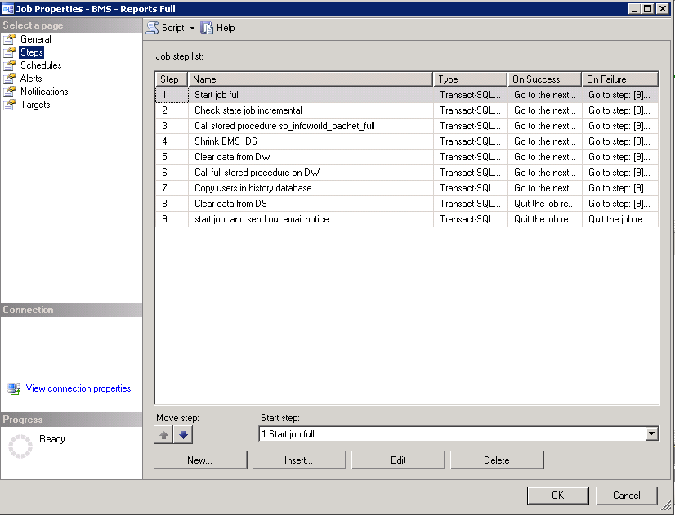

*Figure 2 - BMS - Report Full Job*

The job’s steps can be seen in the figure above and most of them execute stored procedures. At the beginning of the process, the operations are done between the source databases and the destination database, which is BMS_DS in our case.

Each step is described below:

**Step 1.** Start job full: this is only an informative step for the log file.

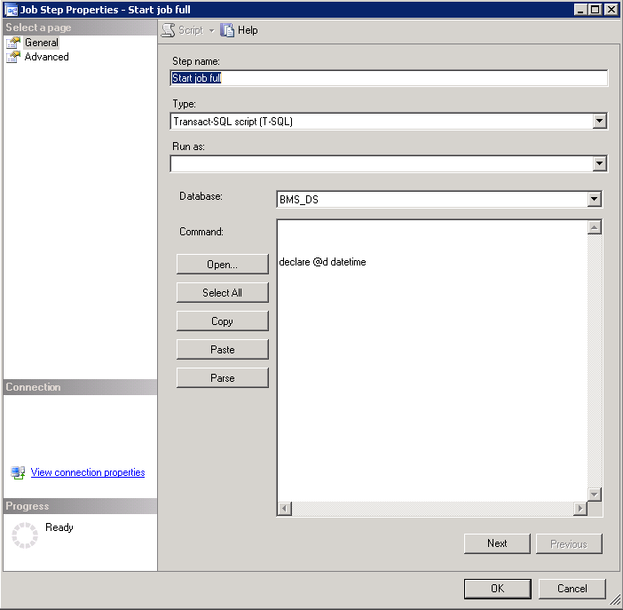

*Figure 3 - BMS - Start Full Job*

**Step 2.** Check state job incremental: it checks the state of the BMS incremental job in order to be sure that it is not currently running, in which case the full job cannot continue.

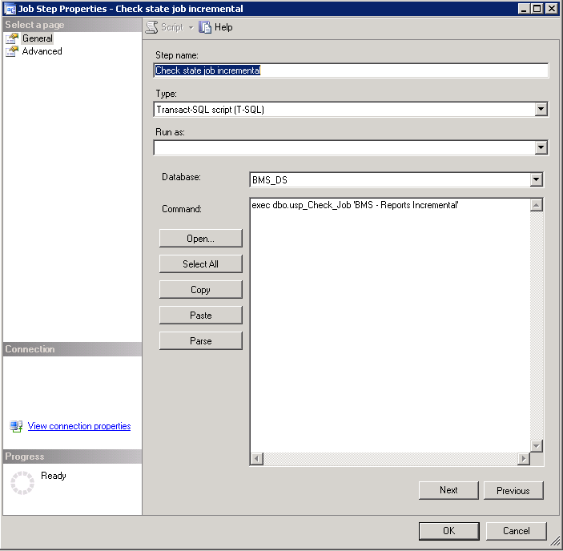

*Figure 4 - BMS - Check State Job Incremental*

**Step 3.** Call procedure sp_infoworld_pachet_full: creates or truncates the existing tables in the destination database and then inserts all the rows from each source table in the corresponding destination table. The destination tables from BMS_DS have the same name as the source tables but prefixed with the source database name. This information is stored in a configuration table in BMS_DS database, dbo.ConfigTable.

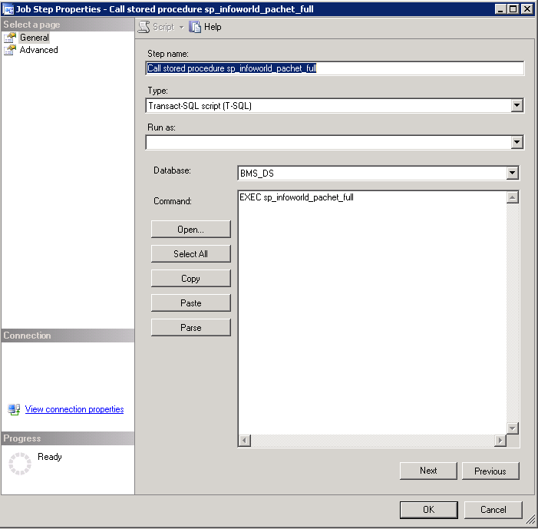

*Figure 5 - BMS - Call Procedure*

**Step 4.** Shrink BMS_DS: Shrinks the file with the id 2 (the log file), to the size of 1 MB.

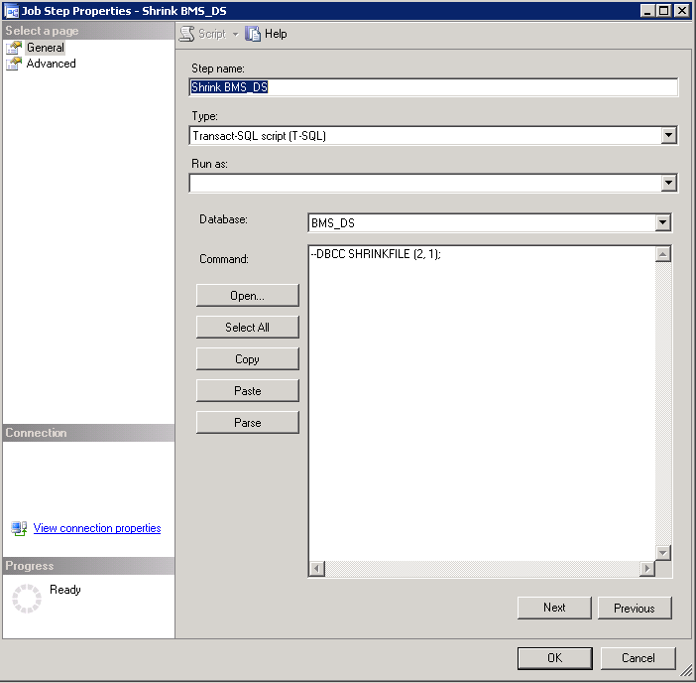

*Figure 6 - BMS - Shrink*

**Step 5.** Clear data from BMS_DW: the data warehouse database is cleared, meaning that its tables will become empty, but of course exceptions can exist and they really do - tables that contain static data and should not be removed. Thus, the database becomes ready to receive all the source data.

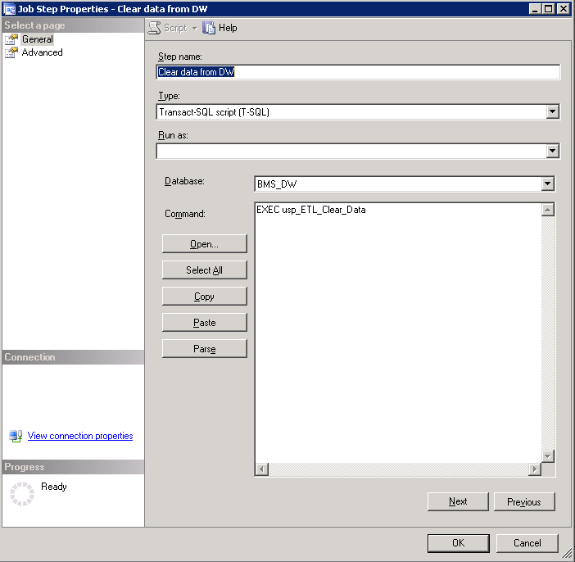

*Figure 7 - BMS - Clear Data*

**Step 6.** Call procedure full on BMS_DW: it inserts first the vocabulary data, then EIS entities (ETL dimension tables) and BMS acts (ETL facts tables).

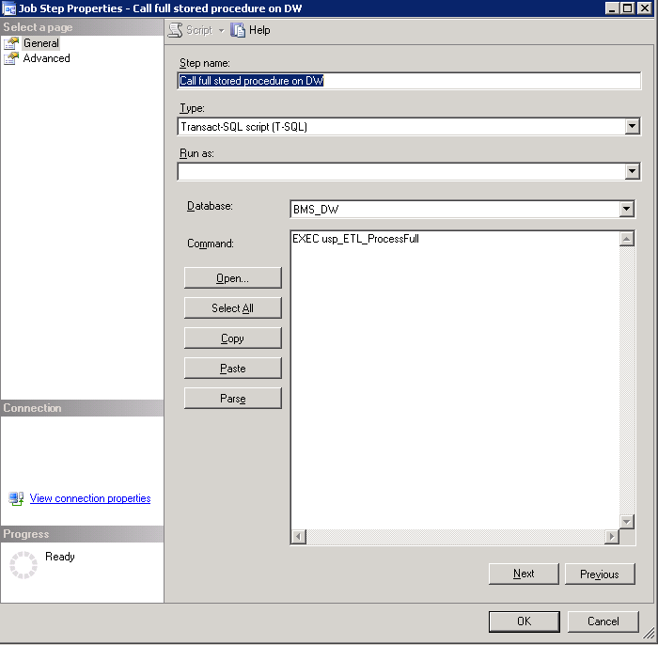

*Figure 8 - BMS - Call Procedure Full*

**Step 7.** Copy users in history database: adds users in user_h table from BMS History database. This step is needed because some reports need to display users that did certain insert/update/delete operations in the application.

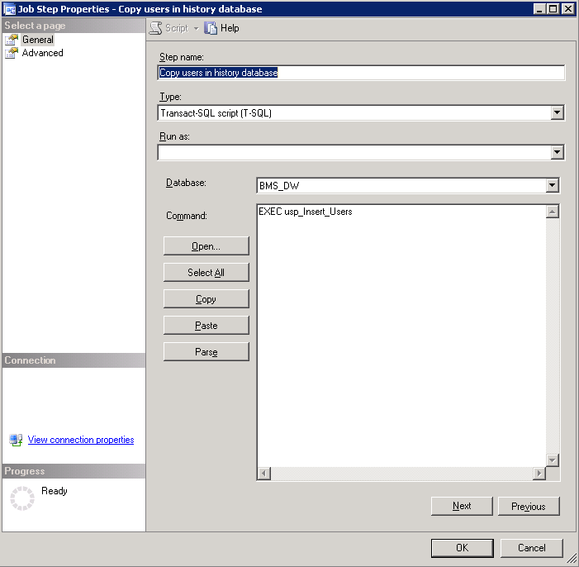

*Figure 9 - Copy Users in History Database*

For each step a log file can be set, see screenshot below for step 7:

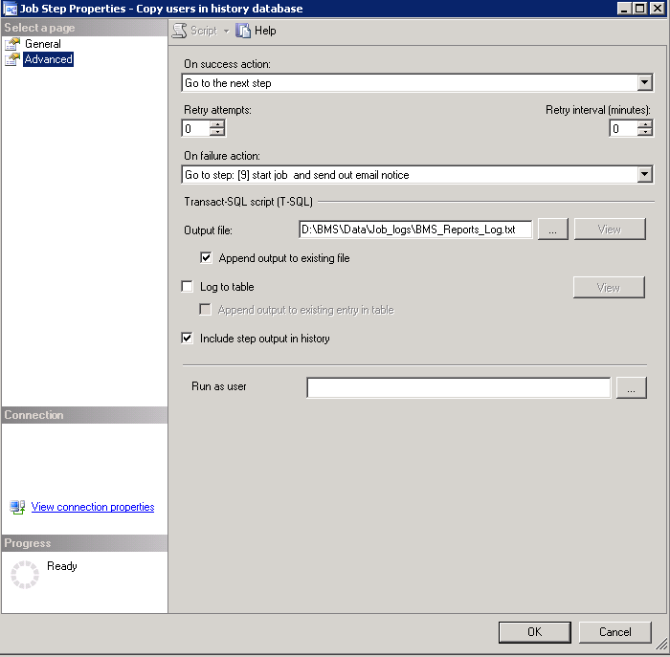

*Figure 10 - BMS Reports Full Path File Log*

The job can be run by right clicking on the job and then choosing “Start job at step…”, selecting the first job in the appearing window and then hitting the Start button. Then a smaller window remains open, showing the progress of the execution and its result: success or failure. The detailed results can be found in the log file that you set at the installation phase. If an operation fails at any step, the job will quit. This setting can be changed in the step’s *Advanced* tab.

**Step 8.** Clear data from BMS DS database.

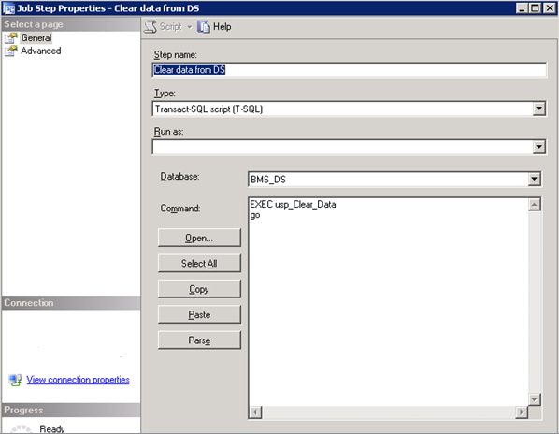

**Step 9.** This step is only invoked if any of the prior steps of the BMS Report Full job fail. Once invoked, email notification of the failure is sent to the BMS Technical team and BMS Report Full job is restarted.

### BMS Incremental

BMS Incremental logic is to keep the BMS_DW database up to date without having to delete all the existing data. The following picture shows the job’s steps.

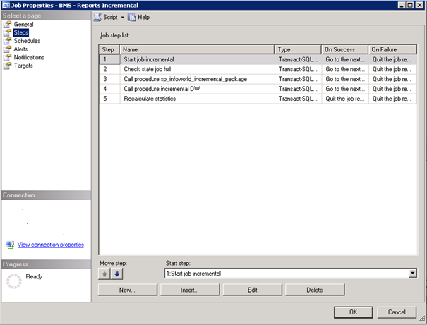

*Figure 11 - BMS - Report Incremental Job*

**Step 1.** Start job incremental: this is only an informative step for the log file.

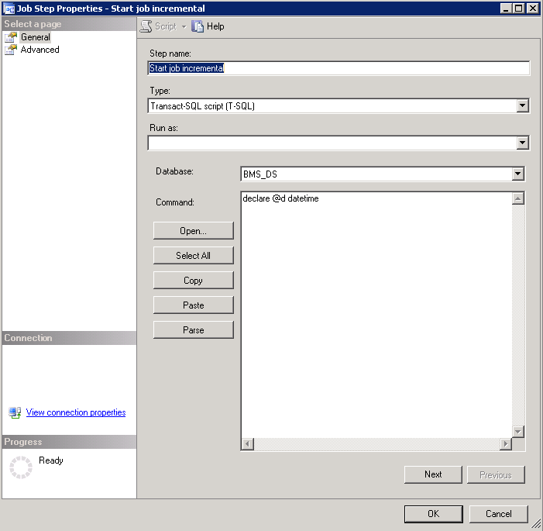

*Figure 12 - BMS - Start Job Incremental*

**Step 2.** Check state job full: it checks the state of the BMS full job described above in order to be sure that it is not currently running, in which case the incremental job cannot continue.

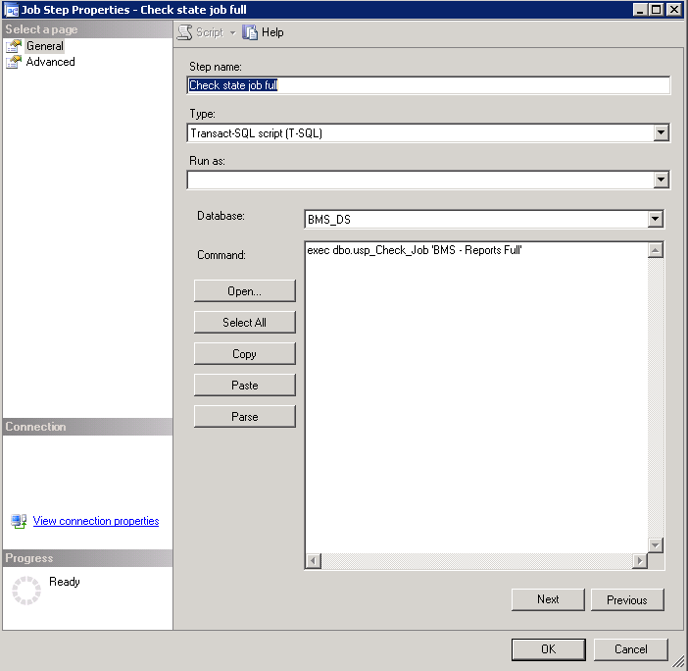

*Figure 13 - BMS - Check State Job Full*

**Step 3.** Call procedure sp_infoworld_incremental_package: makes all the necessary updates from the source databases to the BMS_DS database. When rows are deleted in the source tables, an update is made in BMS_DS database (in the necessary tables) by changing a flag column’s value to 1 (deleted) from 0 (existing).



*Figure 14 - BMS - Call Procedure Properties*

**Step 4.** Call procedure incremental DW: will search for any new, updated or deleted row in BMS_DS database’s tables in order to do the correspondent operations in its tables.

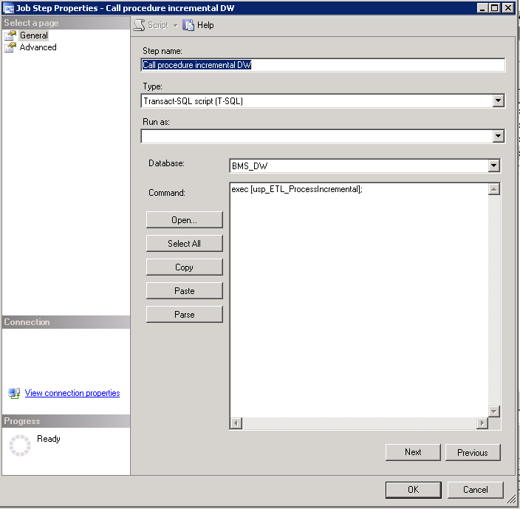

*Figure 15 - BMS - Call Procedure Incremental*

For each step a log file can be set, see screenshot below for step 4:

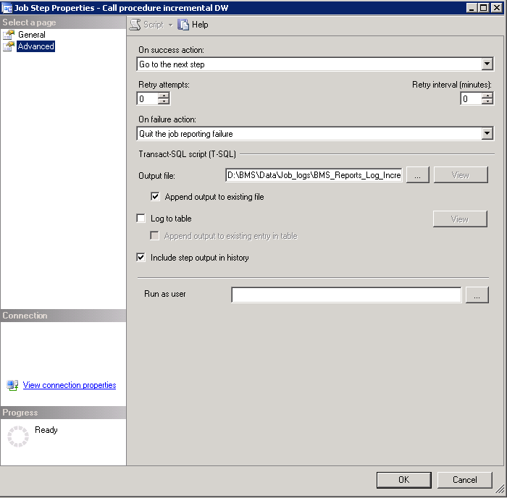

*Figure 16 - BMS Incremental Path File Log*

**Step 5.** If the duration of the last completed incremental job exceeded 3 minutes, then recalculate statistics to improve query plan execution for the next job run.

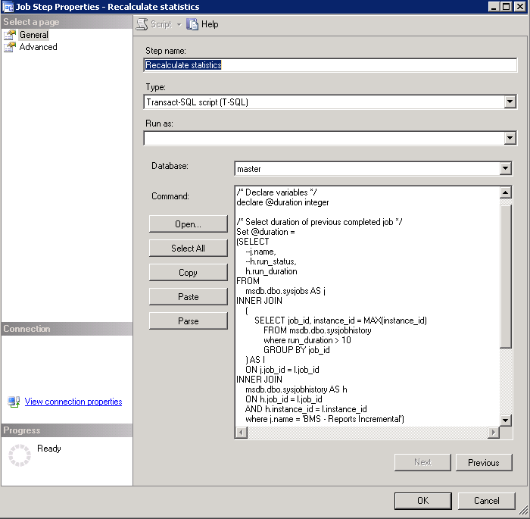

*Figure 12 - BMS – Call procedure Recalculate Statistics*

### 2.4.3 BMS Reports Windows Management Instrumentation (WMI)

This job runs a process through Windows Task Scheduler “BMS - Execute WMI_UserGroup” that takes all the users and user groups from the Active Directory and inserts them in BMS_DW database.

In order to run the process successfully, the user needs to configure WMI_UserGroup.config file (Reference Table 12 - WMI User Group Configuration Parameters) and set the connection of the database in the Connections.xml file. These files are stored in the folder where WMI_UserGroup application is installed.

The steps performed by this process include the following:

Below are the steps:

1. Deletes from the following tables from the BMS_DW database:  
   dbo.DOMAIN_USER_GROUP  
   dbo.DIM_DOMAIN_USER  
   dbo.DIM_DOMAIN_GROUP
2. Inserts the domain groups (all) into dbo.DIM_DOMAIN_GROUP table
3. Inserts the users (all) into the dbo.DIM_DOMAIN_USER table
4. Inserts the users group information into the dbo.DOMAIN_USER_GROUP table.
   1. Here it determines who belongs to what group and adds them, since a single user can belong to many groups
5. Writes the log messages
6. Closes the connections
7. Exits

Windows Task Scheduler calls a Batch script D:\BMS\Data\WMI_UserGroup\WMI_Wrapper.BAT

The script sets up some variables for Log Files. The ‘Start’ time is recorded in a variable then calls the WMI_UserGroup binary file. After the execution of the binary file the ‘End’ time is recorded. Calulations for the duration are done between the ‘Start’ and ‘End’ times, the metrics is sent to Introscope via a batch script which calls a Powershell script to send the Data. If the ‘Duration’ was less than 8 minutes, the base wrapper script is called again with an additional parameter of “2” added ( Second run ).

Introscope records the ‘Duration’ and ‘Exit’ Results of the binary executable. If the second run also fails to complete with a duration longer than 8 minutes, email alerts are sent via the Introscope rules engine.

## 2.5 Ward Whiteboard Kiosk Mode Display Configuration (BMS Whiteboard Kiosk Setup)

An electronic kiosk (or computer kiosk) houses a computer terminal designed to function while preventing users from accessing system functions. BMS has adopted the use of electronic kiosks to provide sites with the capability to setup Large Screen Displays for the BMS Ward Whiteboard for greater visibility. The Whiteboard Kiosk is read only access page that presents an overview of the beds in the current facility (or in the selected ward) and allows the user to assess at a glance the bed availability in their facility (or ward). Kiosk mode locks down the user interface to protect applications from accidental or deliberate misuse. These displays should be placed carefully, considering that confidential patient data (Social Security Number) should not be in view of people who are not authorized to see it.

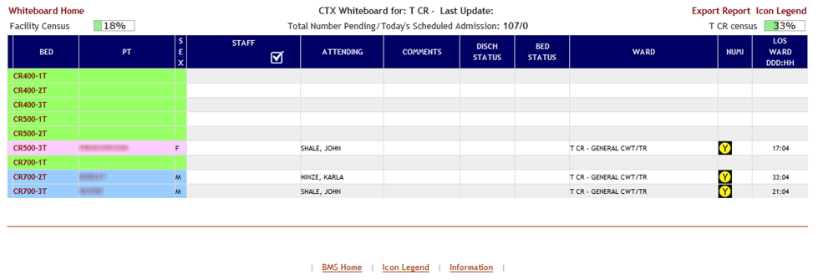

Figure 17 - BMS Ward Whiteboard Screen

Setting up for the BMS Whiteboard Kiosk involves a series of steps that most often are performed by IT staff with access to Local Site network configuration and/or staff with authority to request the required Local Site and Active Directory (AD) network configuration changes.

Steps for configuring the BMS Whiteboard Kiosk can be divided into three major categories:

* The Ward Whiteboard Kiosk URL
* The Network User for BMS Kiosk Access
* The Kiosk Workstation for Local Site Use

Each category involves a series of required steps to ensure successful operation of the Kiosk. Following is an outline of the process to setup and configure the BMS Whiteboard Kiosk for a local site.

1. *Create the Ward Whiteboard Kiosk URL. See details in* *2.5.1 Create the Ward Whiteboard Kiosk URL*
   1. Determine the BMS Whiteboard Parameters For Kiosk Operation and Setup
   2. Test the URL in a browser
2. *Set up a default user for the kiosk. See details in* *2.5.2 Set up a default user for the BMS Kiosk*
   1. Set up the Network User for BMS Access
   2. Configure the Whiteboard Kiosk Default Login User in BMS
   3. Assign a Role to the Whiteboard Kiosk Default User in BMS
3. *Set up the Workstation / Kiosk Machine. See details in* *2.5.3 Set up the Workstation / Kiosk Machine*
   1. Disable the Screen Saver
   2. Configure the Power Settings to Disable Sleep and Stand By Mode
   3. Configure Auto Log in Option and stop MS Lync from opening upon start up
   4. Set the URL as the Home Page in IE
   5. Add <https://vaww.bms.va.gov> to “Trusted Sites” in IE
   6. Add to the start-up commands (Windows) the launch of the browser
   7. Close IE, and restart to test
   8. Set Registry Keys to configure Kiosk for local Site use

### 2.5.1 Create the Ward Whiteboard Kiosk URL

The Ward Whiteboard display uses parameters to determine the behavior of the display. For example, the whiteboard can display a specific ward or ALL wards for a site by setting the parameter **wardName**. Below is a description for each whiteboard display parameter along with available options for each.

| **Parameter** | **Short Description** | **Options** |
| --- | --- | --- |
| facilityCode | Code of facility (e.g., BROCKTON = BRK). | Enter the 3 character facility ID. |
| wardName | Name of BMS Ward Name. To see all the wards the value that needs to be configured is ALL. | These are the BMS WARDS as defined in the Facility, Site Options, VistA Ward Add/Edit. The Ward name value should match the "BMS WARD GROUP TEXT". A single ward can be entered or the value "ALL" to display all the wards at the facility. |
| splitScreen | To split the page in two tables enters the value "Yes". | Yes No |
| displayPTCode | How the patient should be displayed under the column "Patient" (full name or 1st+Last 4) or LastName. **LastName is required for Kiosk mode due to Privacy regulations.** | FirstAndLast4 **LastName** |
| genderColorCode | To change the background color for the row according with patient’s gender. | Blue/Pink None |
| displayFooterCensus | To view the footer census. | Yes No |
| displayStaffAttending | What column is displayed in the table? (Staff column, Attending column or both). | Staff and Attending Staff  Attending |
| scrollRate | The timer interval will affect the scrolling speed. This parameter can be absent. (If specified then it represents seconds). | Null or an integer value. |

Table 1 - Ward Whiteboard URL Configuration Parameters

#### 2.5.1.1 Determine the parameters for the Kiosk, and create the URL

Sample URL to display All Wards for site BRK:

<https://vaww.bms.va.gov/WardWhiteboardUrl?facilityCode=BRK&wardName=ALL&splitScreen=No&displayPTCode=LastName&genderColorCode=Blue/Pink&displayFooterCensus=Yes&displayStaffAttending=Staff%20and%20Attending&scrollRate=20>

#### 2.5.1.2 Test the URL

Once you have the URL, type it into a browser to test. The BMS Ward Whiteboard should come up. Note: a site can have a different URL for each kiosk.

### 2.5.2 Set up a default user for the BMS Kiosk

Create a network service account for accessing the BMS page. Make sure that it is in an Organizational Unit (OU) that will not get the Enterprise System Engineering (ESE) Federal Desktop Core Configuration (FDCC) / US Government Configuration Baseline (USGCB) User Settings. Set the “Log on to” so the account can only log onto the kiosk PC you are setting up.

#### 2.5.2.1 Set up the Network User for BMS Access

* Create AD User with non-expiring password under Service Accounts for the local site. If you are not an AD administrator then provide the following instruction to the AD along with your request for a new service account.

In Active Directory Create a Generic User with a Non-Expiring password in Service Accounts for your location with Access to All Computers.

**NOTE: You will create a single ID, not one for every PC. Also, do not setup auto login with this generic account at this point as PCs will automatically lock at this level.**

* Right click the “Service Accounts” folder (VXX.med.va.gov/VISNxx/Facility(XXX)/Service Accounts) and select New…User.

**NOTE: Do not use the “Service Accounts” folder directly under vXX.med.va.gov.** Under First Name, enter vhaXXX________ (such as vhaSTLBMSUser)

* Enter the same under “User Login Name”
* Enter a password when prompted and select
* Uncheck “User must change password at next logon”
* Check “Password never expires”
* Click “OK” at the warning that the user will not be prompted to change the password.
* Click “Next”
* At the top of the screen the path should read, “vXX.med.va.gov/VISNxx/Facility(XXX)/Service Accounts”
* Uncheck “Create an Exchange Mailbox”
* Click “Next”
* Review confirmation screen for accuracy and click “Finish”.
* Your new account should be available in your “Service Accounts” list. You may have to refresh your list to see it.
* Double-click your new account, in the description field, add
* SERVICE ACCOUNT: VHAxxxxxxxx(YourUserName): BMS DISPLAY
* In the Account tab, ensure “This user can log on to “All computers”. Do not identify any specific computers.
* When you are finished, your new account in the Service Accounts list should only show a Name, Type, and Description. All other fields should be blank.

#### 2.5.2.2 Configure the Whiteboard Kiosk Default Login User in BMS

For the current facility that will display the associated Whiteboard page, a default user needs to be configured in BMS application for the Ward Whiteboard Kiosk.

To configure the Whiteboard Kiosk Default User:

* + - * *Go to the BMS Site Home Page*
      * *Click on the Site Options link*
      * *Click on the Facility Setting link*
      * *Fill the fields “****Whiteboard Kiosk Default User Name:****”, “****Whiteboard Kiosk Password:”*** *and “****Whiteboard Kiosk Password Confirm:”*** *with the BMS Service Account ID*

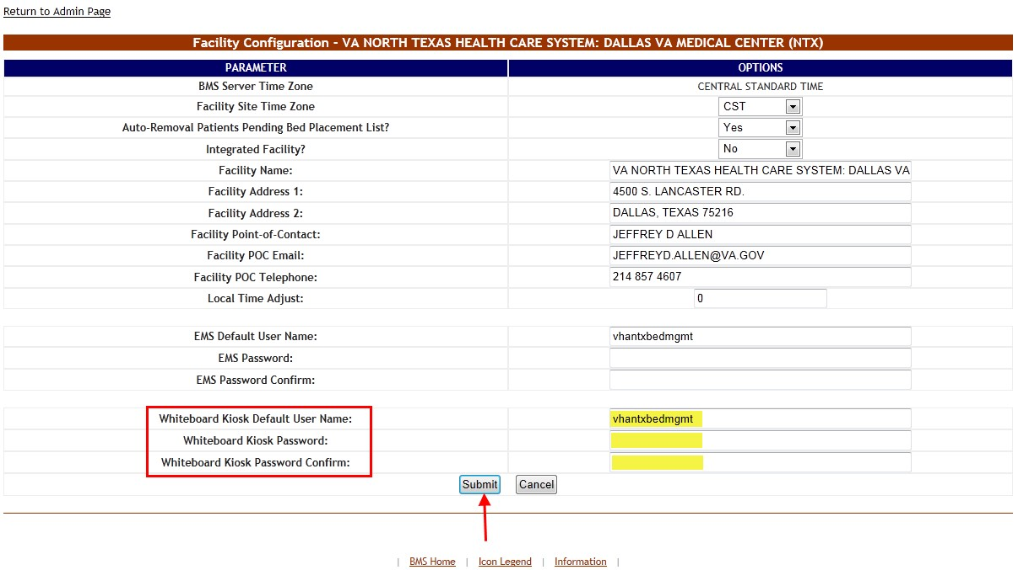

Figure 18 - Facility Settings

* + - * *Click Submit*

#### 2.5.2.3 Assign a Role to the Whiteboard Kiosk Default User in BMS

Each facility must assign the BMS “EMS USER” Role to the Service Account ID created to run the Whiteboard Kiosk URL. This assignment can be done from the **BMS Admin Section** → **Add/Edit BMS User** hyperlink or Facility **Site Options** → **BMS User Add/Edit** hyperlink.

* + - * *Click the* ***Select Existing NT User Name*** *button*
      * *Select the correct VISN Domain from the left Drop Down Box.*
      * *In the User Name box Enter the BMS Service Account ID created for the BMS EMS/Whiteboard Kiosk. Then click the Find button*
      * *Click the Selected Radio button for the user. Then click the Select button.*
      * *In the EMS User box, select “Yes”. All other roles should be “No”.*
      * *In the Default Region box, select the correct Region.*
      * *In the Default VISN box, select the correct VISN.*
      * *In the Default Site box, select your Site.*
      * *In the READ Access box, select “Yes”.*
      * *In the WRITE Access box, select “Yes”.*

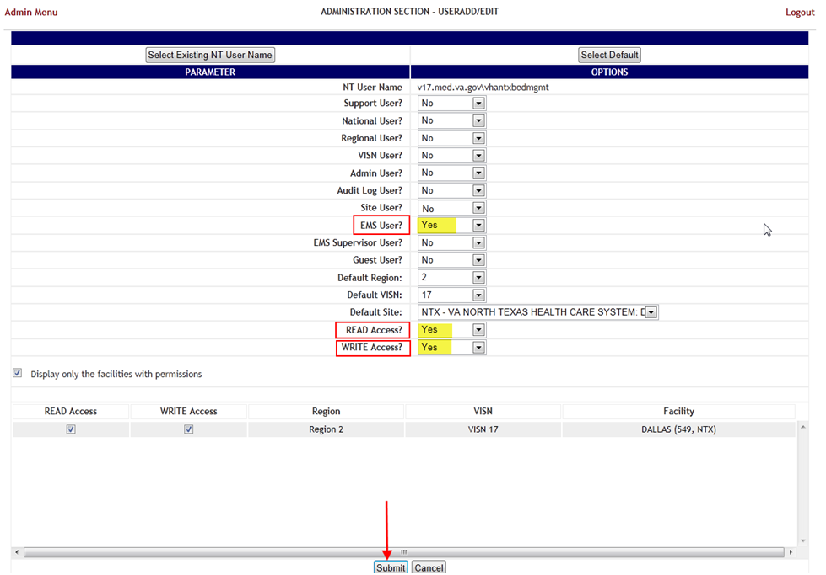

Figure 19 - Whiteboard Kiosk User Role Assignment Fields Filled in on the BMS Admin Section Add/Edit BMS User Page

* + - * *Click Submit*

### 2.5.3 Set up the Workstation / Kiosk Machine

After setting up the workstation / Kiosk machine, it will automatically log in to Windows, and automatically login to BMS.

#### 2.5.3.1 Disable Screen Saver

In order to display the Whiteboard page continuously the screen saver needs to be disabled.

NOTE: The Windows menu that allows the disable of the screen saver might be different from one version of Windows to another. For example, for Windows 7 the needed operations are:

* + - * *Right click on the desktop*
      * *Click Personalize*
      * *Click on the screensaver button on the lower-right part of the page*

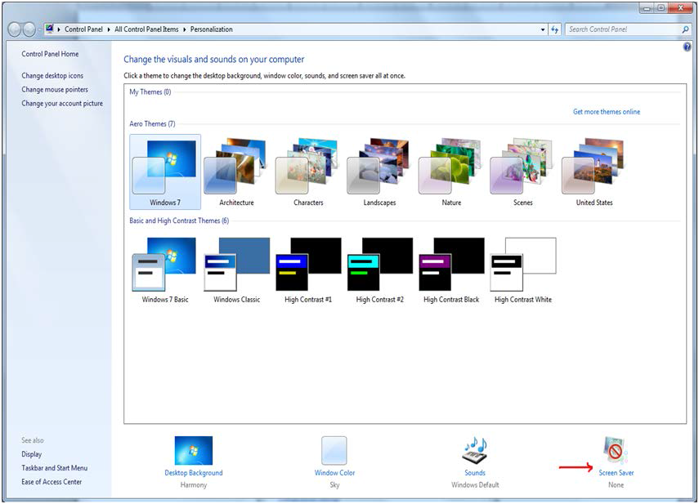

Figure 20 - Screen Saver Option

* + - * *Select None from the screensaver drop down on the displayed form*

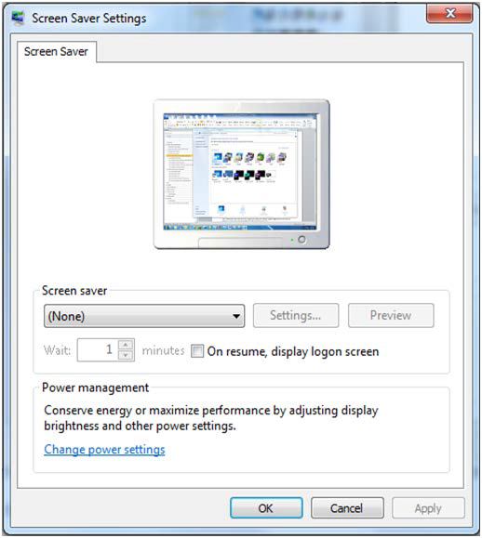

Figure 21 - Screen Saver Settings Window

* + - * *Click OK.*

#### 2.5.3.2 Configure Power Settings: Disable Sleep and Stand-by Mode

In order to display the Whiteboard page continuously the power settings need to be adjusted so that the computer will never enter into hibernate or stand-by and also the screen will never turn off.

**NOTE**: The Windows menu that allows the configuration of the power settings might be different from one version of Windows to another. For example, for Windows 7 the needed operations are:

* + - * *Go To Control Panel*
      * *Select Power Options*

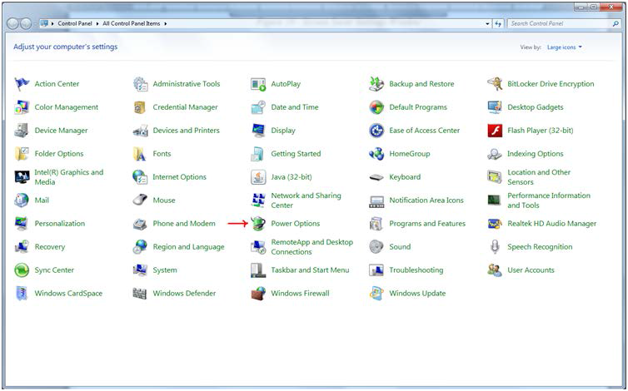

Figure 22 - Power Options

* *Click on “Change Plan settings” for the active plan*

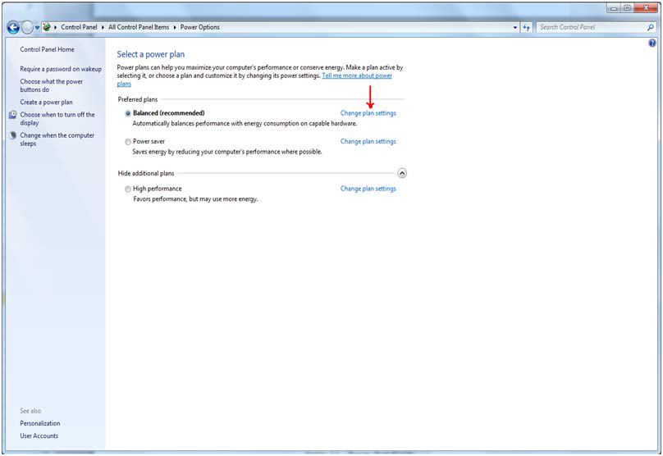

Figure 23 - Change Plan Settings Option

* + - *Select “Never” from the drop downs associated with “Turn off the display” and “Put the computer to sleep”*

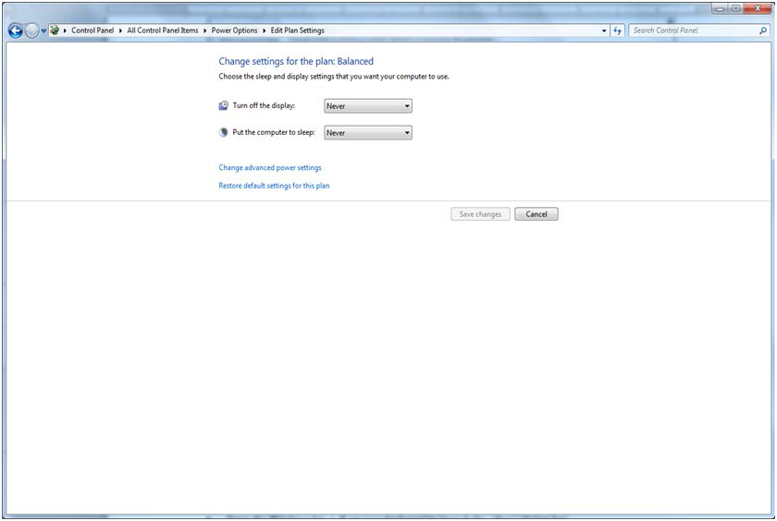

Figure 24 - Power Options Settings

* *Click “Save changes”*

#### 2.5.3.3 Configure Auto-login Option and stop Microsoft Lync from opening upon start up

**Configure Auto-Login:** The computer that will display the Whiteboard page needs to have the auto-login configuration set to” true”.

**NOTE**: The Windows menu that allows the configuration of the auto-login settings might be different from one version of Windows to another. For example, for Windows 7 the needed operations are:

* + - * *Press the Windows key + R on your keyboard to launch the “Run” dialog box.*

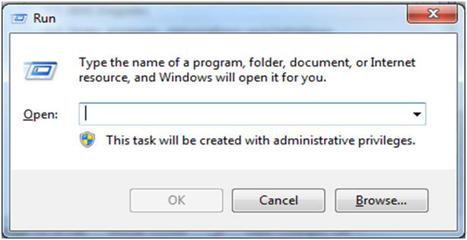

Figure 25 - Run Window

* + - * *Type in “control userpasswords2”*

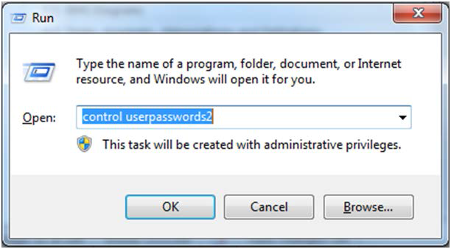

Figure 26 - Run Window with Command Entered

* + - * *Press Enter. The User Accounts window will display.*

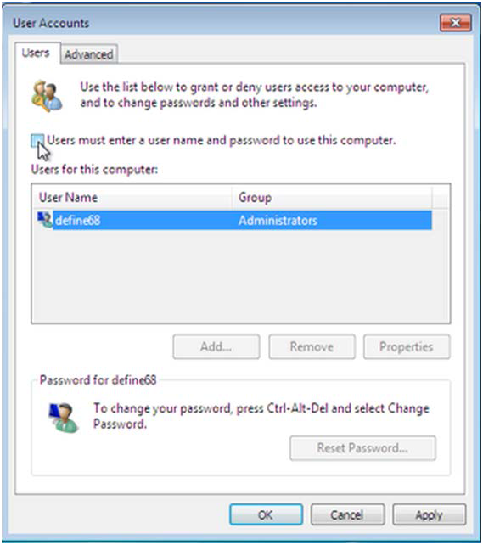

Figure 27 - User Accounts Window

* *Uncheck the option “Users must enter a user name and password to use this computer” for the BMS Default Kiosk User Account*

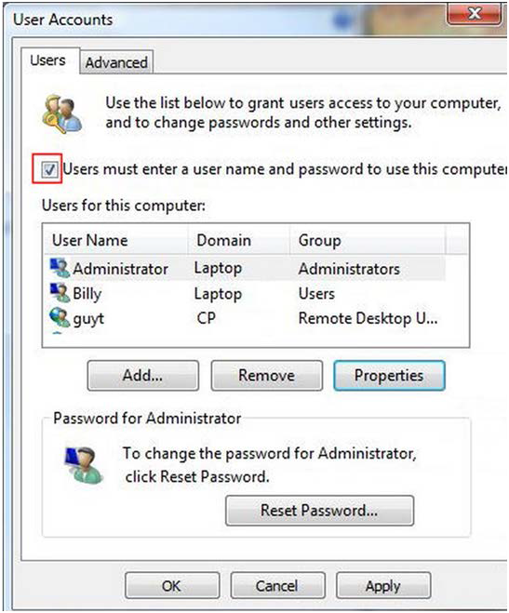

Figure 28 - User must enter a user name and password to use this computer option

* *Click “OK”*

Stop Microsoft Lync from opening at startup: To stop Microsoft Lync from opening at startup follow the steps below

* + - * *From the Start Menu,*
      * *Go to All Programs >Microsoft Lync*
      * *Open Microsoft Lync*
      * *Go to Tools>Options>Personal*
      * *Uncheck “automatically start Lync when I log on to Windows” & “Show Lync in foreground when it starts”.*

#### 2.5.3.4 Set the URL (from step 2.5.1) as the Home Page in Internet Explorer

The specific Ward Whiteboard Kiosk URL needs to be configured as the Home-Page for the intended browser. The menu to set the default home-page might differ from one browser to another.

For example, for Internet Explorer (IE) 9.0 the user needs to:

* + - * *Select Tools menu*

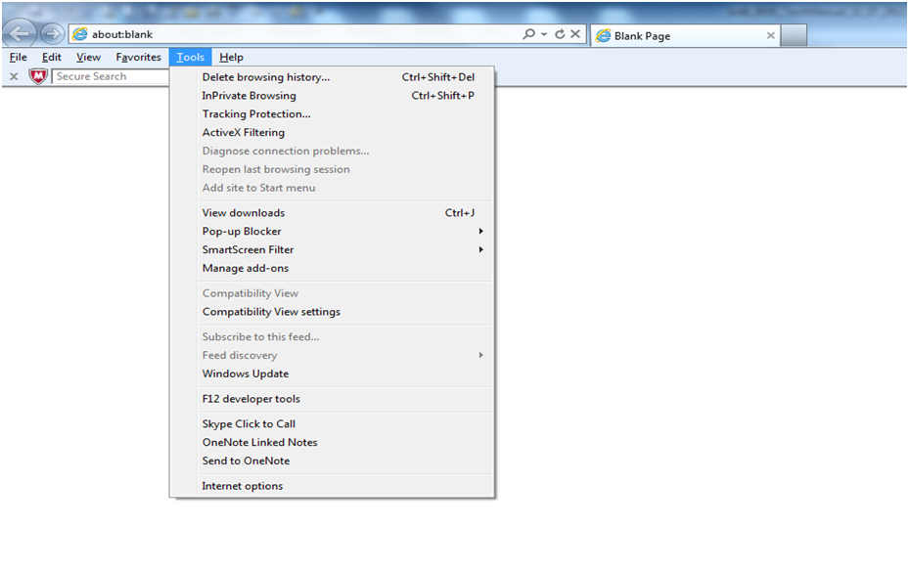

Figure 29 - Tools Menu of Internet Explorer

* + - * *Select Internet Options*
      * *On the General tab, under the homepage text field enter the URL*
      * *Click OK*

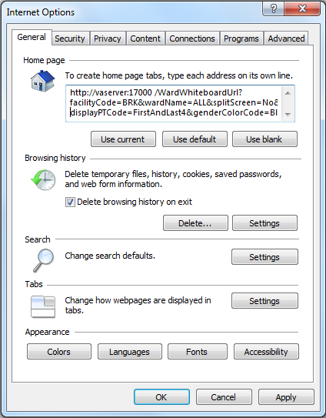

Figure 30 - General Tab of Internet Options

#### 2.5.3.5 Add BMS to the “Trusted Sites”

To add BMS to “Trusted Sites” in Internet Explorer

* *Go to Tools>Internet Options>Security>Trusted sites>Sites*
* *In the “Add this website to the zone:” field, enter* [*https://vaww.bms.va.gov*](https://vaww.bms.va.gov)
* *Click Add, Click OK*

#### 2.5.3.6 Add the launch of the browser to the Windows start up commands.

The next step is to add to the startup commands the launch of the chosen browser.

**NOTE**: This operation might differ from one version of Windows to another. For example for Windows 7 the steps needed are:

* *Click Start*
* *Select All Programs*
* *Right click on the Startup folder*
* *Select Open*

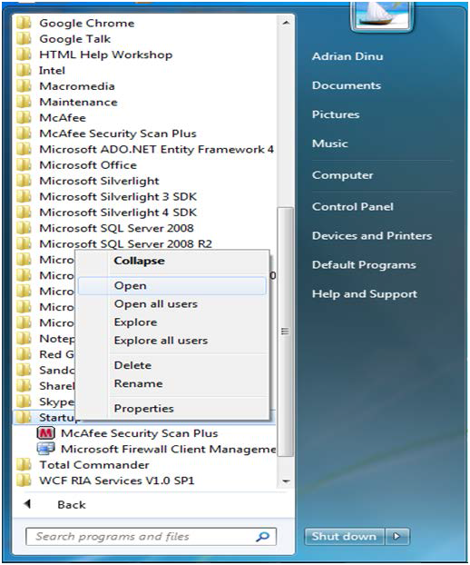

Figure 31 - Open Option

* + - * *Create a shortcut of the Internet Explorer and copy it to Startup folder*

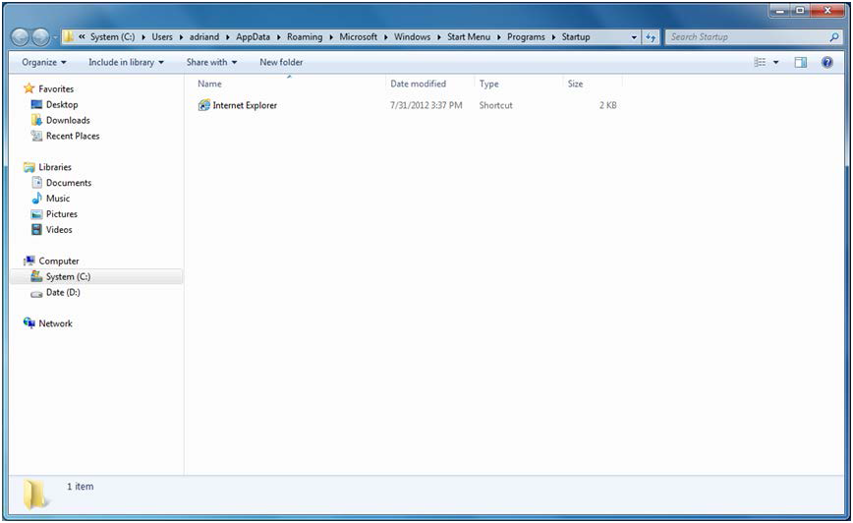

Figure 32 - Internet Explorer Shortcut

#### 2.5.3.7 Test the Kiosk

Close Internet Explorer. Restart Internet Explorer. The BMS Ward Whiteboard for the Kiosk should come up.

#### 2.5.3.8 Set the Registry Keys to configure the Kiosk for local site use.

The purpose of the following steps is to configure Kiosk workstation to serve one function only: BMS Ward Whiteboard display. The following instruction leads you through a series of steps that effectively lock down the workstation for this purpose. Access to workstation software and/or desktop will be prevented after the configuration setup is complete. The Whiteboard Kiosk is read only.

*It is recommended that prior to performing the configuration steps outlined in this section a backup of the existing system be created for rollback / recovery purposes, and that a restoration point be created.

1. Modify Registry Settings

**Restriction.reg**

Windows Registry Editor Version 5.00

[HKEY_LOCAL_MACHINE\SOFTWARE\Policies\Microsoft\Internet Explorer\Restrictions]

"NoBrowserContextMenu"=dword:00000001

"NoFileOpen"=dword:00000001

"NoOpenInNewWnd"=dword:00000001

Figure 33 - Windows Registry Editor

Run Restrictions.reg by double-clicking filename from Windows Explorer.

Verify settings have been applied.

1. Modify Local Group Policy Settings

For local group policy changes run gpedit.msc and make the following changes:

User Configuration\Administrative Templates\System\Ctrl+Alt+Del Options

Remove TaskManager Disable

Remove Lock Computer Enable

Remove Change Password Enable

Remove Logoff Enable

User Configuration\Administrative Templates\Control Panel\Display

* + Password protect the screen saver Disabled

Verify all settings have been applied. The purpose of these settings is to lock down the workstation for one purpose only, BMS Whiteboard Kiosk.

1. Reboot Kiosk Machine to test set up.

*Note; if Kiosk continually “freezes”, please contact the Service Desk to have an IE Refresher script installed.

## Whiteboard Snapshot Configuration

In order to configure the Whiteboard snapshot certain steps need to be completed:

* + 1. Create snapshot folder
    2. Define network share
    3. Assign rights to user
    4. Assign snapshot folder path to ward group
    5. Associate scheduler with the whiteboard report

Suppose the goal is to configure the settings for two BMS Ward Groups: WARD GROUP 1 and WARD GROUP 2.

Assuming that these two Ward groups are in different physical locations, a designated workstation will be assigned for each one of them.

For the purpose of example, these workstations are called: WARDGROUP1-PC and WARDGROUP2- PC.

### Create Snapshot Folder

On WARDGROUP1-PC and WARDGROUP2-PC, a folder should be created for this purpose. For example, assume that this folder is on the “C:” drive, like this “C:\WhiteboardSnapshot”.

*On Windows 7 the needed operations are:*

* + - * Click Start button
      * Select All Programs
      * Select Accessories folder
      * Click Windows Explorer
      * Go to C drive
      * Right click on C drive
      * Select New folder
      * Enter the name of the folder, e.g. WhiteboardSnapshot

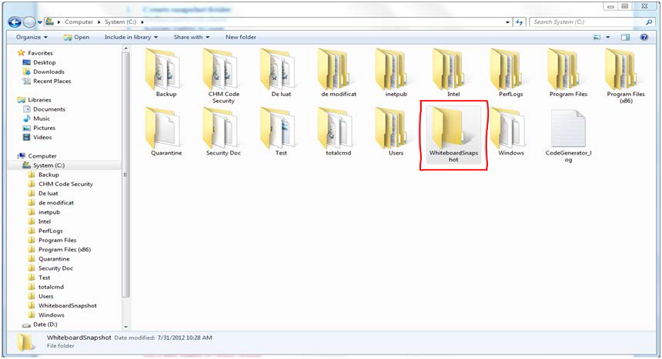

Figure 34: Whiteboard Snapshot Folder

### Define Network Share

For these two folders (one on each computer) the Network Admin needs to define network shares. For example, assume that the network share name on each computer is “WhiteboardSnapshot”.

*Note: The Windows menu that allows the configuration of folder sharing might be different from one version of Windows to another. For example, for Windows 7 the needed operations are:*

* + - * *Navigate to the “WhiteboardSnapshot” folder, right-click it and choose Properties*

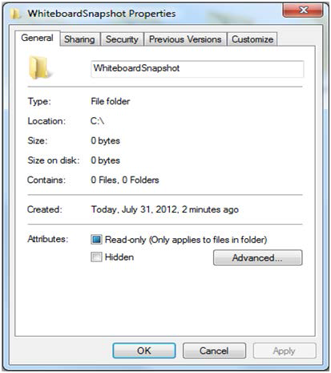

Figure 35: Whiteboard Snapshot Folder Properties

* + - * *Go to Sharing tab and select Advance Sharing option.*

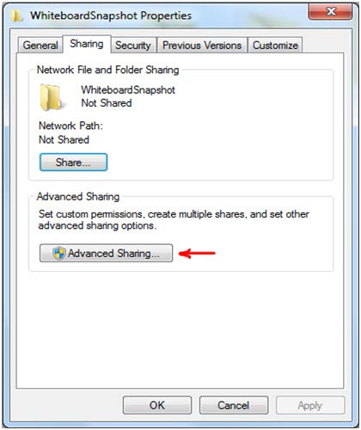

Figure 36: Advanced Sharing Option

* + - * *In Advanced Sharing dialog, enable Share this folder option. It will automatically add folder’s name as Share name.*

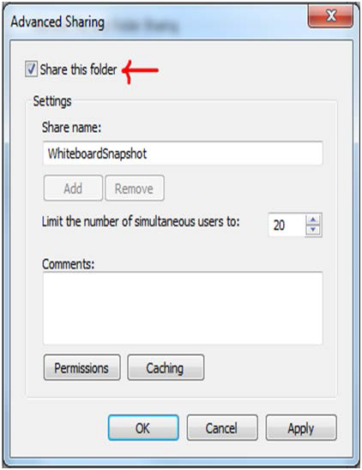

Figure 37:Share this folder Option

### Assign Rights to Master BMS Service Account User

The BMS Application runs under a service account. AICT has created the Windows User (**acc\bms_svc_prod**) as the master service account that the BMS Services runs under. The Windows user (**aac\bms_svc_prod**) that is configured to be the Login that runs the four BMS Windows Services needs to have full rights to these shares.

This user ust have full control on each facilities file folder that is used to store the Whiteboard Contingency Reports.

*On Windows 7 the needed operations are:*

* + - * *Having Advanced Sharing window open click on Permissions button to set the folder's permissions.*

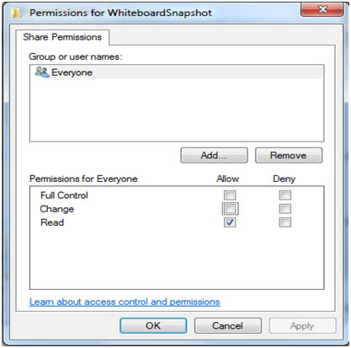

Figure 38: Permissions for Whiteboard Snapshot

* + - * *In the Permissions window click Add button to set the network user rights on the shared folder.*

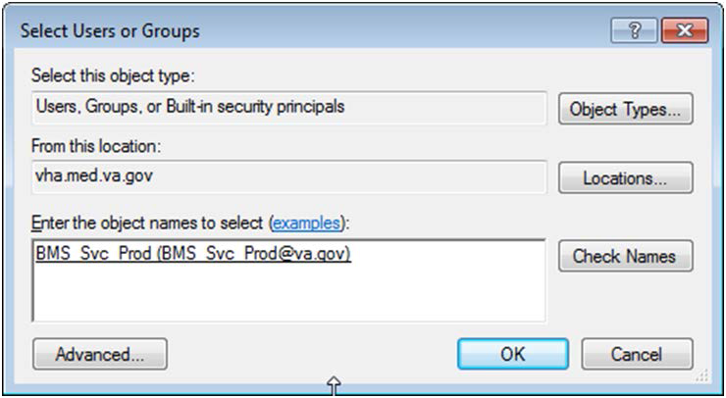

Figure 39:Select Users or Groups Window

* *Click “Advanced” button to select user.*

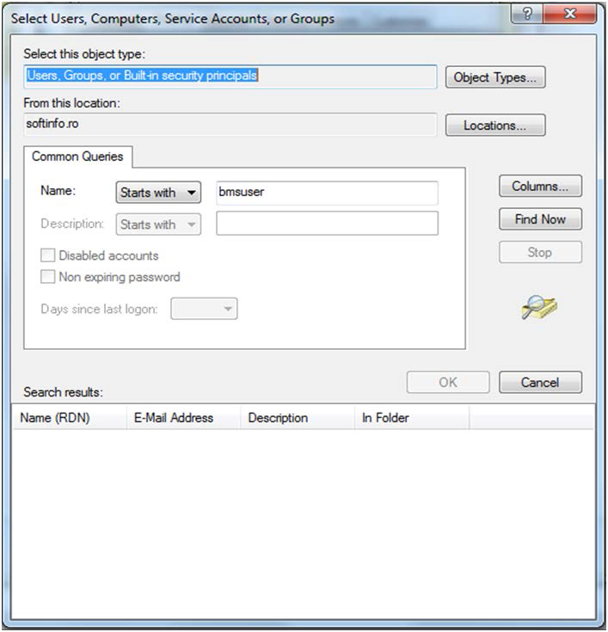

Figure 40: Advanced Section of Select Users or Groups Window

* + - * *Enter the name of the user (****aac\bms_svc_prod****) that runs the two BMS Windows Services. Click Find Now button.*

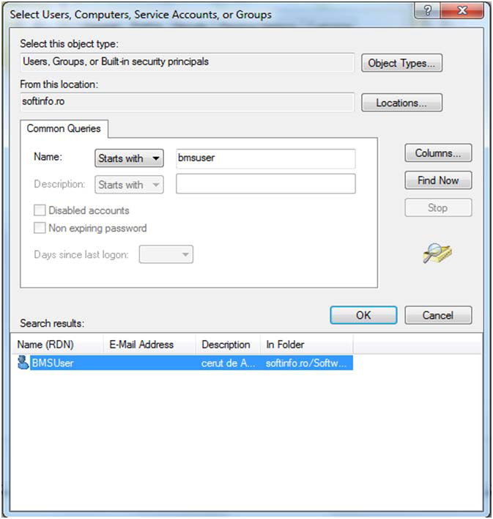

Figure 41:Search Result Section

* + - * *Scroll down the Search results section to select the user. Once done, click OK. It will add the user within the object names section.*



Figure 42:Object Names Section

*Clicking OK will add folder access permission for user and takes you back to Permissions dialog, allowing you to configure the permissions for newly added users.*

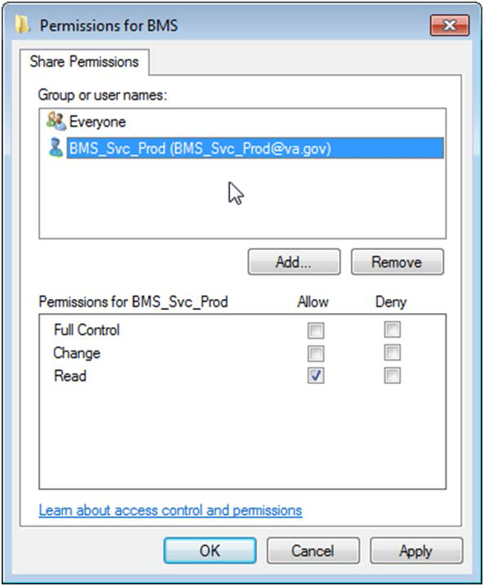

Figure 43:Permissions Window

* + - * *Select user, and from Permission*s *section check Full Control*.

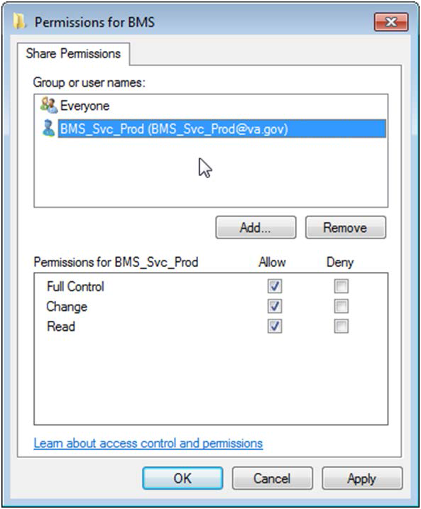

Figure 44:User Permissions

* + - * *Click Ok to close Permissions window. It will take you back to Advanced Sharing window.*

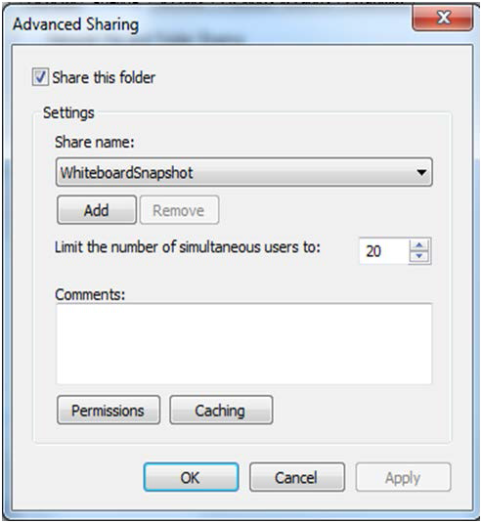

Figure 45:Advanced Sharing Window

* + - * *Now, click OK to share the folder.*
      * *Close Whiteboard Snapshot properties window.*

Having these two folders shared and having that user given the rights previously mentioned, if someone is logged in the network with that user, he/she could access those folders from Windows Explorer using an URI address. See screenshot below:

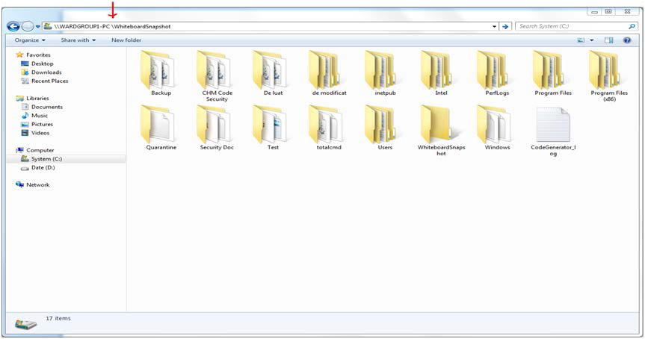

Figure 46: WardGroup1-PC Path

### Assign Snapshot Folder Path to Ward Group

Within the BMS Application, under Site Settings and then Contingency Settings page, the Admin should enter the values as captured in the screenshot (\\WARDGROUP1-PC\WhiteboardSnapshot for WARD GROUP 1 and respectively \\WARDGROUP2-PC \WhiteboardSnapshot for WARD GROUP 2).

**NOTE:** The Windows User **(acc\bms_svc_prod)** must have full read/write access to this folder.

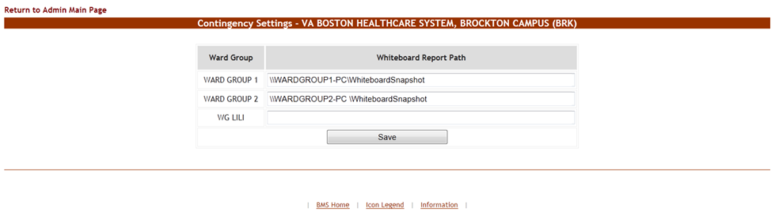

Figure 47:Contingency Settings Page

### Associate Scheduler with Whiteboard Report

Within the BMS Application, Facility Home page, under Site Optionss and then Background Processors page, a Scheduler should be associated in the Whiteboard Report section.

Under the WhiteBoard Report section:

* + - * In the “Add/Update Scheduler:” field, select the schedule frequency that Whiteboard should be backed up.
      * Click Save Scheduler button.

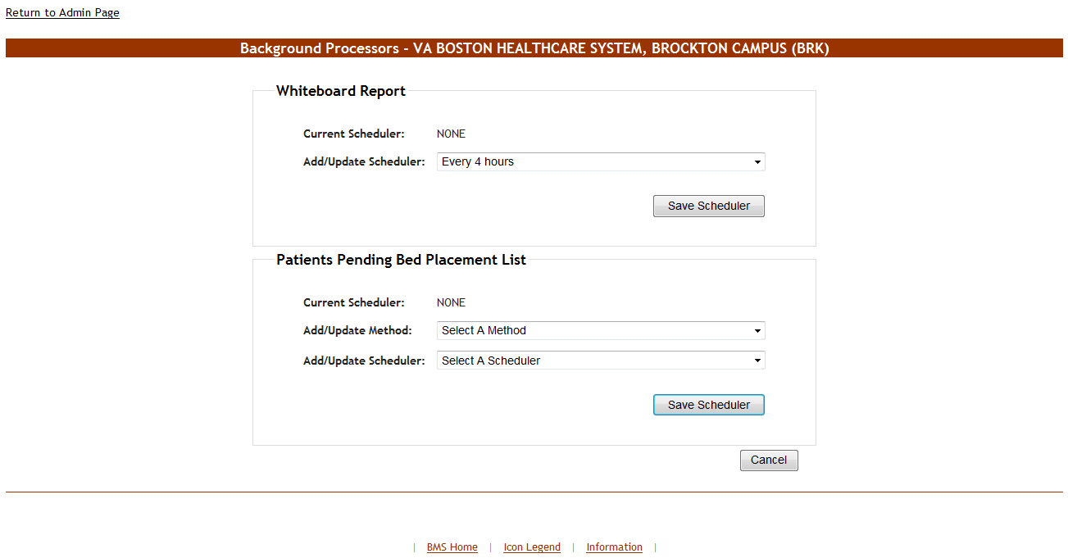

Figure 48:Whiteboard Report Scheduler Association

## EMS Mobile Device Configuration

In order to configure the BMS EMS Mobile Devices, the following steps must be completed:

* + - The local IS must create a local Service Account with a password that never expires and does not change. This account must not have any kind of policy that restricts its use to specific computers. The EMS Mobile Device will use this account to access the EMS Mobile page. This local Service Account can be the same as the Whiteboard Kiosk Default User Account created in Section 2.5.2.
    - Each facility must enter the local Service Account and Password in the EMS Default User and Password fields on the Facilities Settings page.
    - Configure the Mobile Device so that when it boots up, it will automatically open IE and go to the specified URL.

### Configure EMS Mobile Device Default Login User

For the current facility, a default user must be configured in the BMS application for the EMS Mobile Device.

To accomplish this, the Facility Admin User must do the following:

* + - * Go to the Facility Home Page.
      * Click on the Site Options link.
      * Click on the Facility Setting link.
      * Fill the fields “**EMS Default User Name:”,** “**EMS Password:”,** and “**EMS Password Confirm:”** with the BMS Local Service Account.

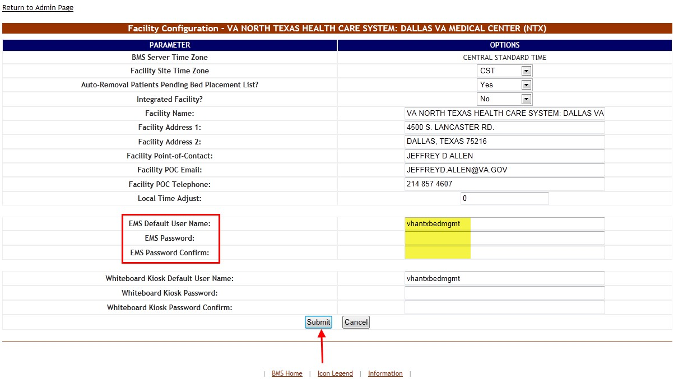

Figure 49: EMS Fields Filled on the Facility Settings Page

* + - * Click the Submit button.

Table 16: Facility Settings Page Parameters

|  |  |
| --- | --- |
| **Column** | **Description** |
| EMS Default User Name: | The BMS Service Account ID needed to load the EMS Mobile Page for Mobile Devices. |
| EMS Password: | The BMS Service Account ID password needed to load the EMS Mobile Page for Mobile Devices. |
| EMS Password confirm: | The confirmation of the password. |

This setup can also be completed by the system Support User:

* + - * + Go to the BMS Admin Page
        + Click on the Edit BMS Facility Settings link
        + Click on the Facility Name Drop Down and select the name of the Facility to be configured
        + Fill the fields “EMS Default User Name”, “EMS Password” and “EMS Password Confirm” with the BMS Local Service Account

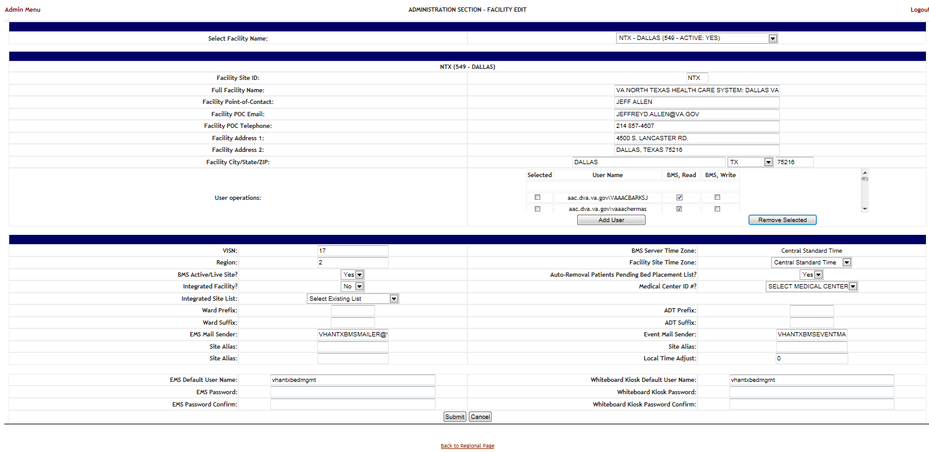

Figure 50:EMS Fields Filled on the BMS Admin Page

* + - * + Click the Submit button

Table 17:BMS Admin Page Parameters

|  |  |
| --- | --- |
| **Column** | **Description** |
| EMS Default User Name: | The BMS Service Account ID needed to load the EMS Mobile Page for Mobile Devices. |
| EMS Password: | The BMS Service Account ID password needed to load the EMS Mobile Page for Mobile Devices. |
| EMS Password confirm: | The confirmation of the password. |

### 

### Configure EMS Mobile Device URL

For the current facility, the EMS Device URL must be configured in the EMS Mobile Device. The URL to be entered has a special format:

[https://vaww.bms.va.gov/EMSMobileLogon?code=BRK.](https://vaww.bms.va.gov/EMSMobileLogon?code=BRK)

Table 18: Description and Configuration for EMS Mobile Device URL parameters

|  |  |  |
| --- | --- | --- |
| **Parameter** | **Short Description** | **Options** |
| Code | Code of facility (e.g. BROCKTON = BRK) | Enter the 3-character facility ID. |

EMS staff can access the BMS Web page for mobile devices at the URL set up by their local IS staff. Be sure to use the code of the facility for which access is needed.

The following page is displayed:

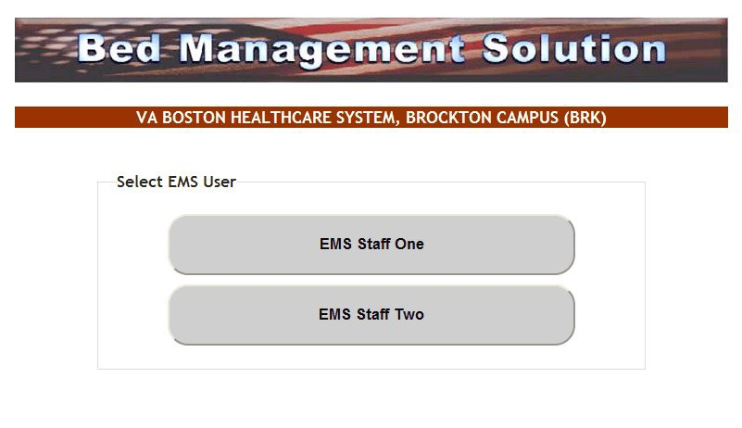

Figure 51:EMS Staff Page for Mobile Devices

## VistA Integration

This chapter describes the process of importing vocabularies, entities, patient admission, transfer, discharge (ADT) and patient pending bed placement information from VistA.

In order to integrate with VistA certain steps should be completed:

* + 1. Choose VistA site
    2. Define Schedulers
    3. Run Scheduler
    4. View Audit Results

### Choose VistA Site

VistA Sites tab from Background Processors page of Admin section allows the user to view the list of VA facility sites sharing the same VistA instance and to add a new VA facility to a VistA instance.

#### Adding a New VistA Site

To add a VA facility site to a VistA instance follow the steps presented below.

* + - * 1. From the Background Processors page of Admin section select VistA Sites to display the page in the following image. A list of VA facility sites is displayed in the column to the left of the page.

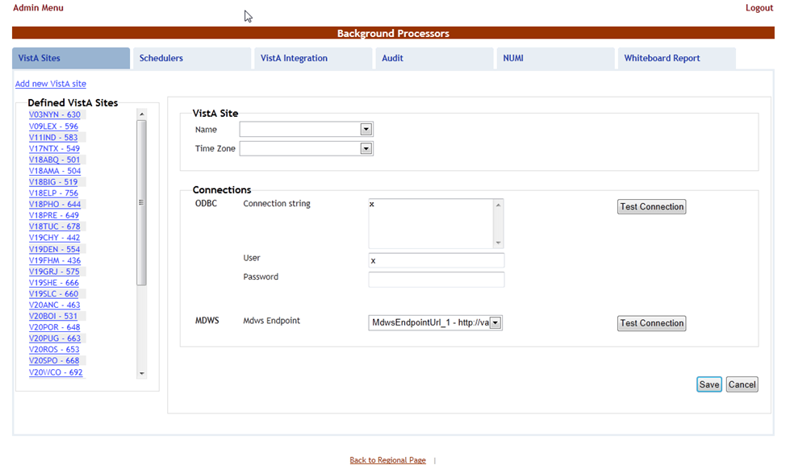

Figure 52: Adding a VistA Site

* + - * 1. Click the Add new VistA site link then from the VistA Site area use the Name field to select the code of the site you want to add to the current VistA instance, and then select the Time Zone.

In the Connections area you can choose between two connection methods: ODBC and MDWS. Fill in the following data for the ODBC method:

Table 19:New VistA Site Parameters

|  |  |
| --- | --- |
| **Column** | **Description** |
| Connection String | The connection string for the ODBC method. |
| User | The username for the connection. |
| Password | The password associated to the user account. |
| MDWS Endpoint | The specific instance of MDWS that the individual site will bind too. |

You can use the Test Connection buttons to verify the connection and press the Save button to enter the data into the system.

The newly added site will be added in the sites list to the left of the screen.

### Define Schedulers

The Schedulers tab from Background Processors page of Admin section displays a list of schedulers defined by user. It allows the user to add new schedulers, edit or remove old schedulers.

NOTE: To run the schedulers, the VistA Integration tab must be used (see next section VistA Integration for details).

The Schedulers tab is displayed as in the following image:

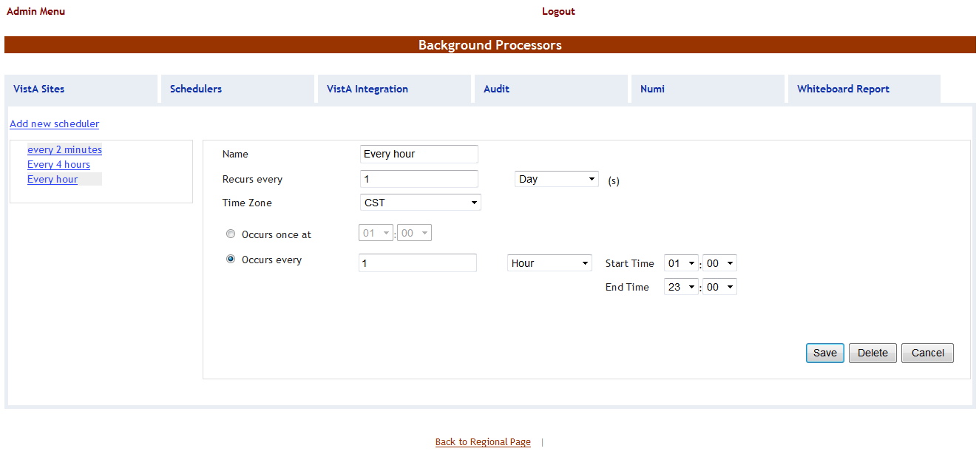

Figure 53: Schedulers Tab

#### Adding a New Scheduler

To add a new scheduler follow the steps presented below.

* + - * 1. From the Background Processors page select the Schedulers tab.
        2. In the Schedulers tab fill in the following data:

Table 20:New Scheduler Parameters

|  |  |
| --- | --- |
| **Column** | **Description** |
| Name | The name of the scheduler. |
| Recurs every | The frequency. |
| Time Zone | Time zone associated with the scheduler. |
| Occurs once at/Occurs every | The frequency values. |

After setting the desired frequency for the new scheduler, do not forget to press the Save button to enter the data into the system.

### Run Scheduler

The VistA Integration tab is used to run (automatically or manually) the defined schedulers and to select which data categories will be affected by a scheduler’s action.

The VistA Integration tab is displayed as in the following image:

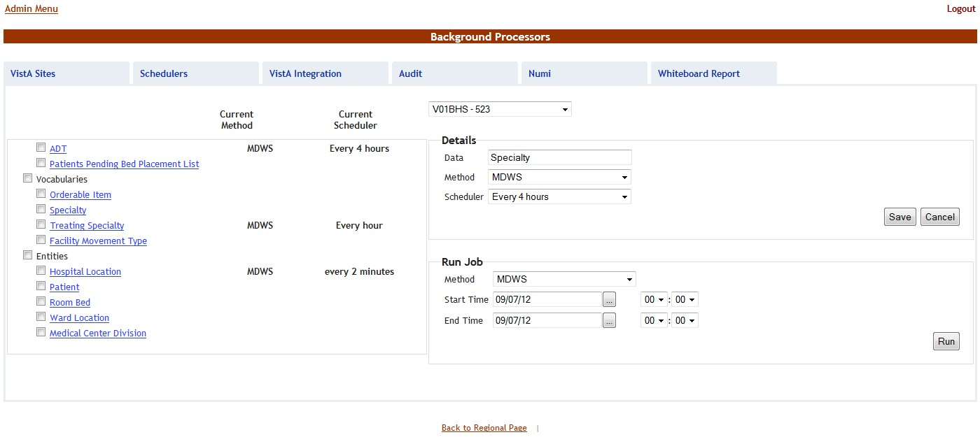

Figure 54: VistA Integration Tab

From the field in the upper part of the page select the VistA site where the scheduler(s) will run. Next step:

* Either click one data category from the column to the left (its name will appear in the Data field) and then select a method and scheduler from the Method and Schedulers fields in the Details area: this will cause the selected scheduler to run at the time set for it in the Schedulers tab and to bring data from the selected category.
* Or select several data categories (using the check-boxes) then select a connection method from the Run Job area, set the Start time/End time and click the Run button: this will cause the scheduler set using the selected method to start running now and bring the data from the selected categories.

### View Audit Results

The Audit tab displays the results of the operations performed in the VistA Integration tab. The Audit tab is displayed as shown in the following image.

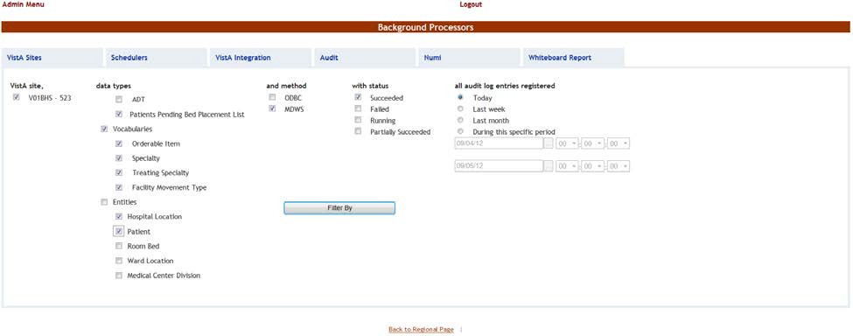

Figure 55:Audit Tab

The options to the left of the page allow the user to determine the filter criteria for the generated audit reports. The options to the right of the screen allow the user to select the type of operation to be captured by the audit report as well as the time interval for the audit.

After selecting the desired criteria, click the Filter by button to display the page as in the following image.

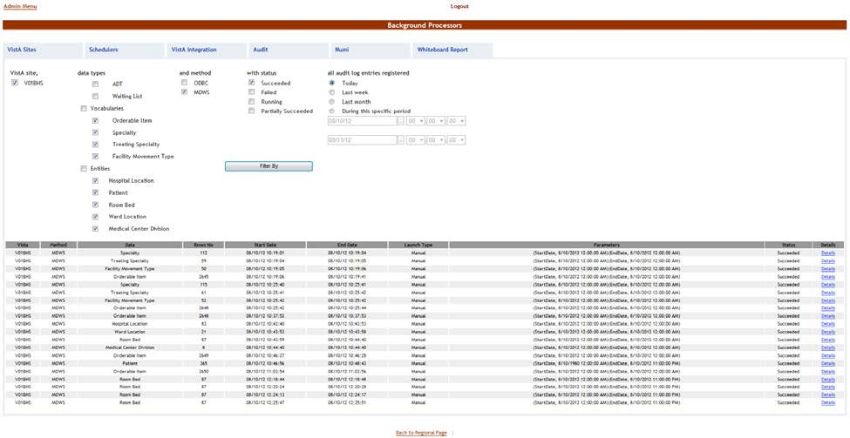

Figure 56:View Audit Results

A list of operations is displayed. For each entry the following data is available:

Table 21:View Audit Results Columns Report

|  |  |
| --- | --- |
| **Column** | **Description** |
| VistA | The VistA site where the audit action has been performed. |
| Method | The method used for connecting to the VistA site. |
| Data | The type of data retrieved by the VistA integration operation. |
| Rows no | The number of operations of the selected type captured by the audit action. |
| Start Date | The start date of the retrieval operation. |
| End Date | The end date of the retrieval operation. |
| Launch Type | The way the audit action has been launched. |
| Parameters | Audit operation start date and time, and end date and time. |
| Status | The status of the VistA integration action. |
| Details | Clicking this link will display the number of entries in the report. |

## NUMI Integration

This chapter describes the process of importing patient level of care information from NUMI.

NUMI connects to VistA for synchronization of patient data using the NUMI Web Service that is part of the Commercial Off the Shelf McKesson product. Authentication to the NUMI Web Service is done by a NUMI supplied secret key.

NUMI Patient Level of Care transaction  involves the following steps:

•         Change patient level of care in NUMI.

•         BMS Reader component will detect the patient level of care in NUMI.

•         Patient level of care will be retrieved through a web service method call.

•         BMS Writer component will update patient level of care in BMS database.

### Integration Settings

There are a limited number of configuration parameters for NUMI.

* Secret Key
* Number of sites per call
* Path to NUMI web service

These configurations are stored in BMS.Service.Host.exe.config

The current secret key is: <authorization key>

The number of site per call parameter how many sites will be bundled together in a transaction to NUMI. If this number is increased one should consider the frequency in which the calls are scheduled. Adding more sites will increase the transaction size and length.

Currently all NUMI servers operate on port 100 at the specified endpoint https://<servername>.aac.dva.va.gov/Inpatient.asmx*.*

In order to integrate with NUMI certain steps should be completed:

* + 1. Choose VistA site
    2. Define Schedulers
    3. Select Scheduler

### Choose VistA Site

This step is the same as the one performed on VistA Integration process and can be referenced from

Section 2.7.1.

### Define Schedulers

The process of defining schedulers can be referenced from Vista Integration process, Section 2.7.2.

### Select Scheduler

The NUMI tab is used to select the scheduler that will connect to the NUMI server and will retrieve data for a certain VistA site.

The NUMI tab is displayed as in the following image.

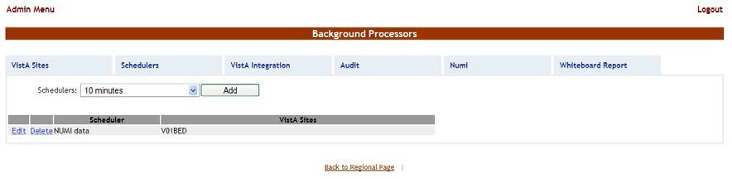

Figure 57: NUMI Tab

From the Schedulers field select the scheduler created to retrieve the NUMI data then click the Add button: following page is displayed.

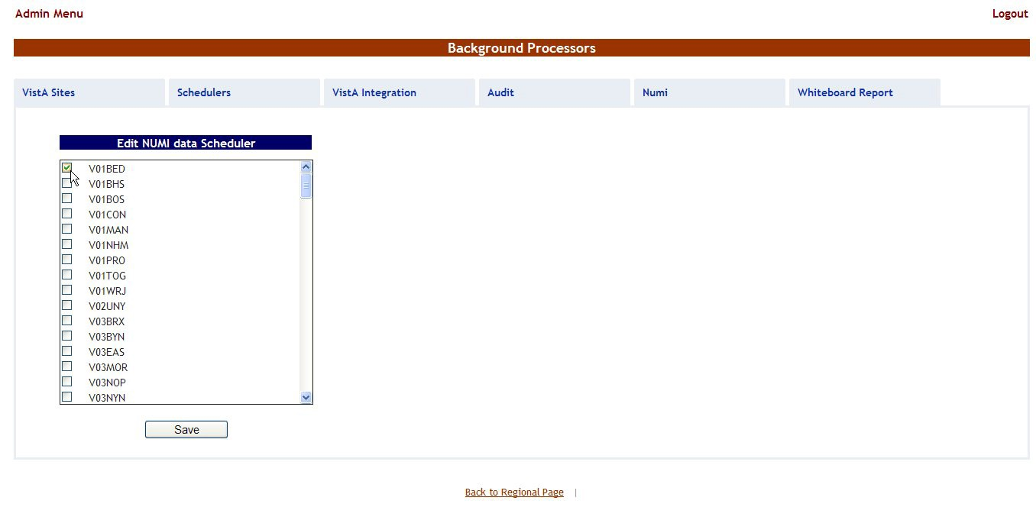

Figure 58: Selecting the VistA Site for Which to Gather NUMI Data

Select the VistA site for which the selected scheduler will retrieve NUMI data then press the Save button. Use the Edit link to select a different site for which the scheduler should retrieve NUMI data.

# Application structure

## Application Components

BMS application consists of the following components:

* + - BMS Databases (BMS Database, BMS Authz, BMS EIS, BMS EVS, BMS_DS, BMS_DW, BMS InstanceStore and BMS History)
    - BMS Services (BMS Service and Win ServiceHost)
      * BMS Service
      * Win Service Host (EIS Service, EVS Service, PAP service, PDP service, RS service and STS service)
    - BMS Web Site
    - WMI UserGroup

## Application Directory Structure

BMS application directory is structured as is presented below:

##### +---Consoles

| +---PolicyManager

+---Databases

| \---SQLData

| | \---Job Logs

| | \---WMI_UserGroup

+---Services

| +---BMS

| | \---DBRepository

| | \---LinqToSql

| | \---LocalReportWhiteboard

| | \---Scripts

| +---EIS

| | \---DBRepository

| +---EVS

| | \---DBRepository

| +---PAP

| | \---DBRepository

| +---PDP

| +---RS

| +---Shared

| \---STS

+---WebSite

| +---bin

| | \--- LocalReportWhiteboard

| | \--- Scripts

| +---Content

| | \---images

| | +---themes

| | | +---base

| | | | \---images

| +---Reporting

| +---ReportsLocal

| +---Scripts

| \---Views

## Database Architecture

The BMS Database implementation is comprised of three main parts:

* BMS Database
  + BMS_EVS (Enterprise Vocabulary database)
  + BMS_EIS (Entity Identification Services database)
  + BMS_AUTHZ (Authorization database)
  + BMS (Bed Management database).
  + BMS_History (BMS Transactional History)
  + BMS_InstanceStore (BMS Instances)
* BMS_DS – Data Loaded by an ETL job
* BMS_DW - Data Loaded by an ETL job

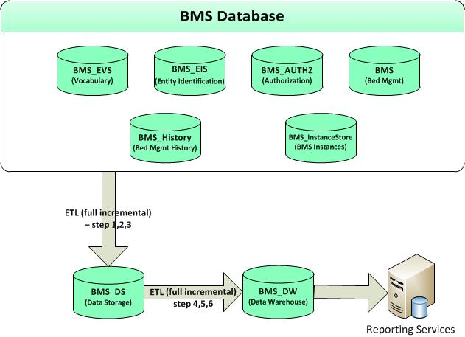

Figure 59: Database Architecture

## Component Files

A list with files for each BMS component is presented below:

Table 22: BMS Database Files

| **Relative Path** | **File** | **Description** |
| --- | --- | --- |
| Databases\SQLData  Databases\SQLData2  Databases\SQLLogs | BMS_Data.mdf | Database files (BMS database, BMS Authz, BMS EIS, BMS EVS….) |
| BMS_Data_F.ndf |
| BMS_Log.ldf |
| BMS_AUTHZ_Data.mdf |
| BMS_AUTHZ_Log.ldf |
| BMS_DS_Data.mdf |
| BMS_DS_Data_F.ndf |
| BMS_DS_Log.ldf |
| BMS_DW_Data.mdf |
| BMS_DW_Log.ldf |
| BMS_EIS_Data.mdf |
| BMS_EIS_Data_F.ndf |
| BMS_EIS_Log.ldf |
| BMS_EVS_Data.mdf |
| BMS_EVS_Data.ndf |
| BMS_EVS_Log.ldf |
| BMS_HISTORY_Data.mdf |
| BMS_HISTORY_Data_F.ndf |
| BMS_HISTORY_Log.ldf |
| BMS_InstanceStore_Data.mdf |
| BMS_InstanceStore_Log.ldf |
| Databases\SQLData\Job_Log s | BMS_Reports_Log.txt | BMS Report Full job file log and BMS Incremental job file log. |
| BMS_Reports_Log_Incremental.txt |
| Databases\SQLData\WMI_Us erGroup | AdapterRepository.dll | Binaries of WMI UserGroup application. |
| Common.dll |
| connectionConfiguration.config |
| Connections.SingleDatabase.dll |
| ContextWriter.dll |
| General.MT.dll |
| Infoworld.Configuration.dll |
| MiddleTier.dll |
| MS.Common.dll |
|  | MS.Configuration.dll |  |
| MS.Connections.dll |
| WMI_UserGroup.exe |
| WMI_UserGroup.exe.config |
| WMI_UserGroup.vshost.exe |
| WMI_UserGroup.vshost.exe.config |
| WMI_UserGroup.vshost.exe.manifest |
| Databases\SQLData\WMI_Us erGroup\ DBRepository | Connections.xml | File used to set the connection to the database. |
| InfoWorld.WMI_UserGroup.DTO.DTOUse rGroupDomain.xml | XML mapping file which contain mapping definitions between ePractice datasets and SQL tables. The dataset is specified by setting the <MyDataSetInfo> tag. The table to interact with – specified through the  <MyDataTable> tag – is defined by four commands – usually stored procedures – which represent the Create, Read, Update  and Delete (CRUD) operations which can be performed on the table: select (Read), insert (Create), update (Update) and delete (Delete). Stored procedure parameters are  passed from these datasets and mapped in the same XML file. |

Table 23: BMS Service Files

| **Relative Path** | **File** | **Description** |
| --- | --- | --- |
| Services\BMS | AdapterRepository.dll | The binaries of the BMS Service. |
| AuditTrailSender.dll |
| AuthenticationProxy.dll |
| AuthorizationSubscriber.dll |
| BMS.Contracts.dll |
| BMS.Facade.dll |
| BMS.Facade.Contracts.dll |
| BMS.Host.dll |
| BMS.MT.dll |
| BMS.MT.dll.config |
| BMS.Numi.dll |
| BMS.Schedulers.dll |
|  | BMS.Security.dll |  |
| BMS.ServiceHost.exe |
| BMS.ServiceHost.exe.config |
| BMS.ServiceImplementation.dll |
| BMS.ServicesWrapper.dll |
| BMS.UnitTesting.dll |
| BMS.UnitTesting.dll.config |
| BMS.Utils.dll |
| BMS.VistaIntegration.dll |
| BMS.VistaIntegration.Cache.dll |
| BMS.VistaIntegration.Data.dll |
| BMS.VistaIntegration.HL7.dll |
| BMS.VistaIntegration.Mdws.dll |
| BMS.VistaIntegration.UnitTesting.dll |
| BMS.VistaIntegration_Accessor.dll |
| BMS.VistaWorker.dll |
| BMS.VistaWorker.Reader.dll |
| BMS.VistaWorker2.Writer.dll |
| BMS.Web.dll |
| BMS.WhiteboardReport.dll |
| BMS.Workflows.CustomActivities.dll |
| BMS.Workflows.PropertyPromotionActivity  .dll |
| BMS.Workflows.WF.dll |
| Castle.Core.dll |
| Common.dll |
| connectionConfiguration.config |
| Connections.SingleDatabase.dll |
| ContextWriter.dll |
| DataUtil.dll |
| FakeItEasy.dll |
| General.MT.dll |
|  | HL7DataTypes.dll |  |
| IContracts.dll |
| ICTSEdit.dll |
| Infoworld.Configuration.dll |
| InterSystems.Data.CacheClient.dll |
| log4net.dll |
| Mdws2ORM.dll |
| Microsoft.Web.Mvc.dll |
| MiddleTier.dll |
| MS.Common.dll |
| MS.Configuration.dll |
| MS.Connections.dll |
| PAPProxy.dll |
| RS.Contracts.dll |
| Saml20.dll |
| SecurityTokenCache.dll |
| trace.log |
| Tracing.dll |
| VistASites.xml |
| Xacml2.dll |
| XacmlCore.dll |
| Services\BMS\DBRepository | BMS.MT.Admission.xml | XML mapping files which contains mapping definitions between ePractice datasets and SQL tables. The dataset is specified by setting the <MyDataSetInfo> tag. The table to interact with – specified through the  <MyDataTable> tag – is defined by four commands – usually stored procedures –  which represent the CRUD operations which  can be performed on the table: select (Read), insert (Create), update (Update) and  delete (Delete). Stored procedure parameters are passed from these datasets and mapped in the same XML file. Connections.xml file is used to set the  connection string to BMS database. |
| BMS.MT.AdmissionInfo.xml |
| BMS.MT.AdmissionLevelOfCare.xml |
| BMS.MT.BedCleanInfo.xml |
| BMS.MT.BedCleaning.xml |
| BMS.MT.BedCleanMobileInfo.xml |
| BMS.MT.BedDNDAndOOSFromVista.xml |
| BMS.MT.BedOccupancyCount.xml |
| BMS.MT.BedOccupancyInfo.xml |
| BMS.MT.BedStaff.xml |
|  | BMS.MT.BedStaffHistory.xml |  |
| BMS.MT.BedSwitch.xml |
| BMS.MT.BedUnavailable.xml |
| BMS.MT.BedUnavailableHistory.xml |
| BMS.MT.BedUnavailableInfo.xml |
| BMS.MT.CancelableOrderInfo.xml |
| BMS.MT.Configuration.xml |
| BMS.MT.Discharge.xml |
| BMS.MT.Diversion.xml |
| BMS.MT.EISOrganization.xml |
| BMS.MT.EmsStaff.xml |
| BMS.MT.EvacuationPatients.xml |
| BMS.MT.IconAssociation.xml |
| BMS.MT.IconAssociationInfo.xml |
| BMS.MT.IconDetail.xml |
| BMS.MT.IconInfo.xml |
| BMS.MT.IconOrder.xml |
| BMS.MT.JobAudit.xml |
| BMS.MT.JobAuditInfo.xml |
| BMS.MT.LastActInfo.xml |
| BMS.MT.LevelOfCare.xml |
| BMS.MT.LoggedUser.xml |
| BMS.MT.Movement.xml |
| BMS.MT.NewEvent.xml |
| BMS.MT.OccupiedBedInfo.xml |
| BMS.MT.PatientIconAssociation.xml |
| BMS.MT.PatientLocation.xml |
| BMS.MT.PatientsWaitingCount.xml |
| BMS.MT.PatientWaitingDateView.xml |
| BMS.MT.PatientWaitingStandardView.xml |
| BMS.MT.Transfer.xml |
|  | BMS.MT.TransferInfo.xml |  |
| BMS.MT.VistaIntegrationLog.xml |
| BMS.MT.VistaOperation.xml |
| BMS.MT.WaitingListItem.xml |
| BMS.MT.WaitingListReport.xml |
| ConfigurationService.DataAccess.Configu rationsBE.xml |
| Connections.xml |
| Services\BMS\LocalReportW  hiteboard | WardWhiteboard.rdlc | Ward whiteboard report file. |
| Services\BMS\Scripts | conditional-validation.js | JavaScript conditional validation file. |

Table 24: Win Service Host Files

| **Relative Path** | **File** | **Description** |
| --- | --- | --- |
| Services\EIS | BindingExtensions.dll | Binaries of the EIS Service. |
| DTOGenericService.dll |
| DTOHL7Service.dll |
| EISAuditUtil.dll |
| EISAutomaticLink.dll |
| EISCache.dll |
| EISContracts.dll |
| EISDataAccess.dll |
| EISNotifications.dll |
| EISServiceGenericImplementation.dll |
| EISServiceHL7Implementation.dll |
| EISServiceImplementation.dll |
| EISServiceImplementation.dll.config |
| ICSharpCode.SharpZipLib.dll |
| Services\EIS\DBRepository | Connections.xml | XML mapping files which contains mapping definitions between ePractice datasets and SQL tables. The dataset is specified by setting the <MyDataSetInfo> tag. The table to interact with – specified through the  <MyDataTable> tag – is defined by four commands – usually stored procedures – which represent the CRUD operations which can be performed on the table: select |
| InfoWorld.EIS.DTOGenericService.DTOA utomaticLink.xml |
| InfoWorld.EIS.DTOGenericService.DTOD omain.xml |
| InfoWorld.EIS.DTOGenericService.DTOE ntity.xml |
|  | InfoWorld.EIS.DTOGenericService.DTOE ntityType.xml | (Read), insert (Create), update (Update) and delete (Delete). Stored procedure parameters are passed from these datasets and mapped in the same XML file. Connections.xml file is used to set the connection string to BMS_EIS database. |
| InfoWorld.EIS.DTOGenericService.DTOE ntityTypeClassifier.xml |
| InfoWorld.EIS.DTOGenericService.DTOE ntityTypeTraitCoresp.xml |
| InfoWorld.EIS.DTOGenericService.DTOTr ait.xml |
| InfoWorld.EIS.DTOGenericService.DTOTr aitAssignment.xml |
| InfoWorld.EIS.DTOGenericService.Entity Management.DTOEntityManageLink.xml |
| InfoWorld.EIS.DTOGenericService.Entity Management.DTOEntityMerge.xml |
| InfoWorld.EIS.DTOGenericService.Entity Management.DTOEntitySetStatus.xml |
| InfoWorld.EIS.DTOGenericService.LinkAl gorithmManagement.LinkAlgorithmTrait.x ml |
| InfoWorld.EIS.DTOGenericService.LinkAl gorithmManagement.LinkAlgorithmTraits.x ml |
| InfoWorld.EIS.DTOGenericService.LinkAl gorithmManagement.Match.xml |
| InfoWorld.EIS.DTOGenericService.Query Functions.DTOConflictingEntities.xml |
| InfoWorld.EIS.DTOGenericService.Query Functions.DTOFindEntity.xml |
| InfoWorld.EIS.DTOGenericService.Query Functions.DTOGetAllInfoPar.xml |
| InfoWorld.EIS.DTOGenericService.Query Functions.DTOGetAllInformationForAnEnt ity.xml |
| InfoWorld.EIS.DTOGenericService.Query Functions.DTOGetSupportedDomains.xml |
| InfoWorld.EIS.DTOGenericService.Query Functions.DTOLinkedEntities.xml |
| InfoWorld.EIS.DTOHL7Service.Address.x ml |
| InfoWorld.EIS.DTOHL7Service.Container. xml |
| InfoWorld.EIS.DTOHL7Service.Container Filtr.xml |
| InfoWorld.EIS.DTOHL7Service.ContainerI nfo.xml |
| InfoWorld.EIS.DTOHL7Service.Device.xm l |
| InfoWorld.EIS.DTOHL7Service.DeviceFiltr  .xml |
|  | InfoWorld.EIS.DTOHL7Service.DeviceInfo  .xml |  |
| InfoWorld.EIS.DTOHL7Service.Manufactu redMaterial.xml |
| InfoWorld.EIS.DTOHL7Service.Manufactu redMaterialFiltr.xml |
| InfoWorld.EIS.DTOHL7Service.Manufactu redMaterialInfo.xml |
| InfoWorld.EIS.DTOHL7Service.Material.x ml |
| InfoWorld.EIS.DTOHL7Service.MaterialFil tr.xml |
| InfoWorld.EIS.DTOHL7Service.MaterialInf o.xml |
| InfoWorld.EIS.DTOHL7Service.NonPerso nLivingSubject.xml |
| InfoWorld.EIS.DTOHL7Service.NonPerso nLivingSubjectFiltr.xml |
| InfoWorld.EIS.DTOHL7Service.NonPerso nLivingSubjectInfo.xml |
| InfoWorld.EIS.DTOHL7Service.Organizati on.xml |
| InfoWorld.EIS.DTOHL7Service.Organizati onFiltr.xml |
| InfoWorld.EIS.DTOHL7Service.Organizati onInfo.xml |
| InfoWorld.EIS.DTOHL7Service.Person.xm l |
| InfoWorld.EIS.DTOHL7Service.PersonFiltr  .xml |
| InfoWorld.EIS.DTOHL7Service.PersonInfo  .xml |
| InfoWorld.EIS.DTOHL7Service.Place.xml |
| InfoWorld.EIS.DTOHL7Service.PlaceFiltr. xml |
| InfoWorld.EIS.DTOHL7Service.PlaceInfo. xml |
| InfoWorld.EIS.DTOHL7Service.Telecom.x ml |
| InfoWorld.WSEventing.DTO.CustomSubs criptions.xml |
| InfoWorld.WSEventing.DTO.Endpoints.xm l |
| InfoWorld.WSEventing.DTO.FilterDialects. xml |
| InfoWorld.WSEventing.DTO.Message.xml |
| InfoWorld.WSEventing.DTO.MessageGet. xml |
|  | InfoWorld.WSEventing.DTO.MessageGet DeliveryTo.xml |  |
| InfoWorld.WSEventing.DTO.Subscriptions  .xml |
| Services\EVS | ActionManager.dll | Binaries of EVS service. |
| BindingExtensions.dll |
| CodingSystems.DAL.dll |
| Configuration.dll |
| connectionConfiguration.config |
| Connections.Common.dll |
| CTSEdit.dll |
| CTSEdit.Utils.dll |
| CTSEditBulk.dll |
| CTSExport.dll |
| CTSImport.dll |
| CTSImportProxy.dll |
| CTSService.Utils.dll |
| DTOCodeMappingEdit.dll |
| DTOMapping.dll |
| DTOMessageBrowser.dll |
| DTOMessageEdit.dll |
| DTOMessageRuntime.dll |
| DTOVocabularyEdit.dll |
| DTOVocabularyEdit.dll.config |
| EVSWrapper.dll |
| EVSWrapper.dll.config |
| Factory.dll |
| HL7DataTypes.XmlSerializers.dll |
| IContracts.dll |
| ICSharpCode.SharpZipLib.dll |
| ICTSEdit.dll |
| ICTSEditBulk.dll |
| ICTSExport.dll |
|  | ICTSImport.dll |  |
| IEventing.dll |
| MappingImpl.dll |
| Message.dll |
| MessageImpl.dll |
| MessageImpl.dll.config |
| MS.Caching.dll |
| Notify.dll |
| SecureChannel.dll |
| Security.Null.dll |
| securityConfiguration.config |
| VocabularyBrowser.DTO.dll |
| VocabularyImpl.dll |
| VocabularyRuntime.DTO.dll |
| XamlContracts.dll |
| XamlDataContracts.dll |
| XamlImpl.dll |
| Services\EVS\DBRepository | Connections.xml | XML mapping files which contains mapping definitions between ePractice datasets and SQL tables. The dataset is specified by setting the <MyDataSetInfo> tag. The table to interact with – specified through the  <MyDataTable> tag – is defined by four commands – usually stored procedures –  which represent the CRUD operations which can be performed on the table: select (Read), insert (Create), update (Update) and delete (Delete). Stored procedure  parameters are passed from these datasets and mapped in the same XML file. Connections.xml file is used to set the connection string to BMS_EVS database. |
| InfoWorld.EVS.CTSEdit.DTO.Association. xml |
| InfoWorld.EVS.CTSEdit.DTO.CodingSyst em.xml |
| InfoWorld.EVS.CTSEdit.DTO.Concept.xml |
| InfoWorld.EVS.CTSEdit.DTO.ConceptAss ociationsToCMultiAttrib.xml |
| InfoWorld.EVS.CTSEdit.DTO.ConceptPro perty.xml |
| InfoWorld.EVS.CTSEdit.DTO.DSMap.xml |
| InfoWorld.EVS.CTSEdit.DTO.DSMapEntr y.xml |
| InfoWorld.EVS.CTSEdit.DTO.DTOReExp andValueSet.xml |
| InfoWorld.EVS.CTSEdit.DTO.DTOValueS et.xml |
| InfoWorld.EVS.CTSEdit.DTO.DTOVocabu laryDomain.xml |
| InfoWorld.EVS.CTSEdit.DTO.Relation.xml |
|  | InfoWorld.EVS.CTSEdit.DTO.ValueSets.x ml |  |
| InfoWorld.EVS.CTSMAPI.DTO.CodeSyste mInfo.xml |
| InfoWorld.EVS.CTSMAPI.DTO.DomainVal ueSetFiltr.xml |
| InfoWorld.EVS.CTSMAPI.DTO.DSConcep tsByCode.xml |
| InfoWorld.EVS.CTSMAPI.DTO.DSConcep tsByCodeProperties.xml |
| InfoWorld.EVS.CTSMAPI.DTO.DSConcep tsByDesignation.xml |
| InfoWorld.EVS.CTSMAPI.DTO.DSConcep tsByDesignationProperties.xml |
| InfoWorld.EVS.CTSMAPI.DTO.DSFullVal ueSetDescription.xml |
| InfoWorld.EVS.CTSMAPI.DTO.DSValueS etContextExpansion.xml |
| InfoWorld.EVS.CTSMAPI.DTO.DSValueS etExpansion.xml |
| InfoWorld.EVS.CTSMAPI.DTO.DSValueS etExpansionProperties.xml |
| InfoWorld.EVS.CTSMAPI.DTO.DSValueS etExpansionReverse.xml |
| InfoWorld.EVS.CTSMAPI.DTO.DSVocabu laryDomainDescription.xml |
| InfoWorld.EVS.CTSMAPI.DTO.GetFillInD etailsCD.xml |
| InfoWorld.EVS.CTSMAPI.DTO.IsCodeInV alueSet.xml |
| InfoWorld.EVS.CTSMAPI.DTO.ValidateCo de.xml |
| InfoWorld.EVS.CTSMAPI.DTO.ValueSetC odeReference.xml |
| InfoWorld.EVS.CTSMAPI.DTO.ValueSetFi ltr.xml |
| InfoWorld.EVS.CTSMAPI.DTO.Vocabular yDomainFiltr.xml |
| InfoWorld.EVS.CTSMapping.DTO.DSMap ConceptCode.xml |
| InfoWorld.EVS.CTSMapping.DTO.DSMap Entry.xml |
| InfoWorld.EVS.CTSMapping.DTO.DSSup portedMapsFiltr.xml |
| InfoWorld.EVS.CTSVAPI.DTO.CodeSyste m.xml |
| InfoWorld.EVS.CTSVAPI.DTO.CodeSyste mFiltr.xml |
|  | InfoWorld.EVS.CTSVAPI.DTO.CodingSch emeFiltr.xml |  |
| InfoWorld.EVS.CTSVAPI.DTO.ConceptCo deValid.xml |
| InfoWorld.EVS.CTSVAPI.DTO.ConceptDe scription.xml |
| InfoWorld.EVS.CTSVAPI.DTO.ConceptEx pansion.xml |
| InfoWorld.EVS.CTSVAPI.DTO.ConceptPr operties.xml |
| InfoWorld.EVS.CTSVAPI.DTO.ConceptsB yDesignation.xml |
| InfoWorld.EVS.CTSVAPI.DTO.ConceptsB yProperty.xml |
| InfoWorld.EVS.CTSVAPI.DTO.Designatio n.xml |
| InfoWorld.EVS.CTSVAPI.DTO.RelatedCo ncepts.xml |
| InfoWorld.EVS.DTOEditBulk.ConceptBulk. xml |
| InfoWorld.EVS.DTOEditBulk.ConceptProp ertyBulk.xml |
| InfoWorld.EVS.DTOEditBulk.RelationBulk. xml |
| InfoWorld.WSEventing.DTO.CustomSubs criptions.xml |
| InfoWorld.WSEventing.DTO.Endpoints.xm l |
| InfoWorld.WSEventing.DTO.FilterDialects. xml |
| InfoWorld.WSEventing.DTO.Message.xml |
| InfoWorld.WSEventing.DTO.MessageGet. xml |
| InfoWorld.WSEventing.DTO.MessageGet DeliveryTo.xml |
| InfoWorld.WSEventing.DTO.Subscriptions  .xml |
| XamlDataContracts.DSXamlReverse.xml |
| XamlDataContracts.RootXaml.xml |
| XamlDataContracts.XAMLFiltr.xml |
| Services\PAP | ActionManager.dll | Binaries of PAP service. |
| AuthorizationProxy.dll |
| Configuration.dll |
| connectionConfiguration.config |

| **Relative Path** | **File** | **Description** |
| --- | --- | --- |
|  | Connections.Common.dll |  |
| Microsoft.ApplicationBlocks.Data.dll |
| Microsoft.ApplicationBlocks.ExceptionMan agement.dll |
| Microsoft.ApplicationBlocks.ExceptionMan agement.Interfaces.dll |
| Microsoft.Practices.EnterpriseLibrary.Com mon.dll |
| Microsoft.Practices.EnterpriseLibrary.Exce ptionHandling.dll |
| Microsoft.Practices.EnterpriseLibrary.Exce ptionHandling.Logging.dll |
| Microsoft.Practices.EnterpriseLibrary.Logg ing.dll |
| Microsoft.Practices.ObjectBuilder.dll |
| MS.Caching.dll |
| ObjectPickerHelper2.dll |
| PAPProxy.dll |
| PDPServiceAuthorizationManager.dll |
| PolicyAdministrationPoint.dll |
| PolicyAdministrationPoint.dll.config |
| SecureChannel.dll |
| Security.Null.dll |
| Services\PAP\DBRepository | Connections.xml | XML mapping files which contains mapping definitions between ePractice datasets and SQL tables. The dataset is specified by setting the <MyDataSetInfo> tag. The table to interact with – specified through the  <MyDataTable> tag – is defined by four commands – usually stored procedures – which represent the CRUD operations which  can be performed on the table: select (Read), insert (Create), update (Update) and delete (Delete). Stored procedure parameters are passed from these datasets  and mapped in the same XML file. Connections.xml file is used to set the connection string to BMS_AURHZ database. |
| InfoWorld.DE.DataAccess.LabSet.xml |
| InfoWorld.DE.DataAccess.LabSetId.xml |
| InfoWorld.DE.DataAccess.SentStatus.xml |
| InfoWorld.WSEventing.DTO.CustomSubs criptions.xml |
| InfoWorld.WSEventing.DTO.Endpoints.xm l |
| InfoWorld.WSEventing.DTO.FilterDialects. xml |
| InfoWorld.WSEventing.DTO.Message.xml |
| InfoWorld.WSEventing.DTO.MessageGet. xml |
| InfoWorld.WSEventing.DTO.MessageGet DeliveryTo.xml |
| InfoWorld.WSEventing.DTO.Subscriptions  .xml |
| Services\PDP | PolicyDecisionPoint.dll | Binaries of PDP service. |
| PolicyDecisionPoint.dll.config |
| Services\RS | AuthorizationProxy.dll | Binaries of RS service. |
| RS.Contracts.dll |
| RS.Proxy.dll |
| RS.ServiceImplementation.dll |
| RS.ServiceImplementation.dll.config |
| Services\Shared | 7zip.dll | Shared binaries by BMS Service and Win Service. |
| AdapterRepository.dll |
| AuditTrailSender.dll |
| AuthorizationSubscriber.dll |
| BindingExtensions.dll |
| Common.dll |
| CommonResources.dll |
| Connections.SingleDatabase.dll |
| ContextWriter.dll |
| DataUtil.dll |
| General.MT.dll |
| HL7CDA.dll |
| HL7CMET.dll |
| HL7DataTypes.dll |
| ICSharpCode.SharpZipLib.dll |
| Infoworld.Configuration.dll |
| log4net.dll |
| MiddleTier.dll |
| MS.Common.dll |
| MS.Configuration.dll |
| MS.Connections.dll |
| MS.Security.dll |
| Saml20.dll |
| SecurityTokenCache.dll |

|  |  |  |
| --- | --- | --- |
| **Relative Path** | **File** | **Description** |
|  | Tracing.dll |  |
| WSEventing.dll |
| WSEventing.DataAccess.dll |
| WSEventing.DTO.dll |
| Xacml2.dll |
| XacmlCore.dll |
| Services\STS | SecureTokenService.dll | Binaries of STS service. |
| SecureTokenService.dll.config |
| Services | WinServiceHost.exe | WinServiceHost files. |
| WinServiceHost.exe.config |
| BMS-Services.log |

Table 25:BMS Web Site Files

| **Relative Path** | **File** | **Description** |
| --- | --- | --- |
| WebSite | CacheService.svc | The binaries of the BMS Web Site, web site configuration file. |
| Global.asax |
|  |
|  |
| packages.config |
| Web.config |
| WebTrace.log |
|  | additional_login_msg.txt | Dynamic text for main login page |
| WebSite\bin | AntiXSSLibrary.dll | Web site’s binaries. |
|  | AuditTrailSender.dll |  |
|  | AuthenticationProxy.dll |  |
|  | BMS.Contracts.dll |  |
|  | BMS.Facade.Contracts.dll |  |
|  | BMS.Facade.dll |  |
|  | BMS.PAPContracts.dll |  |
|  | BMS.Security.dll |  |
|  | BMS.ServicesWrapper.dll |  |
|  | BMS.Utils.dll |  |
|  | BMS.Web.dll |  |
|  | EISContracts.dll |  |
|  | HL7DataTypes.dll |  |
|  | HtmlAgilityPack.dll |  |
|  | HtmlSanitizationLibrary.dll |  |
|  | IContracts.dll |  |
|  | ICTSEdit.dll |  |
|  | Infoworld.Configuration.dll |  |
|  | log4net.dll |  |
|  | log4netAsync.dll |  |
|  | Microsoft.ReportViewer.Common.dll |  |
|  | Microsoft.ReportViewer.DataVisualization.dll |  |
|  | Microsoft.ReportViewer.ProcessingObjectModel.dll |  |
|  | Microsoft.ReportViewer.WebForms.dll |  |
|  | Microsoft.Web.Infrastructure.dll |  |
|  | Microsoft.Web.Mvc.dll |  |
|  | RS.Contracts.dll |  |
|  | Saml20.dll |  |
|  | SecurityTokenCache.dll |  |
|  | System.Web.Helpers.dll |  |
|  | System.Web.Mvc.dll |  |
|  | System.Web.Razor.dll |  |
|  | System.Web.WebPages.Deployment.dll |  |
|  | System.Web.WebPages.dll |  |
|  | System.Web.WebPages.Razor.dll |  |
|  | Tracing.dll |  |
|  | Xacml2.dll |  |
|  | XacmlCore.dll |  |
| WebSite\bin\LocalReportWhite board | WardWhitebord.rdlc | Ward Whiteboard report file. |
| WebSite\bin\Scripts | Conditional-validation.js | File used by the site for conditional validation. |
| WebSite\Content | bundleCss.chirp.config | Images, themes and styles. |
|  | Controls.css |  |
|  | LayoutCss.min.css |  |
|  | LayoutVistaIntegrationCss.min.css |  |
|  | Reports.min.css |  |
|  | Site.css |  |
| WebSite\Content\images | add_tab_24.png | Images used by site. |
|  | arrow_down.png |  |
|  | arrow_up.png |  |
|  | BMSLogoV6.jpg |  |
|  | check_inv.png |  |
|  | edit_staff_cancel.png |  |
|  | edit_staff_save.png |  |
|  | FavIcon.ico |  |
|  | Info.png |  |
|  | Ladybug.png |  |
|  | login_logo.png |  |
|  | logo.png |  |
|  | order_down.png |  |
|  | order_up.png |  |
|  | sort_down.png |  |
|  | sort_up.png |  |
| WebSite\Content\themes\base | jquery.ui.accordion.css | jQuery controls style-sheets files. |
|  | jquery.ui.all.css |  |
|  | jquery.ui.autocomplete.css |  |
|  | jquery.ui.base.css |  |
|  | jquery.ui.button.css |  |
|  | jquery.ui.core.css |  |
|  | jquery.ui.datepicker.css |  |
|  | jquery.ui.dialog.css |  |
|  | jquery.ui.progressbar.css |  |
|  | jquery.ui.resizable.css |  |
|  | jquery.ui.selectable.css |  |
|  | jquery.ui.slider.css |  |
|  | jquery.ui.tabs.css |  |
|  | jquery.ui.theme.css |  |
| WebSite\Content\themes\base  \images | ui-bg_flat_0_aaaaaa_40x100.png | Images |
|  | ui-bg_flat_75_ffffff_40x100.png |  |
|  | ui-bg_glass_55_fbf9ee_1x400.png |  |
|  | ui-bg_glass_65_ffffff_1x400.png |  |
|  | ui-bg_glass_75_dadada_1x400.png |  |
|  | ui-bg_glass_75_e6e6e6_1x400.png |  |
|  | ui-bg_glass_95_fef1ec_1x400.png |  |
|  | ui-bg_highlight-soft_75_cccccc_1x100.png |  |
|  | ui-icons_222222_256x240.png |  |
|  | ui-icons_2e83ff_256x240.png |  |
|  | ui-icons_454545_256x240.png |  |
|  | ui-icons_888888_256x240.png |  |
|  | ui-icons_cd0a0a_256x240.png |  |
| WebSite\Reporting | EvacuationPatientReportViewer.aspx | Report Viewer pages. |
|  | LocalReportViewer.aspx |  |
|  | ReportError.aspx |  |
|  | ReportViewer.aspx |  |
| WebSite\ ReportsLocal | BedStatusReport.rdlc | Bed Status Report file. |
| WebSite\Scripts | antiForgeryToken.js | JavaScript files. |
|  | bundleScripts.chirp.config |  |
|  | conditional-validation.js |  |
|  | element-change.js |  |
|  | hoverIntent.js |  |
|  | jquery.autosize.js |  |
|  | jquery.base64.js |  |
|  | jquery.base64.min.js |  |
|  | jquery.jscrollpane.min.js |  |
|  | jquery.maskedinput-1.3.min.js |  |
|  | jquery.mousewheel.js |  |
|  | jquery.tablescroll.js |  |
|  | jquery.tablescroll.min.js |  |
|  | jquery.tablesorter.js |  |
|  | jquery.tablesorter.min.js |  |
|  | jquery.ui.autocomplete.js |  |
|  | jquery.ui.core.js |  |
|  | jquery.ui.position.js |  |
|  | jquery.ui.progressbar.js |  |
|  | jquery.ui.widget.js |  |
|  | jquery.unobtrusive-ajax.js |  |
|  | jquery.unobtrusive-ajax.min.js |  |
|  | jquery.validate.js |  |
|  | jquery.validate.min.js |  |
|  | jquery.validate.unobtrusive.js |  |
|  | jquery.validate.unobtrusive.min.js |  |
|  | jquery.validate-vsdoc.js |  |
|  | jquery-1.5.1.js |  |
|  | jquery-1.5.1.min.js |  |
|  | jquery-1.5.1-vsdoc.js |  |
|  | jquery-1.7.1.js |  |
|  | jquery-1.7.1.min.js |  |
|  | jquery-ui-1.8.11.js |  |
|  | jquery-ui-1.8.11.min.js |  |
|  | jquery-ui-1.8.18.custom.js |  |
|  | json2.js |  |
|  | LayoutAdminAutoCompleteAndDatePicker.js |  |
|  | LayoutAdminScripts.min.js |  |
|  | LayoutAutoCompleteAndDatePicker.js |  |
|  | LayoutScripts.min.js |  |
|  | LayoutVistaIntegrationDatePicker.js |  |
|  | LayoutVistaIntegrationScripts.min.js |  |
|  | MicrosoftAjax.debug.js |  |
|  | MicrosoftAjax.js |  |
|  | MicrosoftMvcAjax.debug.js |  |
|  | MicrosoftMvcAjax.js |  |
|  | MicrosoftMvcValidation.debug.js |  |
|  | MicrosoftMvcValidation.js |  |
|  | modernizr-1.7.js |  |
|  | modernizr-1.7.min.js |  |
|  | Reports.min.js |  |
|  | superfish.js |  |
|  | supersubs.js |  |
|  | whiteboard-script.js |  |
|  | whiteboard-script.min.js |  |
| WebSite\Views | _ViewStart.cshtml | User Interface views. |
|  | Web.config |  |
| WebSite\Views\Account | LogOff.cshtml | Login/Logout user interface views. |
|  | LogOn.cshtml |  |
| WebSite\Views\Admin | AddEditUser.cshtml | Admin section user interface views. |
|  | AddUserOperations.cshtml |  |
|  | CacheConfirmation.cshtml |  |
|  | FacilityEdit.cshtml |  |
|  | FacilityEditSaved.cshtml |  |
|  | Index.cshtml |  |
|  | RefreshUsersConfirmation.cshtml |  |
|  | RemoveUserOperations.cshtml |  |
|  | SelectUser.cshtml |  |
|  | SisterSiteAddEdit.cshtml |  |
|  | SisterSiteEditSaved.cshtml |  |
|  | UserEditHasSaved.cshtml |  |
|  | UserOperationsView.cshtml |  |
| WebSite\Views\AdminSpecialt yAssociation | Delete.cshtml | Admin specialty association user interface views. |
|  | Index.cshtml |  |
| WebSite\Views\AdminUnavailableReason | AddConfirmation.cshtml | Admin unavailable reason user interface |
|  | Delete.cshtml |  |
|  | DeleteConfirmation.cshtml |  |
|  | Edit.cshtml |  |
|  | EditConfirmation.cshtml |  |
|  | Index.cshtml |  |
|  | MissingUnavailableReasonText.cshtml |  |
|  | UnavailableReasonAlreadyExists.cshtml |  |
|  | UnavailableReasonList.cshtml |  |
| WebSite\Views\AdminComments | Index.cshtml |  |
|  | NotifyChange.cshtml |  |
| WebSite\Views\AdminWaitingArea | AddAction.cshtml | Admin waiting area user interface views. |
|  | Delete.cshtml |  |
|  | DeleteAction.cshtml |  |
|  | Edit.cshtml |  |
|  | EditAction.cshtml |  |
|  | Index.cshtml |  |
| WebSite\Views\AdminWhiteboardReport | Delete.cshtml | Admin whiteboard report user interface |
|  | Edit.cshtml |  |
|  | Index.cshtml |  |
| WebSite\Views\AdtOrderableItems | Confirmation.cshtml | ADT Orderable Items user interface views. |
|  | Index.cshtml |  |
|  | OrderableItemsList.cshtml |  |
| WebSite\Views\BackgroundProcessors | AddEditConfirmation.cshtml | Background Processors user interface views. |
|  | DeleteConfirmation.cshtml |  |
|  | Index.cshtml |  |
| WebSite\Views\BedBoard | Index.cshtml | VISN user interface views. |
| WebSite\Views\BedBoardModule | Index.cshtml | Bed Board Module user interface view. |
| WebSite\Views\BedInformation | ClearAll.cshtml | Bed Information user interface views. |
|  | Index.cshtml |  |
|  | NotifyChange.cshtml |  |
| WebSite\Views\BedStatusReport | Index.cshtml | Patients Pending Placement Status report user interface view. |
| WebSite\Views\ContingencySettings | Confirmation.cshtml | Contingency settings user interface views. |
|  | Index.cshtml |  |
| WebSite\Views\DischargeClinic | Index.cshtml | Discharge clinic user interface views. |
|  | MessageConfirmation.cshtml |  |
| WebSite\Views\EmsBedStatusAdmin | Edit.cshtml | EMS bed status user interface views |
|  | EMSBatchAssign.cshtml |  |
|  | Index.cshtml |  |
|  | SaveConfirmation.cshtml |  |
| WebSite\Views\EMSMobile | EMSList.cshtml | EMS Mobile user interface views. |
|  | Users.cshtml |  |
| WebSite\Views\EMSMobileLogon | Index.cshtml | EMS Mobile Logon user interface view. |
| WebSite\Views\EmsNotification | AddEdit.cshtml | EMS Notification user interface views. |
|  | AddEditAction.cshtml |  |
|  | Delete.cshtml |  |
|  | DeleteAction.cshtml |  |
|  | Index.cshtml |  |
| WebSite\Views\EmsStaff | Delete.cshtml | EMS Staff user interface views. |
|  | Edit.cshtml |  |
|  | Index.cshtml |  |
| WebSite\Views\EventNotification | AddConfirmation.cshtml | Event Notification user interface views |
|  | AddEdit.cshtml |  |
|  | Delete.cshtml |  |
|  | DeleteConfirmation.cshtml |  |
|  | EditConfirmation.cshtml |  |
|  | Index.cshtml |  |
| WebSite\Views\Exception | Index.cshtml | Exception user interface views. |
|  | WFException.cshtml |  |
| WebSite\Views\FacilityDiversion | Add.cshtml | Facility Diversion user interface views. |
|  | Confirmation.cshtml |  |
|  | Edit.cshtml |  |
|  | Index.cshtml |  |
| WebSite\Views\FacilitySettings | Index.cshtml | Facility Settings user interface views. |
|  | SaveConfirmation.cshtml |  |
| WebSite\Views\Home | AdmissionList.cshtml | Home user interface views. |
|  | AdmissionSuccessRemove.cshtml |  |
|  | AdmissionSuccessUndoRemove.cshtml |  |
|  | ChangeIntegratedSiteError.cshtml |  |
|  | Edit.cshtml |  |
|  | FeeUtilizationAdmissionList.cshtml |  |
|  | Index.cshtml |  |
|  | PatientFlowAdmissionList.cshtml |  |
|  | PatientInHouseAdmissionList.cshtml |  |
|  | PatientInquiry.cshtml |  |
|  | RemoveAdmission.cshtml |  |
|  | StandardAdmissionList.cshtml |  |
|  | UndoRemoveAdmission.cshtml |  |
| WebSite\Views\IconLegend | Index.cshtml | Icon Legend user interface view. |
| WebSite\Views\IconLibrary | Edit.cshtml | Icon Library user interface views. |
|  | Index.cshtml |  |
|  | ResetConfirmation.cshtml |  |
|  | SaveConfirmation.cshtml |  |
| WebSite\Views\Information | Index.cshtml | Information user interface view. |
| WebSite\Views\LogOff | Index.cshtml | LogOff user interface view. |
| WebSite\Views\MaintainMarquee | Index.cshtml | Maintain Marquee user interface view. |
|  | Saved.cshtml |  |
| WebSite\Views\NationalAndRegional | Index.cshtml | National user interface views. |
|  | PatientListView.cshtml |  |
| WebSite\Views\NewEvents | Index.cshtml | New events user interface view. |
| WebSite\Views\Numi | Delete.cshtml | NUMI user interface views. |
|  | Edit.cshtml |  |
|  | Index.cshtml |  |
| WebSite\Views\Patient | Admission.cshtml | Patient user interface views. |
|  | Confirmation.cshtml |  |
|  | EvacuationData.cshtml |  |
|  | GenericWfFault.cshtml |  |
|  | PatientWaitingAdd.cshtml |  |
|  | Select.cshtml |  |
| WebSite\Views\Reports | Index.cshtml | Patient user interface views. |
| WebSite\Views\Shared | _Layout.cshtml | Shared user interface views. |
|  | _LayoutAdminPages.cshtml |  |
|  | _VistaIntegrationLayout.cshtml |  |
|  | CustomWebViewPage.cs |  |
|  | Error.cshtml |  |
|  | Header.cshtml |  |
|  | HtmlHelpers.cs |  |
|  | RequiredIfHelpers.cs |  |
| WebSite\Views\SiteList | Index.cshtml | Site list user interface view. |
| WebSite\Views\SiteOptions | EvacuationConfirmation.cshtml | Site options user interface views. |
|  | Index.cshtml |  |
| WebSite\Views\Transfer | AddEditResult.cshtml |  |
|  | AddTranfer.cshtml |  |
|  | EditTransfer.cshtml |  |
|  | FinalizeResult.cshtml |  |
|  | Index.cshtml |  |
| WebSite\Views\Unauthorized | PermissionAuth.cshtml | Unauthorized user interface view. |
| WebSite\Views\UserConfiguration | Index.cshtml | User configuration views. |
|  | SelectUser.cshtml |  |
|  | UserEditHasSaved.cshtml |  |
| WebSite\Views\UnavailableReason | AddConfirmation.cshtml | Unavailable reason user interface views. |
|  | Delete.cshtml |  |
|  | DeleteConfirmation.cshtml |  |
|  | Edit.cshtml |  |
|  | EditConfirmation.cshtml |  |
|  | Index.cshtml |  |
|  | MissingUnavailableReasonText.cshtml |  |
|  | UnavailableReasonAlreadyExists.cshtml |  |
|  | UnavailableReasonList.cshtml |  |
| WebSite\Views\VistaIntegration | Audit.cshtml | VistA integration user interface views. |
|  | AuditLogEntries.cshtml |  |
|  | Categories.cshtml |  |
|  | DeleteScheduler.cshtml |  |
|  | EditScheduler.cshtml |  |
|  | EditVistASite.cshtml |  |
|  | ErrorDetail.cshtml |  |
|  | Index.cshtml |  |
|  | Schedulers.cshtml |  |
|  | VistASites.cshtml |  |
| WebSite\Views\WaitingArea | AddAction.cshtml |  |
|  | Delete.cshtml |  |
|  | DeleteAction.cshtml |  |
|  | Edit.cshtml |  |
|  | EditAction.cshtml |  |
|  | Index.cshtml |  |
| WebSite\Views\WardConfiguration | AddEditWardConfirmation.cshtml | Ward configuration user interface views. |
|  | Delete.cshtml |  |
|  | DeleteConfirmation.cshtml |  |
|  | Index.cshtml |  |
|  | Wards.cshtml |  |
| WebSite\Views\WardOccupancy | Index.cshtml | Ward occupancy user interface view. |
| WebSite\Views\WardWhiteboard | ClearAll.cshtml | Ward whiteboard user interface views. |
|  | Edit.cshtml |  |
|  | Index.cshtml |  |
|  | NotifyChange.cshtml |  |
|  | WardWhiteBoard.cshtml |  |
|  | WhiteboardDataOne.cshtml |  |
|  | WhiteboardDataTwo.cshtml |  |
| WebSite\Views\WardWhiteboardUrl | Index.cshtml | Ward whiteboard url user interface view. |
| WebSite\Views\WhiteboardStaff | Index.cshtml | Whiteboard staff user interface view. |
| WebSite\Views\ _ViewStart.cshtml | _ViewStart.cshtml |  |
|  |  |  |

Table 26:PolicyManager Files

|  |  |  |
| --- | --- | --- |
| **Relative Path** | **File** | **Description** |
| C  Consoles\PolicyManager | 7zip.dll | Binaries of PolicyManager application |
| AdapterRepository.dll |
| AuditTrailSender.dll |
| Infoworld.Configuration.dll |
| MS.Common.dll |
| MS.Configuration.dll |
| MS.Connections.dll |
| PAPProxy.dll |
| PolicyEditor.dll |
| PolicyEditor.dll.config |
| PolicyManager.exe |
| PolicyManager.exe.config |
| ResourceSecurityProperties.dll |
| SecurityTokenCache.dll |
| WSEventing.dll |
| WSEventing.DataAccess.dll |
| WSEventing.DTO.dll |
| Consoles\PolicyManager\ ro | PolicyEditor.resources.dll | Binaries used by Policy Manager. |
| ResourceSecurityProperties.resources.dll |
| Consoles\PolicyManager\ ro- RO | PolicyEditor.resources.dll | Binaries used by Policy Manager. |
| ResourceSecurityProperties.resources.dll |

# Archiving

All the sensitive data in the BMS solution is persisted in a collection of SQL Server Databases. Therefore the archiving process is implying the definition of maintenance plans that will regularly make backups of these databases, backups that can be restored if needed.

The maintenance plan can be defined as detailed in the following pictures:

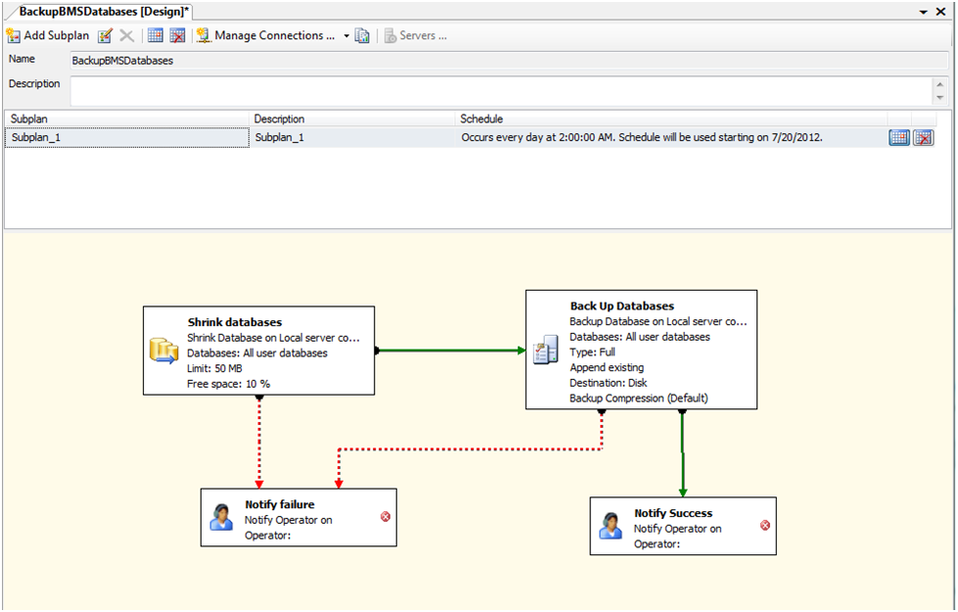

Figure 60: Backup Maintenance Plan

# External Relationships

External relationships can be referenced from External Interfaces in the next section.

# External Interfaces

VistA and NUMI are the external interfaces that are connected with the BMS system (see screenshot below):

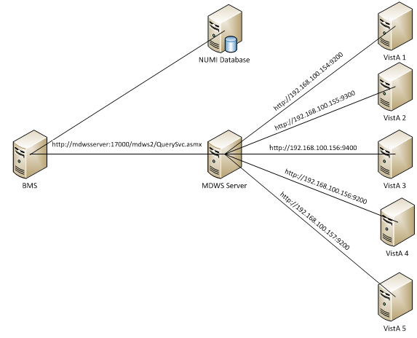

Figure 61:BMS External Interfaces

All the VISTA deployments will be connected through a Healthcare Integration Engine (MDWS version

1. to the BMS. MDWS v.2 is a suite of Service Oriented Architecture (SOA) middle-tier web services that exposes medical domain functionality, Medical Domain Objects (MDO).

In order to connect to MDWS v.2, BMS service configuration file (BMS.ServiceHost.exe.config) should be changed as follows, see *Table 4 - BMS ServiceHost Configuration Parameters* section:

* + A MDWS client service endpoint should be set: *http://mdwsserver:17000/mdws2/QuerySvc.asmx*
  + VistaIntegration.Enabled should be set to true: *VistaIntegration.Enabled=true*

The following configurations should be set in MDWS to be able to connect to VistA deployments:

* + Application protocol: http://192.168.100.156:9200
  + VistA DataSource connection string: <DataSource modality="HIS" protocol="VISTA" source="192.168.100.156" status="active" port="9200"/>

These configurations should be done for each VistA deployment.

A connection string to NUMI database needs to be set in service configuration file (BMS.ServiceHost.exe.config), see ***Table 4 - BMS ServiceHost Configuration Parameters*** section:

*<ConnectionString>Data Source=numiserver;Initial Catalog=NUMI;Integrated Security=True;</ConnectionString>.*

**NOTE**: All the configurations described above are using dummy servers and ports. Real deployment should use appropriate server, port and database connection strings.

# Software Security

BMS Security is implemented at two levels:

* The first level of security consists in deciding which users have access to what pages (National/Regional, VISN, facility, EMS page).
* The second level of security refers to the read/write permissions (which are the pages a user can edit/update).

Both levels of security are implemented by means of the Policy Manager application described in the next section.

An additional level of security is provided by the domain restrictions: users can access only the BMS pages within the domain where they have been granted access rights.

The security services are based on well-established standards and practices such as:

* LDAP protocol;
* WS-Security specification;
* X509 certificates.

These services are in charge of providing for the following ‘functionalities’:

* CIA:
  + Confidentiality – encrypted message.
  + Integrity – message hasn’t been tampered.
  + Authentication – prove identity.
* Authorization – role based access.
* Accountability – audit trail.
* Policies – mutually agreed by involved parties.

From the client application perspective, the security services are in charge of:

* Authentication:
  + SAML assertions verified by the called service.
* Role based authorization:
  + Roles stored in LDAP.
  + Policies defined using XACML language.
* Record level authorization.
* Audit trail.

The audit services provide the means to address the issues of liability management, asset protection and quality of service. To facilitate a timely response to policy violations, security incidents or infrastructure and application failures, InFlow will support monitoring, logging, analysing, and reporting on every level of its architecture.

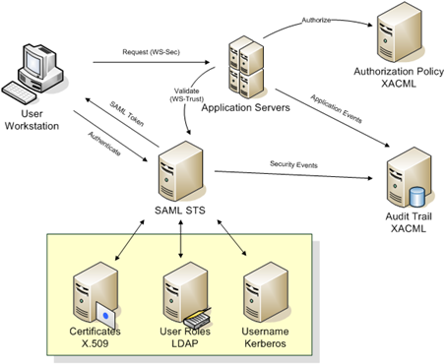

Figure 62 – Security services architecture

The security services consists of the authentication part: STS – security token service and authorization part: PAP – policy administration point and PDP – policy decision point.

## Policy Manager

From the Console folder of your BMS solution, select Policy Manager and then double-click the PolicyManager.exe file to display the following dialog window:

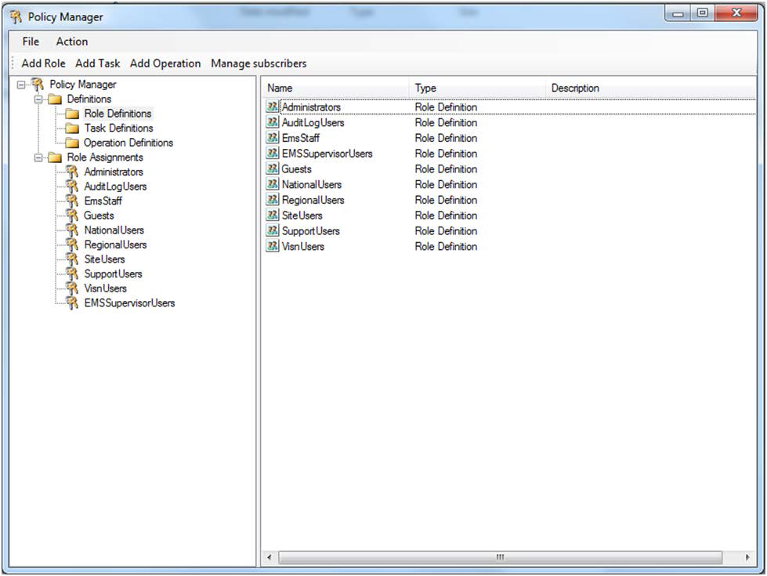

*Figure 62 - Policy Manager Main Window*

The Definitions folder in the left hand panel contains the definitions of the roles, tasks and operations valid within the BMS application.

The Role Definitions folder contains the list of user roles defined within BMS.

The Task Definitions folder contains the list of tasks that can be performed within BMS and their corresponding definitions. A task usually requires the completion of several operations.

The Operation Definitions folder contains the list of operations that can be performed within BMS and their corresponding definitions.

## Operation Definitions

To view the definition of an operation select Operation definitions from the left-hand panel of the main Policy Manager window and double-click the operation to display the following dialog window:

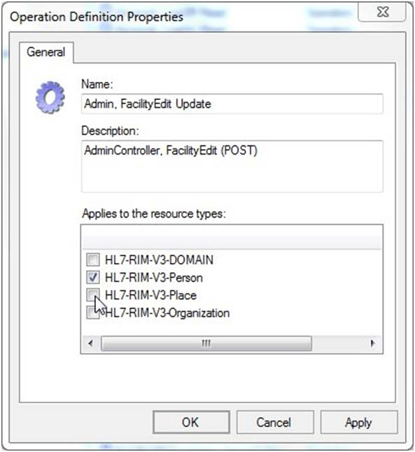

*Figure 63 - Operation Definition*

A list with all the operations of BMS application is presented below:

*Table 27 - BMS Operations*

|  |  |
| --- | --- |
| **Operation Name** | **Operation Description** |
| Admin, AddEditUser Read | 'Add/Edit BMS User' hyperlink from the Administration section's menu. |
| Admin, FacilityEdit Read | 'Edit BMS Site' hyperlink from the Administration section's menu. |
| Admin, Index Read | 'BMS Admin' hyperlink from the National And Regional Page. |

|  |  |
| --- | --- |
| **Operation Name** | **Operation Description** |
| Admin, SelectUser Read | 'Select Existing NT User Name' button from the ADMINISTRATION SECTION - USERADD/EDIT page. |
| Admin, SisterSiteAddEdit Read | 'Edit Sister Sites' hyperlink from the Administration section's menu. |
| Admin, AddUserOperations Read | 'Add User' button from the ADMINISTRATION SECTION  - FACILITY EDIT page (Edit BMS Site submenu). |
| Admin, RemoveUsers Read | 'Remove Selected' button from the ADMINISTRATION SECTION - FACILITY EDIT page (Edit BMS Site  submenu). |
| Admin, SearchUser Read | 'Find' button from the 'Select user' page ('Select Existing NT User Name' button from the Administration Section  menu, 'Add/Edit BMS User' submenu). |
| Admin, SearchUsers Read | 'Find' button from the ADMINISTRATION SECTION - FACILITY EDIT page (Edit BMS Site submenu). |
| Admin, ClearCache Read | 'Clear Cache' link from the Administration section's menu. |
| Admin, AddEditUser Update | 'Submit' button from the ADMINISTRATION SECTION - USERADD/EDIT page. |
| Admin, FacilityEdit Update | 'Submit' button from Administration section's menu 'Edit BMS Site' hyperlink (page ADMINISTRATION SECTION  - FACILITY EDIT). |
| Admin, SisterSiteAddEdit Update | 'Edit Sister Sites' hyperlink from the Administration section's menu, 'Submit' button. |
| Admin, AddUserOperations Update | 'Add' button from Add users page (Add User button from the Facility page). |
| Admin, RemoveUserOperations Update | 'Remove Selected' button from the ADMINISTRATION SECTION - FACILITY EDIT page (Edit BMS Site  submenu). |
| AdminComments, Delete Read | 'Delete' hyperlink from the Common Medical Terms page. |
| AdminComments, Edit Read | 'Edit' hyperlink from the Common Medical Terms page. |
| AdminComments, Index Read | 'Common Medical Terms' hyperlink from the Administration section's menu. |
| AdminComments, Index Update | 'Save' button from the Common Medical Terms page. |
| AdminIcon, Delete Read | 'Delete Icon' button on ADMINISTRATION SECTION - EDIT ICON page (Add/Edit Icon Submenu) |
| AdminIcon, Edit Read | 'Edit' Link on ADMINISTRATION SECTION - ICON  ADD/EDIT page (Add/Edit Icon Submenu) |
| AdminIcon, Index Read | 'Add/Edit Icon' link on ADMINISTRATION SECTION |
| AdminIcon, Search Read | 'Search' Link on ADMINISTRATION SECTION - ICON  ADD/EDIT page (Add/Edit Icon Submenu) |
| AdminIcon, ViewIconReport Read | ''Report' Link on ADMINISTRATION SECTION - ICON  ADD/EDIT page (Add/Edit Icon Submenu) |
| AdminIcon, Delete Update | 'Remove' button on ADMINISTRATION SECTION - DELETE ICON page (Add/Edit Icon Submenu) |
| AdminIcon, Edit Update | 'Save' button on ADMINISTRATION SECTION - EDIT  ICON page (Add/Edit Icon Submenu) |
| AdminIcon, Index Update | 'Up/Down arrow' buttons on ADMINISTRATION SECTION - ICON ADD/EDIT page (Add/Edit Icon  Submenu) |
| AdminSpecialtyAssociation, Delete Read | 'Delete' Link on ADMINISTRATION SECTION - Treating Specialty/NUMA/HAvBED Edit page (Treating  Specialty/NUMA/HAvBED Submenu) |
| AdminSpecialtyAssociation, Index Read | 'Treating Specialty/NUMA/HAvBED' Link on ADMINISTRATION SECTION |

|  |  |
| --- | --- |
| **Operation Name** | **Operation Description** |
| AdminSpecialtyAssociation, Delete Update | 'Delete' Button on ADMINISTRATION SECTION - Treating Specialty/NUMA/HAvBED Delete page  (Treating Specialty/NUMA/HAvBED Submenu) |
| AdminSpecialtyAssociation, Index Update | 'Save' Button on ADMINISTRATION SECTION - Treating Specialty/NUMA/HAvBED Edit page (Treating  Specialty/NUMA/HAvBED Submenu) |
| AdminUnavailableReason, Delete Read | 'Delete' link on ADMINISTRATION SECTION - National Unavailable Reason page (National Unavailable Reason  Submenu) |
| AdminUnavailableReason, Edit Read | 'Edit' link on ADMINISTRATION SECTION - National Unavailable Reason page (National Unavailable Reason  Submenu) |
| AdminUnavailableReason, Index Read | 'National Unavailable Reason' Link on ADMINISTRATION SECTION |
| AdminUnavailableReason, Delete Update | 'Delete Record' button on ADMINISTRATION SECTION  - National Unavailable Reason Delete page (National Unavailable Reason Submenu) |
| AdminUnavailableReason, Edit Update | 'Submit' button on ADMINISTRATION SECTION - National Unavailable Reason Edit page (National Unavailable Reason Submenu) |
| AdminUnavailableReason, Index Update | 'Add' button on ADMINISTRATION SECTION - National Unavailable Reason page (National Unavailable Reason Submenu) |
| AdminWaitingArea, Delete Read | 'Delete' link on ADMINISTRATION SECTION - National Waiting Areas Parameter page (National Waiting Area Submenu) |
| AdminWaitingArea, Edit Read | 'Edit' link on ADMINISTRATION SECTION - National Waiting Areas Parameter page (National Waiting Area Submenu) |
| AdminWaitingArea, Index Read | 'National Waiting Area' Link on ADMINISTRATION SECTION |
| AdminWaitingArea, DeleteAction Update | 'Delete Record' button on ADMINISTRATION SECTION  - National Waiting Area Parameter Delete page (National Waiting Area Submenu) |
| AdminWaitingArea, Edit Update | 'Submit' button on ADMINISTRATION SECTION - National Waiting Area Parameter Edit page (National Waiting Area Submenu) |
| AdminWaitingArea, Index Update | 'Add' button on ADMINISTRATION SECTION - National Waiting Area Parameter page (National Waiting Area  Submenu) |
| AdminWhiteboardReport, Delete Read | 'Delete' link on ADMINISTRATION SECTION - Whiteboard Report page (Background Processor  Submenu) |
| AdminWhiteboardReport, Edit Read | 'Edit' link on ADMINISTRATION SECTION - Whiteboard Report page (Background Processor Submenu) |
| AdminWhiteboardReport, Index Read | 'Whiteboard Report' tab on ADMINISTRATION SECTION - Background Processor page |
| AdminWhiteboardReport, Delete Update | 'Delete Record' button on ADMINISTRATION SECTION  - Whiteboard Report Delete page (Background Processor Submenu) |
| AdminWhiteboardReport, Edit Update | 'Save' button on ADMINISTRATION SECTION - Whiteboard Report Edit page (Background Processor Submenu) |
| AdtOrderableItems, Index Read | Site Options, ADT Orderable Items Add/Delete hyperlink |
| AdtOrderableItems, Delete Update | 'Delete' hyperlink from the list of orderable items. |
| AdtOrderableItems, Index Update | 'Add' button from the Bed Board ADT Orderable Items Configuration. |

|  |  |
| --- | --- |
| **Operation Name** | **Operation Description** |
| BackgroundProcessors, Index Read | 'Backgroung Processors' hyperlink from Site Options page. |
| BackgroundProcessors, Index Update | 'Save Scheduler' button from Background Processors page within Site Options. |
| AuditLogReport, Index Read | 'View audit log' link on ADMINISTRATION SECTION |
| rep, Audit Log Report | Access the Audit Log Report. |
| BedBoard, ChangeFacility Read | Click on a facility link from the VISN Network Bed Boards list. |
| BedBoard, Index Read | 'Return to VISN Network' hyperlink from the home page. |
| BedBoard, ShowFacilityBedSummaryReport Read | Click on a Facility Summary Report on VISN Network Bed Boards list |
| BedBoard, ShowVISNBedSummaryReport Read | Click on a VISN Summary Report on VISN Network Bed Boards list |
| BedBoardModule, Index Read | Site Options, Bed Board Module Enable/Disable link. |
| BedBoardModule, Index Update | 'Submit' button from the Bed Board Module Activation and Configuration page. |
| BedInformation, Index Read | Ward Occupancy, click on a hyperlink from the BED column. |
| BedInformation, ClearAll Read | Click on button 'Clear ALL Comments For ALL Wards Associate To This Bed…'. |
| BedInformation, NotifyChange Read | 'Submit' button from the Add/Edit Bed Unavailable Reason page. |
| BedInformation, Index Update | Click on buttons 'Submit' and/or 'Update Reason and Comments'. |
| ContingencySettings, Index Read | 'Contingency Settings" link on Site Settings pages. |
| ContingencySettings, Index Update | 'Save' button on Contingency Settings page on Site Settings pages. |
| DischargeClinic, Index Read | Site Options, 'Discharge Appt Clinics Add/Delete' hyperlink. |
| DischargeClinic, Delete Update | Site Options, 'Discharge Appt Clinics Add/Delete' hyperlink, 'Delete' button. |
| DischargeClinic, Index Update | Site Options, 'Discharge Appt Clinics Add/Delete' hyperlink, 'Add' button. |
| EmsBedStatusAdmin, EMS Supervisor Read/Update | 'Assigned To' drop down on EMS Bed Edit page |
| EmsBedStatusAdmin, EMSBatchAssign Read | 'Batch Assign' button on Ems Bed Status Admin page |
| EmsBedStatusAdmin, EMSBatchAssign Update | 'Submit' button on EMS Bed Edit page on EMS Bed Status Admin page |
| EmsBedStatusAdmin, Edit Read | RoomBed column link click. |
| EmsBedStatusAdmin, Index Read | 'Return to VISN Network' link from the home page, 'Return to Regional Page' link, 'Go To Facility Bed  Cleaning Page (EMS Staff Only) button. |
| EmsBedStatusAdmin, SaveConfirmation Read | 'Submit' button click in the Environmental Management Service Bed Status page. |
| EmsBedStatusAdmin, Edit Update | 'Submit' button click in the Environmental Management Service Bed Status page. |
| EMSMobile, EMSList Read | Load Bed Clean Requests on EMS Mobile Pages |
| EMSMobile, Users Read | Click on a User button on EMS Mobile Pages |
| EMSMobile, EMSList Update | Click on a Bed Clean Request button on EMS Mobile Pages |
| EMSMobile, Users Update | Click on Submit button after entering a PIN on EMS Mobile Pages |

|  |  |
| --- | --- |
| **Operation Name** | **Operation Description** |
| EmsNotification, AddEdit Read | 'Edit' link from the Current Locations table (EMS Bed Notification). |
| EmsNotification, AddEditAction Read | 'Submit' button from the EMS Bed Notification Edit page. |
| EmsNotification, Delete Read | 'Delete' link from the Current Locations table (EMS Bed Notification). |
| EmsNotification, Index Read | Site Options, 'EMS Notification Add/Edit' link |
| EmsNotification, DeleteAction Update | 'Delete Record' button from the EMS Bed Status Notification Delete page. |
| EmsNotification, Index Update | 'Submit' button from the EMS Bed Notification Edit page or Notifications Add page. |
| EmsStaff, Delete Read | 'Delete' link on EMS Staff page on Site Options pages |
| EmsStaff, Edit Read | 'Edit' link on EMS Staff page on Site Options pages |
| EmsStaff, Index Read | EMS Staff link on Site Options page |
| EmsStaff, Delete Update | 'Delete Record' button on Ems Staff Delete page on Site Options pages |
| EmsStaff, Edit Update | 'Submit' button on Ems Staff Edit page on Site Options pages |
| EventNotification, AddConfirmation Read | 'Submit' button from the Event Notification Add page. |
| EventNotification, AddEdit Read | 'Add' button or 'Edit' link from the Event Notifications page. |
| EventNotification, EditConfirmation Read | 'Submit' button from the Event Notifications Edit page. |
| EventNotification, Index Read | Site Options, 'Event Notification Add/Edit' hyperlink. |
| EventNotification, Index Update | 'Submit' button from the Event Notification Add page. |
| Exception, Index Read | Appears when an exception occurs. |
| FacilityDiversion, Add Read | 'Add' button from the Facility Diversion page. |
| FacilityDiversion, AddConfirmation Read | 'Add' button from the Add New Diversion Status page. |
| FacilityDiversion, Edit Read | 'Edit' link from the Facility Diversion page. |
| FacilityDiversion, EditConfirmation Read | 'Save' button from the Diversion Status edit page. |
| FacilityDiversion, FilterDiversions Read | 'Current Diversions' or 'All Diversions' button from the main Facility Diversions page. |
| FacilityDiversion, Index Read | 'Facility Diversion' hyperlink from the home page. |
| FacilityDiversion, Index Update | 'Add' button or 'Edit' link from the Facility Diversion page. |
| FacilitySettings, Index Read | Site Options, Facility Settings link |
| FacilitySettings, Index Update | Site Options, Facility Settings link, Submit button |
| Home, Index Read | Home page. |
| Home, Index2 Read | Current, Past 30-Days, Past 60-Days, Past 90-Days home page's buttons. |
| Home, PatientInquiry Read | Click on the patient link from the Patients Pending Placement list (Home page). |
| Home, RemoveAdmission Read | Remove link from the Patients Pending Placement list (Home page). |
| Home, UndoRemoveAdmission Read | Undo link from the Patients Pending Placement list (Home page). |

|  |  |
| --- | --- |
| **Operation Name** | **Operation Description** |
| Home, RemoveAdmissionPost Update | Remove link from the Patients Pending Placement list (Home page), Remove button from the confirmation  page. |
| Home, UndoRemoveAdmissionPost Update | 'Undo' button on Undo Remove Admission Page on Facility HomePage |
| IconLegend, Index Read | 'Icon Legend' link from the bottom of the Home page or Site Options, BMS Icon Legend link. |
| IconLibrary, Edit Read | 'Edit' Link on Site Options - Site Configurable Icons page. |
| IconLibrary, Index Read | Site Options, Site Configurable Icons link. |
| IconLibrary, ResetConfirmation Read | 'Reset' button on Edit Site Configurable Icon page. |
| IconLibrary, Edit Update | 'Save' button on Site Options - Site Configurable Icons page. |
| IconLibrary, Index Update | 'Up/Down arrow' buttons on Site Options - Site Configurable Icons page. |
| IconLibrary, ResetConfirmation Update | 'Reset' button on Reset Site Configurable Icon page. |
| Information, Index Read | 'Information' link from the bottom of the Home page. |
| MaintainMarquee, Index Read | 'Maintain Marquee Text' link from the Administration Section's menu. |
| MaintainMarquee, ChangeMarquee Update | 'Submit' button from the ADMINISTRATION SECTION - MAINTAIN MARQUEE TEXT page. |
| NationalAndRegional, Index Read | Home page, Return to VISN Network link, Return to Regional Page link. |
| NewEvents, Index Read | Home page, New Events link. |
| Numi, Add Read | 'Add' button on ADMINISTRATION SECTION -  Background Processors page (Background Processors Submenu). |
| Numi, Delete Read | 'Delete' Link on ADMINISTRATION SECTION -  Background Processors page (Background Processors Submenu). |
| Numi, Edit Read | 'Edit' Link on ADMINISTRATION SECTION -  Background Processors page (Background Processors Submenu). |
| Numi, Index Read | 'Numi' tab on ADMINISTRATION SECTION -  Background Processors page (Background Processors Submenu). |
| Numi, Delete Update | 'Delete Record' button on ADMINISTRATION SECTION  - Background Processors Delete page (Background Processors Submenu). |
| Numi, Edit Update | 'Save' button on ADMINISTRATION SECTION - Background Processors Add/Edit page (Background  Processors Submenu). |
| <http://tempuri.org/IAdministrativeFunctions/GetDomain> s | Functions used in the Administration Section, Add/Edit BMS User and Edit BMS Site submenus. |
| <http://tempuri.org/IAdministrativeFunctions/GetCurrent> Domain |
| <http://tempuri.org/IAdministrativeFunctions/GetRoles> |
| <http://tempuri.org/IAdministrativeFunctions/GetBulkPoli> cies |
| <http://tempuri.org/IAdministrativeFunctions/GrantPermi> ssion |
| <http://tempuri.org/IAdministrativeFunctions/RevokePer> mission |

|  |  |
| --- | --- |
| **Operation Name** | **Operation Description** |
| <http://tempuri.org/IAdministrativeFunctions/GetRoleBy> Name |  |
| <http://tempuri.org/IAdministrativeFunctions/GetPermiss> ionsByResourceType |
| <http://tempuri.org/IAdministrativeFunctions/GetAllUser> sAndDomain |
| <http://tempuri.org/IAdministrativeFunctions/GetAllUser> Roles |
| <http://tempuri.org/IAdministrativeFunctions/AssignUser> |
| <http://tempuri.org/IAdministrativeFunctions/DeassignU> ser |
| <http://tempuri.org/IAdministrativeFunctions/GetPolicy> |
| <http://tempuri.org/IAdministrativeFunctions/ClearPermi> ssionsForResource |
| <http://tempuri.org/IAdministrativeFunctions/AddActionE> ntityType |
| <http://tempuri.org/IAdministrativeFunctions/AddOperati> on |
| <http://tempuri.org/IAdministrativeFunctions/AddRole> |
| <http://tempuri.org/IAdministrativeFunctions/AddTask> |
| <http://tempuri.org/IAdministrativeFunctions/AssignOper> ations |
| <http://tempuri.org/IAdministrativeFunctions/AssignRole> |
| <http://tempuri.org/IAdministrativeFunctions/ChangeUse> rPassword |
| <http://tempuri.org/IAdministrativeFunctions/DeassignO> perations |
| <http://tempuri.org/IAdministrativeFunctions/DeassignR> ole |
| <http://tempuri.org/IAdministrativeFunctions/DeleteActio> nEntityType |
| <http://tempuri.org/IAdministrativeFunctions/DeleteOper> ation |
| <http://tempuri.org/IAdministrativeFunctions/DeletePerm> issionForResourceAndOperation |
| <http://tempuri.org/IAdministrativeFunctions/DeletePerm> issionsForResourcesAndOperations |
| <http://tempuri.org/IAdministrativeFunctions/DeleteRole> |
| <http://tempuri.org/IAdministrativeFunctions/DeleteTask> |
| <http://tempuri.org/IAdministrativeFunctions/GetActionE> ntityTypes |
| <http://tempuri.org/IAdministrativeFunctions/GetAvailabl> eDomains |
| <http://tempuri.org/IAdministrativeFunctions/GetCallerIs> SuperUser |
| <http://tempuri.org/IAdministrativeFunctions/GetConnec> tedRolesAndOperations |
| <http://tempuri.org/IAdministrativeFunctions/GetEntityTy> pes |
| <http://tempuri.org/IAdministrativeFunctions/GetOperati> onByName |
| <http://tempuri.org/IAdministrativeFunctions/GetOperati> onByNameExcludingId |

|  |  |
| --- | --- |
| **Operation Name** | **Operation Description** |
| <http://tempuri.org/IAdministrativeFunctions/GetOperati> ons |  |
| <http://tempuri.org/IAdministrativeFunctions/GetRoleBy> NameExcludingId |
| <http://tempuri.org/IAdministrativeFunctions/GetRoleDef> inition |
| <http://tempuri.org/IAdministrativeFunctions/GetRolesD> efinitionIntersect |
| <http://tempuri.org/IAdministrativeFunctions/GetRoleUs> ers |
| <http://tempuri.org/IAdministrativeFunctions/GetSubscri> ptions |
| <http://tempuri.org/IAdministrativeFunctions/GetTaskBy> Name |
| <http://tempuri.org/IAdministrativeFunctions/GetTaskBy> NameExcludingId |
| <http://tempuri.org/IAdministrativeFunctions/GetTaskDe> finition |
| <http://tempuri.org/IAdministrativeFunctions/GetTasks> |
| <http://tempuri.org/IAdministrativeFunctions/GetUserBy> Sid |
| <http://tempuri.org/IAdministrativeFunctions/GetUserBy> UserName |
| <http://tempuri.org/IAdministrativeFunctions/GetUserDef> inedRoles |
| <http://tempuri.org/IAdministrativeFunctions/GetUserGr> oupId |
| <http://tempuri.org/IAdministrativeFunctions/GetUserRol> es |
| <http://tempuri.org/IAdministrativeFunctions/InsertPermi> ssionForResourceAndOperation |
| <http://tempuri.org/IAdministrativeFunctions/InsertPermi> ssionsForResourcesAndOperations |
| <http://tempuri.org/IAdministrativeFunctions/InsertReso> urce |
| <http://tempuri.org/IAdministrativeFunctions/IsChild> |
| <http://tempuri.org/IAdministrativeFunctions/RefreshCac> he |
| <http://tempuri.org/IAdministrativeFunctions/SearchUser> s |
| <http://tempuri.org/IAdministrativeFunctions/SetCurrent> Domain |
| <http://tempuri.org/IAdministrativeFunctions/Syncronize> AllSubscribers |
| <http://tempuri.org/IAdministrativeFunctions/UpdateOpe> ration |
| <http://tempuri.org/IAdministrativeFunctions/UpdateRole> |
| <http://tempuri.org/IAdministrativeFunctions/UpdateTas> k |
| Patient, Admission Read | 'Edit' link from the Home page, Patients Pending Placement list. |
| Patient, Select Read | 'Add New Patient' link from the Home page, Patients Pending Placement section. |
| Patient, Admission Update | 'Submit' button from ADD/EDIT Patients Pending Placement page. |

|  |  |
| --- | --- |
| **Operation Name** | **Operation Description** |
| rep, Active Admission Orders Report | Access the Active Admission Orders Report. |
| rep, Active Discharge Orders Report | Access the Active Discharge Orders Report. |
| rep, Active Transfer Orders Report | Access the Active Transfer Orders Report. |
| rep, Antic Discharge Orders Report | Access the Antic Discharge Orders Report. |
| rep, BED AVAILABILITY STATUS REPORT | Access the BED AVAILABILITY STATUS REPORT. |
| rep, Bed Specialty Report | Access the Bed Specialty Report. |
| rep, Bed Specialty Roster | Access the Bed Specialty Roster. |
| rep, Bed Summary Report | Access the Bed Summary Report. |
| rep, Bed Turnaround Time Report | Access the Bed Turnaround Time Report. |
| rep, Beds Out of Service Report (All) | Access the Beds Out of Service Report (All). |
| rep, Beds Out of Service Report (By Date) | Access the Beds Out of Service Report (By Date). |
| rep, Discharges In Progress | Access the Discharges In Progress. |
| rep, Emergency Management Evacuation Report | Access Emergency Management Evacuation Report |
| rep, Icon Usage Report | Access the Icon Usage Report |
| rep, Patient Inquiry | Access the Patient Inquiry report. |
| rep, Patient Movement Report | Access the Patient Movement Report. |
| rep, Patient Movements by Date | Access the Patient Movements by Date. |
| rep, Patients w Discharge Appointments | Access the Patients w Discharge Appointments. |
| rep, Scheduled Admissions by Date | Access the Scheduled Admissions by Date. |
| rep, Scheduled Admissions Report | Access the Scheduled Admissions Report. |
| rep, VISN Bed Summary Report | Access VISN Bed Summary Report |
| rep, VISN Network Active Report | Access the VISN Network Active Report. |
| rep, VISN Network Audit Report | Access the VISN Network Audit Report. |
| rep, VISN Network Contract Report | Access the VISN Network Contract Report. |
| rep, VISN Network Disposition Report | Access the VISN Network Disposition Report. |
| rep, Wait List Status Report | Access the Patients Pending Placement Status Report. |
| Reports, Index Read | 'Submit' buttons from the Home page corresponding to the reports. |
| SiteOptions, Index Read | Home page, Site Options link. |
| SiteOptions, EvacuationConfirmation Read | Access to Evacuation Confirmation page. |
| SiteOptions, Index Update | 'Submit' button from Site Options page. |
| SiteOptions, EvacuationConfirmation Update | 'Save' button from Evacuation Confirmation page. |
| Transfer, AddTransfer Read | VISN page, Add New Patient button, Submit button from the Select Patient page. |
| Transfer, EditTransfer Read | 'Edit' link from the VISN page, Patients in Community |

|  |  |
| --- | --- |
| **Operation Name** | **Operation Description** |
|  | Hospitals list. |
| Transfer, FinalizeTransfer Read | 'Finalize' link from the VISN page, Patients in Community Hospitals list. |
| Transfer, Index Read | VISN page, Add New Patient button. |
| Transfer, AddTransfer Update | VISN page, Add New Patient button, Submit button from the Select Patient page, and Submit button from the Enter Patient Data page. |
| Transfer, EditTransfer Update | 'Edit' link from the VISN page's Patients in Community Hospitals list and then Submit button. |
| Transfer, FinalizeTransfer Update | 'Finalize' link from the VISN page's Patients in Community Hospitals list and then Submit button from the Finalize Patient Data page. |
| UnavailableReason, Delete Read | 'Delete' link from the Bed Board Site Unavailable Reason page's list. |
| UnavailableReason, Edit Read | 'Edit' link from the Bed Board Site Unavailable Reason page's list. |
| UnavailableReason, Index Read | Site Options, Unavailable Reason Add/Edit link. |
| UnavailableReason, Delete Update | 'Delete' link from the Bed Board Site Unavailable Reason page's list and then 'Delete Record' button. |
| UnavailableReason, Edit Update | 'Edit' link from the Bed Board Site Unavailable Reason page's list and then Submit button. |
| UnavailableReason, Index Update | 'Add' button from the Bed Board Site Unavailable Reason page. |
| UserConfiguration, Index Read | Site Options, Add/Edit BMS User link. |
| UserConfiguration, SearchUser Read | 'Find and Save' buttons from the 'Select user' page ('Select Existing NT User Name' button from the Site  Options, 'Add/Edit BMS User' link ). |
| UserConfiguration, SelectUser Read | 'Select Existing NT User Name' button from the Site Options - Add/Edit BMS User page. |
| UserConfiguration, Index Update | 'Submit' button from the Site Options - Add/Edit BMS User page. |
| VistaIntegration, Audit Read | 'Audit' tab on ADMINISTRATION SECTION -  Background Processors page (Background Processors Submenu) and 'Filter By' button from the 'Audit' tab. |
| VistaIntegration, Categories Read | 'VistA Integration' tab on ADMINISTRATION SECTION - Background Processors page (Background Processors Submenu). |
| VistaIntegration, DeleteScheduler Read | 'Add new scheduler' link and select a scheduled name from the 'Scheduled' tab. |
| VistaIntegration, Index Read | 'Background Processors' link on ADMINISTRATION SECTION. |
| VistaIntegration, Schedulers Read | 'Schedulers' tab on ADMINISTRATION SECTION - Background Processors page (Background Processors  Submenu). |
| VistaIntegration, TestMDWSConnection Read | 'TestMDWSConnection' button from the 'VistA Sites' tab. |
| VistaIntegration, TestODBCConnection Read | 'TestODBCConnection' button from the 'VistA Sites' tab. |
| VistaIntegration, VistASites Read | 'VistA Sites' tab on ADMINISTRATION SECTION - Background Processors page (Background Processors  Submenu). |
| VistaIntegration, Categories Update | 'Save and Run' buttons from the 'VistA Integration' tab. |
| VistaIntegration, DeleteScheduler Update | 'Delete' link from the 'Scheduled' tab and then 'Delete Record' button. |

|  |  |
| --- | --- |
| **Operation Name** | **Operation Description** |
| VistaIntegration, Schedulers Update | 'Save' button from the 'Scheduled' tab. |
| VistaIntegration, VistASites Update | 'Save' button from the 'VistA Sites' tab. |
| WaitingArea, Delete Read | 'Delete' link from the Patient Waiting Areas page's list of Current Waiting Areas. |
| WaitingArea, Edit Read | 'Edit' link from the Patient Waiting Areas page's list of Current Waiting Areas. |
| WaitingArea, Index Read | Site Options, Waiting Area Add/Delete link. |
| WaitingArea, DeleteAction Update | 'Delete' link from the Patient Waiting Areas page's list of Current Waiting Areas and then 'Delete Record button. |
| WaitingArea, Edit Update | 'Edit' link from the Patient Waiting Areas page's list of Current Waiting Areas and then Submit button. |
| WaitingArea, Index Update | 'Add' button from the Patient Waiting Areas page. |
| WardConfiguration, Delete Read | 'Delete' link from the Bed Board Ward Configuration, Current Vista Wards list. |
| WardConfiguration, Index Read | Site Options, Vista Ward Add/Edit link. |
| WardConfiguration, Index Update | Site Options, Vista Ward Add/Edit link, Save button. |
| WardConfiguration, DeleteWard Update | Site Options, Vista Ward Add/Edit link, Delete operation. |
| WardOccupancy, Index Read | 'Submit' button from the Home page corresponding to the Ward Occupancy. |
| WardWhiteboard, Edit Read | Click on a link from the BED column from WARD Whiteboard Report. |
| WardWhiteboard, EditPT Read | Click on a link from the PT column from the WARD Whiteboard Report. |
| WardWhiteboard, Index Read | Home page, 'Ward Whiteboard' link. |
| WardWhiteboard, NotifyChange Read | Click on a link from the BED column from WARD Whiteboard Report and then on the Submit button. |
| WhiteboardStaff, Index Read | Click on the checkbox from the STAFF column from the WARD Whiteboard Home. |
| WardWhiteboard, ShowReport Read | 'Export Report' link from the right of the WARD Whiteboard Home page or WARD Whiteboard Report page, Export Report. |
| WardWhiteboard, Submit Read | 'Submit' button from the WARD Whiteboard Home page. |
| WardWhiteBoard, WardWhiteBoard Read | Home page, 'Ward Whiteboard' link, Submit button from the WARD Whiteboard Home. |
| WardWhiteboard, ClearAll Read | Click on a link from the BED column from WARD Whiteboard Report and then click on the button 'Clear ALL Comments For ALL Wards Associate To This  Bed…'. |
| WardWhiteBoard, WardWhiteBoard Update | Click on a staff name from the STAFF column from the WARD WhiteBoard Report and then click on the image  'Save Staff'. |
| WhiteboardStaff, Index Update | Click on the checkbox from the STAFF column from WARD Whiteboard Report and then on the 'Save' button. |
| WardWhiteboard, Edit Update | Click on a link from the BED column from WARD Whiteboard Report and then on the Submit button. |

## Task Definitions

To view the definition of a task, select Task definitions from the left-hand panel of the main Policy Manager window and in the list in the right-hand area, double-click the task to display the following dialog window.

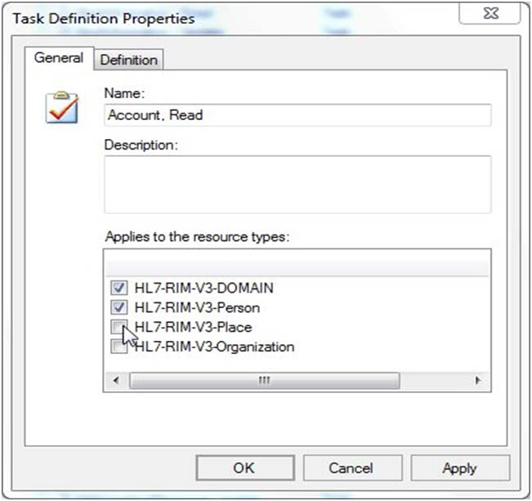

*Figure 64 - Task Definition*

To determine what resource type the task refers to, select one or more of the elements in the “*Applies to resource types”* area.

To view the operations that need to be performed in order to complete the task, select the Definition tab to display it as in the following image:

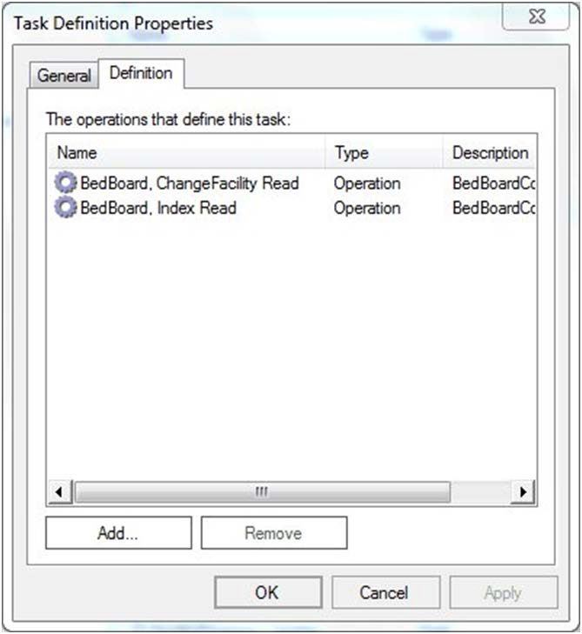

*Figure 65 - Operations Defining a Task*

Use the Add and Remove buttons to add or remove operations from the list.

A list with all the tasks, along with corresponding operations of the BMS application, is presented below:

*Table 28 - BMS Tasks*

|  |  |  |
| --- | --- | --- |
| **Task Name** | **Task Description** | **Operation Name** |
| Admin, Read | Admin Read permission, user has the right only to view data. | Admin, AddEditUser Read |
| Admin, FacilityEdit Read |
| Admin, Index Read |
| Admin, SelectUser Read |
| Admin, SisterSiteAddEdit Read |
| Admin, AddUserOperations Read |
| Admin, RemoveUsers Read |
| Admin, SearchUser Read |
| Admin, SearchUsers Read |
| Admin, ClearCache Read |
| Admin, Update | Admin Update permission, user has the right to modify data. | Admin, AddEditUser Update |
| Admin, FacilityEdit Update |
| Admin, SisterSiteAddEdit Update |
| Admin, AddUserOperations Update |
| Admin, RemoveUserOperations Update |
| AdminComments, Read | AdminComments Read Read permission, user has the right only to view data. | AdminComments, Delete Read |
| AdminComments, Edit Read |
| AdminComments, Index Read |
| AdminComments, Update | AdminComments Update permission, user has the right to modify data. | AdminComments, Index Update |
| AdminIcon, Read | AdminIcon Read permission, user has the right only to view data. | AdminIcon, Delete Read |
| AdminIcon, Edit Read |
| AdminIcon, Index Read |
| AdminIcon, Search Read |
| AdminIcon, ViewIconReport Read |
| AdminIcon, Update | AdminIcon Update permission, user has the right to modify data. | AdminIcon, Delete Update |
| AdminIcon, Edit Update |

|  |  |  |
| --- | --- | --- |
| **Task Name** | **Task Description** | **Operation Name** |
|  |  | AdminIcon, Index Update |
| AdminSpecialtyAssociation, Read | AdminSpecialtyAssociation Read permission, user has the right only to view data. | AdminSpecialtyAssociation, Delete Read |
| AdminSpecialtyAssociation, Index Read |
| AdminSpecialtyAssociation, Update | AdminSpecialtyAssociation Update permission, user has the right to modify data. | AdminSpecialtyAssociation, Delete Update |
| AdminSpecialtyAssociation, Index Update |
| AdminUnavailableReason, Read | AdminUnavailableReason Read permission, user has the right only to view data. | AdminUnavailableReason, Delete Read |
| AdminUnavailableReason, Edit Read |
| AdminUnavailableReason, Index Read |
| AdminUnavailableReason, Update | AdminUnavailableReason Update permission, user has the right to modify data. | AdminUnavailableReason, Delete Update |
| AdminUnavailableReason, Edit Update |
| AdminUnavailableReason, Index Update |
| AdminWaitingArea, Read | AdminWaitingArea Read permission, user has the right only to view data. | AdminWaitingArea, Delete Read |
| AdminWaitingArea, Edit Read |
| AdminWaitingArea, Index Read |
| AdminWaitingArea, Update | AdminWaitingArea Update permission, user has the right to modify data. | AdminWaitingArea, DeleteAction Update |
| AdminWaitingArea, Edit Update |
| AdminWaitingArea, Index Update |
| AdminWhiteboardReport, Read | AdminWhiteboardReport Read permission, user has the right only to view data. | AdminWhiteboardReport, Delete Read |
| AdminWhiteboardReport, Edit Read |
| AdminWhiteboardReport, Index Read |
| AdminWhiteboardReport, Update | AdminWhiteboardReport Update permission, user has the right to modify data. | AdminWhiteboardReport, Delete Update |
| AdminWhiteboardReport, Edit Update |
| AdtOrderableItems, Read | AdtOrderableItems Read permission, user has the right only to view data. | AdtOrderableItems, Index Read |
| AdtOrderableItems, Update | AdtOrderableItems Update permission, user has the right to modify data. | AdtOrderableItems, Delete Update |
| AdtOrderableItems, Index Update |
| BackgroundProcessors, Read | BackgroundProcessors Read permission, user has the right only to view data. | BackgroundProcessors, Index Read |
| BackgroundProcessors, Update | BackgroundProcessors Update permission, user has the right to modify data. | BackgroundProcessors, Index Update |
| AuditLogReport, Read | AuditLogReport Read permission, user has the right | AuditLogReport, Index Read |

|  |  |  |
| --- | --- | --- |
| **Task Name** | **Task Description** | **Operation Name** |
|  | only to view data. | rep, Audit Log Report |
| BedBoard, Read | BedBoard Read permission, user has the right only to view data. | BedBoard, ChangeFacility Read |
| BedBoard, Index Read |
| BedBoard, ShowFacilityBedSummaryReport Read |
| BedBoard, ShowVISNBedSummaryReport Read |
| BedBoardModule, Read | BedBoardModule Read permission, user has the right only to view data. | BedBoardModule, Index Read |
| BedBoardModule, Update | BedBoardModule Update permission, user has the right to modify data. | BedBoardModule, Index Update |
| BedInformation, Read | BedInformation Read permission, user has the right only to view data. | BedInformation, Index Read |
| BedInformation, ClearAll Read |
| BedInformation, NotifyChange Read |
| BedInformation, Update | BedInformation Update permission, user has the right to modify data. | BedInformation, Index Update |
| ContingencySettings, Read | ContingencySettings Read permission, user has the right only to view data. | ContingencySettings, Index Read |
| ContingencySettings, Update | ContingencySettings Update permission, user has the right to modify data. | ContingencySettings, Index Update |
| DischargeClinic, Read | DischargeClinic Read permission, user has the right only to view data. | DischargeClinic, Index Read |
| DischargeClinic, Update | DischargeClinic Update permission, user has the right to modify data. | DischargeClinic, Delete Update |
| DischargeClinic, Index Update |
| EmsBedStatusAdmin, EMS Supervisor | EmsBedStatusAdmin EMS Supervisor permission, user has the right to re-assign the bed cleaning to another person and to batch assign the cleaning to a person. | EmsBedStatusAdmin, EMS Supervisor Read/Update |
| EmsBedStatusAdmin, EMSBatchAssign Read |
| EmsBedStatusAdmin, EMSBatchAssign Update |
| EmsBedStatusAdmin, Read | EmsBedStatusAdmin Read permission, user has the right only to view data. | EmsBedStatusAdmin, Edit Read |
| EmsBedStatusAdmin, Index Read |
| EmsBedStatusAdmin, SaveConfirmation Read |
| EmsBedStatusAdmin, Update | EmsBedStatusAdmin Update permission, user has the right to modify data. | EmsBedStatusAdmin, Edit Update |
| EMSMobile, Read | EMSMobile Read permission, user has the right only to | EMSMobile, EMSList Read |

|  |  |  |
| --- | --- | --- |
| **Task Name** | **Task Description** | **Operation Name** |
|  | view data. | EMSMobile, Users Read |
| EMSMobile, Update | EMSMobile Update permission, user has the right to modify data. | EMSMobile, EMSList Update |
| EMSMobile, Users Update |
| EmsNotification, Read | EmsNotification Read permission, user has the right only to view data. | EmsNotification, AddEdit Read |
| EmsNotification, AddEditAction Read |
| EmsNotification, Delete Read |
| EmsNotification, Index Read |
| EmsNotification, Update | EmsNotification Update permission, user has the right to modify data. | EmsNotification, DeleteAction Update |
| EmsNotification, Index Update |
| EmsStaff, Read | EmsStaff Read permission, user has the right only to view data. | EmsStaff, Delete Read |
| EmsStaff, Edit Read |
| EmsStaff, Index Read |
| EmsStaff, Update | EmsStaff Update permission, user has the right to modify data. | EmsStaff, Delete Update |
| EmsStaff, Edit Update |
| EventNotification, Read | EventNotification Read permission, user has the right only to view data. | EventNotification, AddConfirmation Read |
| EventNotification, AddEdit Read |
| EventNotification, EditConfirmation Read |
| EventNotification, Index Read |
| EventNotification, Update | EventNotification Update permission, user has the right to modify data. | EventNotification, Index Update |
| Exception, Read | Exception Read permission, user has the right only to view data. | Exception, Index Read |
| FacilityDiversion, Read | FacilityDiversion Read permission, user has the right only to view data. | FacilityDiversion, Add Read |
| FacilityDiversion, AddConfirmation Read |
| FacilityDiversion, Edit Read |
| FacilityDiversion, EditConfirmation Read |
| FacilityDiversion, FilterDiversions Read |
| FacilityDiversion, Index Read |
| FacilityDiversion, Update | FacilityDiversion Update permission, user has the right to modify data. | FacilityDiversion, Index Update |

|  |  |  |
| --- | --- | --- |
| **Task Name** | **Task Description** | **Operation Name** |
| FacilitySettings, Read | FacilitySettings Read permission, user has the right only to view data. | FacilitySettings, Index Read |
| FacilitySettings, Update | FacilitySettings Update permission, user has the right to modify data. | FacilitySettings, Index Update |
| Home, Read | Home Read permission, user has the right only to view data. | Home, Index Read |
| Home, Index2 Read |
| Home, PatientInquiry Read |
| Home, RemoveAdmission Read |
| Home, UndoRemoveAdmission Read |
| Home, Update | Home Update permission, user has the right to modify data. | Home, RemoveAdmissionPost Update |
| Home, UndoRemoveAdmissionPost Update |
| IconLegend, Read | IconLegend Read permission, user has the right only to view data. | IconLegend, Index Read |
| IconLibrary, Read | IconLibrary Read permission, user has the right only to view data. | IconLibrary, Edit Read |
| IconLibrary, Index Read |
| IconLibrary, ResetConfirmation Read |
| IconLibrary, Update | IconLibrary Update permission, user has the right to modify data. | IconLibrary, Edit Update |
| IconLibrary, Index Update |
| IconLibrary, ResetConfirmation Update |
| Information, Read | Information Read permission, user has the right only to view data. | Information, Index Read |
| MaintainMarquee, Read | MaintainMarquee Read permission, user has the right only to view data. | MaintainMarquee, Index Read |
| MaintainMarquee, Update | MaintainMarquee Update permission, user has the right to modify data. | MaintainMarquee, ChangeMarquee Update |
| NationalAndRegional, Read | NationalAndRegional Read permission, user has the right only to view data. | NationalAndRegional, Index Read |
| NewEvents, Read | NewEvents Read permission, user has the right only to view data. | NewEvents, Index Read |
| Numi, Read | NUMI Read permission, user has the right only to view data. | Numi, Add Read |
| Numi, Delete Read |

|  |  |  |
| --- | --- | --- |
| **Task Name** | **Task Description** | **Operation Name** |
|  |  | Numi, Edit Read |
| Numi, Index Read |
| Numi, Update | NUMI Update permission, user has the right to modify data. | Numi, Delete Update |
| Numi, Edit Update |
| PAP, User | PAP permission, the right to access methods exposed by PAP service. | <http://tempuri.org/IAdministrativeFunctions/GetDomains> |
| <http://tempuri.org/IAdministrativeFunctions/GetCurrentD> omain |
| <http://tempuri.org/IAdministrativeFunctions/GetRoles> |
| <http://tempuri.org/IAdministrativeFunctions/GetBulkPolic> ies |
| <http://tempuri.org/IAdministrativeFunctions/GrantPermis> sion |
| <http://tempuri.org/IAdministrativeFunctions/RevokePerm> ission |
| <http://tempuri.org/IAdministrativeFunctions/GetRoleByN> ame |
| <http://tempuri.org/IAdministrativeFunctions/GetPermissi> onsByResourceType |
| <http://tempuri.org/IAdministrativeFunctions/GetAllUsers> AndDomain |
| <http://tempuri.org/IAdministrativeFunctions/GetAllUserR> oles |
| <http://tempuri.org/IAdministrativeFunctions/AssignUser> |
| <http://tempuri.org/IAdministrativeFunctions/DeassignUs> er |
| <http://tempuri.org/IAdministrativeFunctions/GetPolicy> |
| <http://tempuri.org/IAdministrativeFunctions/ClearPermis> sionsForResource |
| <http://tempuri.org/IAdministrativeFunctions/AddActionEn> tityType |
| <http://tempuri.org/IAdministrativeFunctions/AddOperatio> n |
| <http://tempuri.org/IAdministrativeFunctions/AddRole> |
| <http://tempuri.org/IAdministrativeFunctions/AddTask> |
| <http://tempuri.org/IAdministrativeFunctions/AssignOpera> tions |
| <http://tempuri.org/IAdministrativeFunctions/AssignRole> |
| <http://tempuri.org/IAdministrativeFunctions/ChangeUser> |

|  |  |  |
| --- | --- | --- |
| **Task Name** | **Task Description** | **Operation Name** |
|  |  | Password |
| <http://tempuri.org/IAdministrativeFunctions/DeassignOp> erations |
| <http://tempuri.org/IAdministrativeFunctions/DeassignRol> e |
| <http://tempuri.org/IAdministrativeFunctions/DeleteAction> EntityType |
| <http://tempuri.org/IAdministrativeFunctions/DeleteOpera> tion |
| <http://tempuri.org/IAdministrativeFunctions/DeletePermi> ssionForResourceAndOperation |
| <http://tempuri.org/IAdministrativeFunctions/DeletePermi> ssionsForResourcesAndOperations |
| <http://tempuri.org/IAdministrativeFunctions/DeleteRole> |
| <http://tempuri.org/IAdministrativeFunctions/DeleteTask> |
| <http://tempuri.org/IAdministrativeFunctions/GetActionEn> tityTypes |
| <http://tempuri.org/IAdministrativeFunctions/GetAvailable> Domains |
| <http://tempuri.org/IAdministrativeFunctions/GetCallerIsS> uperUser |
| <http://tempuri.org/IAdministrativeFunctions/GetConnect> edRolesAndOperations |
| <http://tempuri.org/IAdministrativeFunctions/GetEntityTyp> es |
| <http://tempuri.org/IAdministrativeFunctions/GetOperatio> nByName |
| <http://tempuri.org/IAdministrativeFunctions/GetOperatio> nByNameExcludingId |
| <http://tempuri.org/IAdministrativeFunctions/GetOperatio> ns |
| <http://tempuri.org/IAdministrativeFunctions/GetRoleByN> ameExcludingId |
| <http://tempuri.org/IAdministrativeFunctions/GetRoleDefi> nition |
| <http://tempuri.org/IAdministrativeFunctions/GetRolesDef> initionIntersect |
| <http://tempuri.org/IAdministrativeFunctions/GetRoleUser> s |
| <http://tempuri.org/IAdministrativeFunctions/GetSubscript> ions |

|  |  |  |
| --- | --- | --- |
| **Task Name** | **Task Description** | **Operation Name** |
|  |  | <http://tempuri.org/IAdministrativeFunctions/GetTaskByN> ame |
| <http://tempuri.org/IAdministrativeFunctions/GetTaskByN> ameExcludingId |
| <http://tempuri.org/IAdministrativeFunctions/GetTaskDefi> nition |
| <http://tempuri.org/IAdministrativeFunctions/GetTasks> |
| <http://tempuri.org/IAdministrativeFunctions/GetUserBySi> d |
| <http://tempuri.org/IAdministrativeFunctions/GetUserByU> serName |
| <http://tempuri.org/IAdministrativeFunctions/GetUserDefi> nedRoles |
| <http://tempuri.org/IAdministrativeFunctions/GetUserGro> upId |
| <http://tempuri.org/IAdministrativeFunctions/GetUserRole> s |
| <http://tempuri.org/IAdministrativeFunctions/InsertPermis> sionForResourceAndOperation |
| <http://tempuri.org/IAdministrativeFunctions/InsertPermis> sionsForResourcesAndOperations |
| <http://tempuri.org/IAdministrativeFunctions/InsertResour> ce |
| <http://tempuri.org/IAdministrativeFunctions/IsChild> |
| <http://tempuri.org/IAdministrativeFunctions/RefreshCac> he |
| <http://tempuri.org/IAdministrativeFunctions/SearchUsers> |
| <http://tempuri.org/IAdministrativeFunctions/SetCurrentD> omain |
| <http://tempuri.org/IAdministrativeFunctions/SyncronizeA> llSubscribers |
| <http://tempuri.org/IAdministrativeFunctions/UpdateOper> ation |
| <http://tempuri.org/IAdministrativeFunctions/UpdateRole> |
| <http://tempuri.org/IAdministrativeFunctions/UpdateTask> |
| Patient, Read | Patient Read permission, user has the right only to view data. | Patient, Admission Read |
| Patient, Select Read |
| Patient, Update | Patient Update permission, user has the right to modify data. | Patient, Admission Update |
| Reporting Services, Fetch | Reporting Services Fetch permission, the right to bring | rep, Active Admission Orders Report |

|  |  |  |
| --- | --- | --- |
| **Task Name** | **Task Description** | **Operation Name** |
|  | the list of reports from Reporting Services. | rep, Active Discharge Orders Report |
| rep, Active Transfer Orders Report |
| rep, Antic Discharge Orders Report |
| rep, BED AVAILABILITY STATUS REPORT |
| rep, Bed Specialty Report |
| rep, Bed Specialty Roster |
| rep, Bed Summary Report |
| rep, Bed Turnaround Time Report |
| rep, Beds Out of Service Report (All) |
| rep, Beds Out of Service Report (By Date) |
| rep, Discharges In Progress |
| rep, Emergency Management Evacuation Report |
| rep, Icon Usage Report |
| rep, Patient Inquiry |
| rep, Patient Movement Report |
| rep, Patient Movements by Date |
| rep, Patients w Discharge Appointments |
| rep, Scheduled Admissions by Date |
| rep, Scheduled Admissions Report |
| rep, VISN Bed Summary Report |
| rep, VISN Network Active Report |
| rep, VISN Network Audit Report |
| rep, VISN Network Contract Report |
| rep, VISN Network Disposition Report |
| rep, Wait List Status Report |
| Reports, Read | Reports permission, user has the right only to view data. | Reports, Index Read |
| SiteOptions, Read | SiteOptions permission, user has the right only to view data. | SiteOptions, Index Read |
| SiteOptions, EvacuationConfirmation Read |
| SiteOptions, Update | SiteOptions Update permission, user has the right to | SiteOptions, Index Update |

|  |  |  |
| --- | --- | --- |
| **Task Name** | **Task Description** | **Operation Name** |
|  | modify data. | SiteOptions, EvacuationConfirmation Update |
| Transfer, Read | Transfer permission, user has the right only to view data. | Transfer, AddTransfer Read |
| Transfer, EditTransfer Read |
| Transfer, FinalizeTransfer Read |
| Transfer, Index Read |
| Transfer, Update | Transfer Update permission, user has the right to modify data. | Transfer, AddTransfer Update |
| Transfer, EditTransfer Update |
| Transfer, FinalizeTransfer Update |
| UnavailableReason, Read | UnavailableReason Read permission, user has the right only to view data. | UnavailableReason, Delete Read |
| UnavailableReason, Edit Read |
| UnavailableReason, Index Read |
| UnavailableReason, Update | UnavailableReason Update permission, user has the right to modify data. | UnavailableReason, Delete Update |
| UnavailableReason, Edit Update |
| UnavailableReason, Index Update |
| UserConfiguration, Read | UserConfiguration permission, user has the right only to view data. | UserConfiguration, Index Read |
| UserConfiguration, SearchUser Read |
| UserConfiguration, SelectUser Read |
| UserConfiguration, Update | UserConfiguration Update permission, user has the right to modify data. | UserConfiguration, Index Update |
| VistaIntegration, Read | VistaIntegration permission, user has the right only to view data. | VistaIntegration, Audit Read |
| VistaIntegration, Categories Read |
| VistaIntegration, DeleteScheduler Read |
| VistaIntegration, Index Read |
| VistaIntegration, Schedulers Read |
| VistaIntegration, TestMDWSConnection Read |
| VistaIntegration, TestODBCConnection Read |
| VistaIntegration, VistASites Read |
| VistaIntegration, Update | VistaIntegration Update permission, user has the right to modify data. | VistaIntegration, Categories Update |
| VistaIntegration, DeleteScheduler Update |
| VistaIntegration, Schedulers Update |

|  |  |  |
| --- | --- | --- |
| **Task Name** | **Task Description** | **Operation Name** |
|  |  | VistaIntegration, VistASites Update |
| WaitingArea, Read | WaitingArea permission, user has the right only to view data. | WaitingArea, Delete Read |
| WaitingArea, Edit Read |
| WaitingArea, Index Read |
| WaitingArea, Update | WaitingArea Update permission, user has the right to modify data. | WaitingArea, DeleteAction Update |
| WaitingArea, Edit Update |
| WaitingArea, Index Update |
| WardConfiguration, Read | WardConfiguration permission, user has the right only to view data. | WardConfiguration, Delete Read |
| WardConfiguration, Index Read |
| WardConfiguration, Update | WardConfiguration Update permission, user has the right to modify data. | WardConfiguration, Index Update |
| WardConfiguration, DeleteWard Update |
| WardOccupancy, Read | WardOccupancy permission, user has the right only to view data. | WardOccupancy, Index Read |
| WardWhiteboard, Read | WardWhiteboard permission, user has the right only to view data. | WardWhiteboard, Edit Read |
| WardWhiteboard, EditPT Read |
| WardWhiteboard, Index Read |
| WardWhiteboard, NotifyChange Read |
| WhiteboardStaff, Index Read |
| WardWhiteboard, ShowReport Read |
| WardWhiteboard, Submit Read |
| WardWhiteBoard, WardWhiteBoard Read |
| WardWhiteboard, ClearAll Read |
| WardWhiteboard, Update | WardWhiteboard Update permission, user has the right to modify data. | WardWhiteBoard, WardWhiteBoard Update |
| WhiteboardStaff, Index Update |
| WardWhiteboard, Edit Update |

## Role Definitions

To view the actual definition of a BMS user role, from the Definitions folder select Role Definitions and double click the role name in the main panel of Policy Manager: in the Role Definition Properties dialog window, select the Definition tab to display it as in the following image:

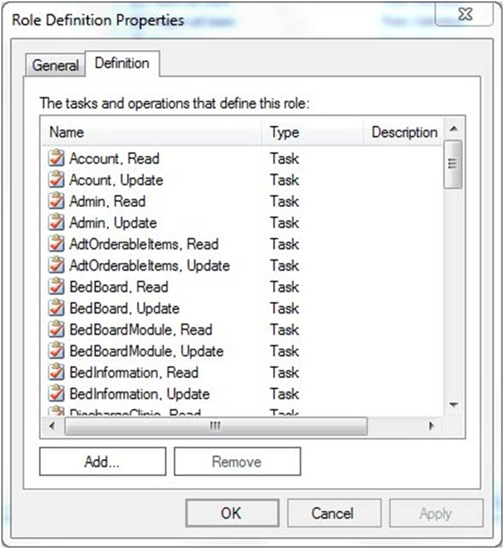

*Figure 66 - Role Definition*

## Assigning a Role to a User

To assign one of the roles defined for BMS to a user follow the steps below.

From the main page of Policy Manager, from Role assignments folder select a role then right-click and select “*Assign Windows Users and Groups”*: the following dialog is displayed.

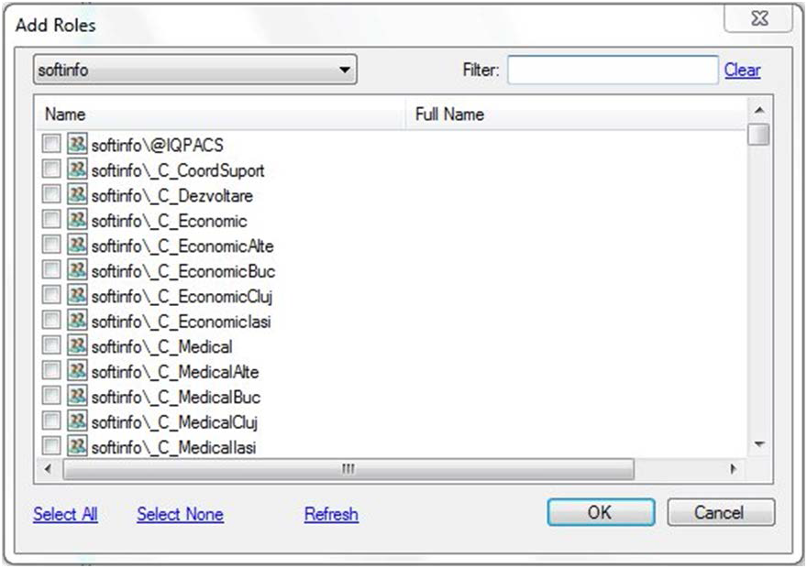

*Figure 67 - Assigning Roles to Users*

A list of users and user groups existing in the current domain are displayed. Use the arrow button of the field in the upper left corner of the dialog to select the domain and the Filter field if necessary, and then click each applicable check box to select the user or group of users for which you want to assign the selected BMS role. Click OK to finalize the operation.

## Adding a New Role

To add a new role, click the Add Role button from the main Policy Manager window or right-click Role Definitions folder and select New Role Definition…: the following dialog window is displayed:

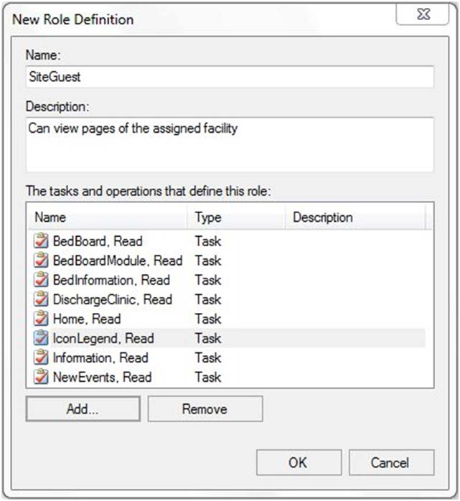

*Figure 68 - New Role Definition*

Enter the name of the new role and a short description.

To add the tasks and operations that can be performed for this role click the Add button to display the following dialog window:

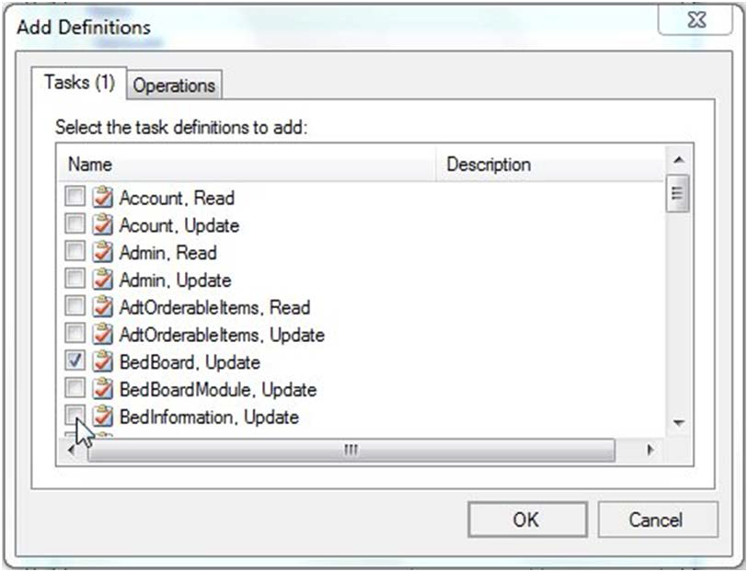

*Figure 69 - Adding Tasks and Operations to a Role*

Tasks and operations that can be performed within the BMS system are available in separate tabs. Select the ones to be included in the definition of the current role (the number of selected tasks/operations will be displayed in the corresponding tab title) then press OK:

The selected tasks and operations will be displayed in the New Role Definition dialog box. Press OK to add the role to the list of roles defined for BMS: The Roles Definitions list will be updated to contain the new role.

To add the new role to the Role Assignment folder, select the folder, right-click and select Assign Roles to display the following dialog window:

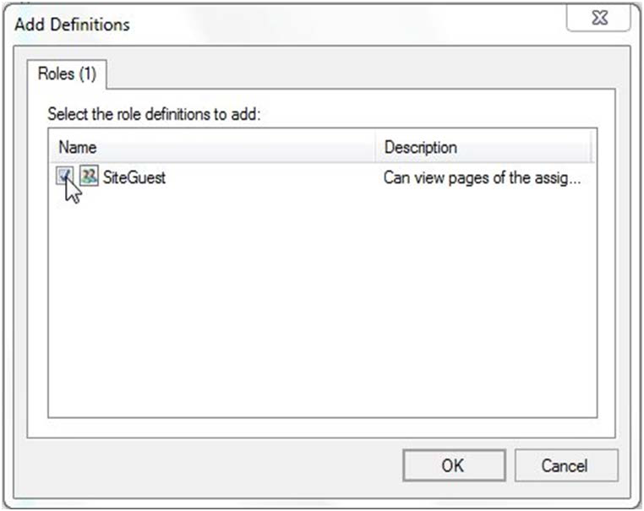

*Figure 70 - Add Role to Role Assignments List*

Select the role then press OK: The newly added role will be displayed in the Role Assignments list and you will be able to assign the new role to BMS users.

## Adding a New Task

To add a new task, click the Add Task button from the main Policy Manager window or right-click Task Definitions folder and select New Task Definition: The following dialog window is displayed:

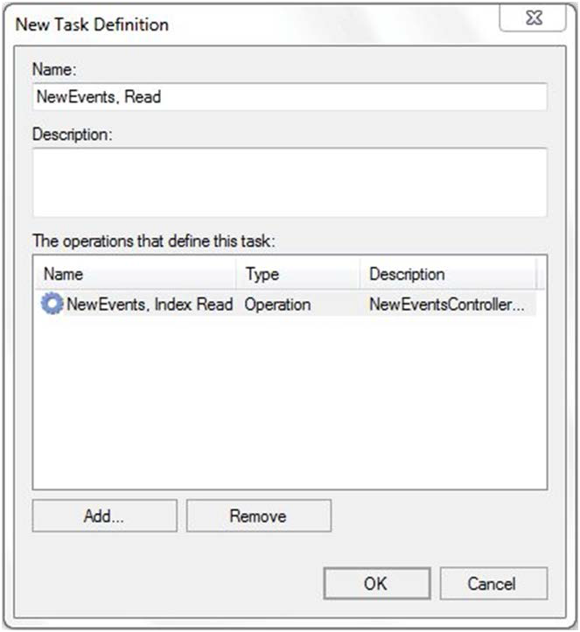

*Figure 71 - New Task Definition*

Enter the name of the new task followed by read/write option and a short description.

To add the operations that define the Task, click the Add button to display the following dialog window:

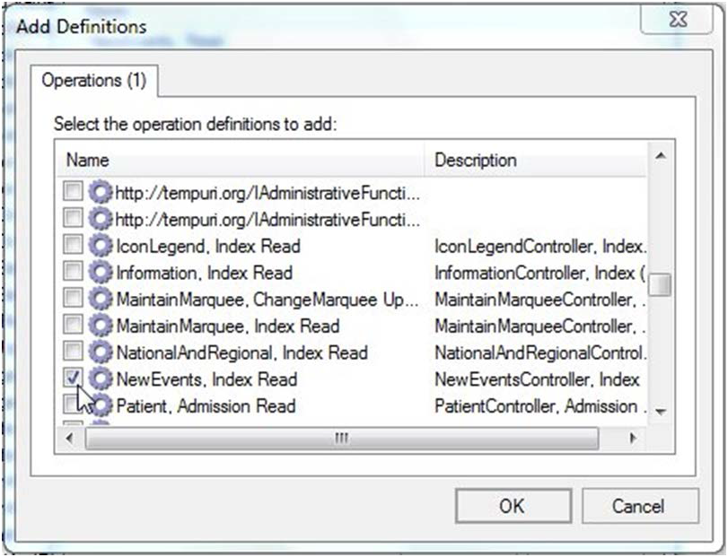

*Figure 72 - Adding Operations to a Task*

Select the operations that define the selected task then click OK to return to the New Task Definition dialog box. Click OK to add the new task to the Task Definitions list.

## Adding a New Operation

To add a new operation, click the Add Operation button from the main Policy Manager window or right- click Operation Definitions folder and select New Operation Definition: The following dialog window is displayed.

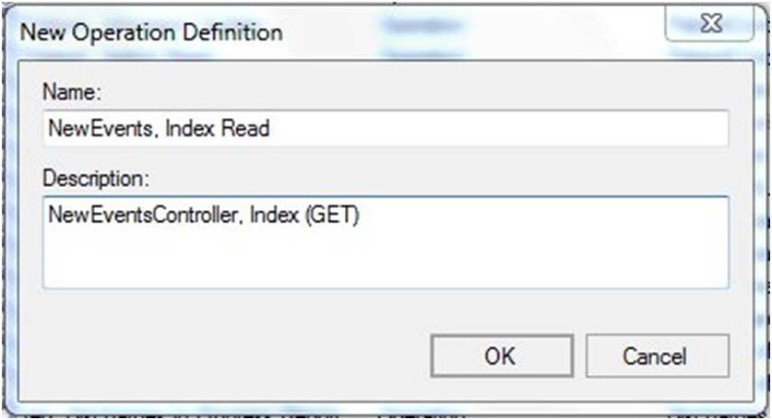

Figure 63 *- New Operation Definition*

Enter the name of the new operation followed by read/write option and a short description. Click OK to add the new operation to the Operation Definitions list.

## Business scenarios and use cases

**Authentication**



Figure 64– Authentication use cases

| ***Section*** | ***Description*** |
| --- | --- |
| **Use Case Name** | User authentication |
| **Summary** | In the above diagram it is represented the methods that a client application can use to authenticate their users. |
| **Preconditions** | The users, that will use the client application, need to be defined in an Active Directory |
| **Triggers** | External |
| **Basic course of events** | 1. The client application will send the user and the password or windows credentials 2. The system verifies the login information. 3. The system returns the result of the verification to the client application. |
| **Alternative paths** | 1. The client application will send the X509 certificate of his user 2. The system verifies the certificate 3. The system return the result |

**Authorization**



Figure 65 – Authorization use cases

| ***Section*** | ***Description*** |
| --- | --- |
| **Use Case Name** | User authorization |
| **Summary** | In the above diagram it is represented the methods that a client application can use to check if an authenticated user has access to a specified action on a resource. |
| **Preconditions** | The users, actions and resources must be defined in an Active Directory structure that the Security Service is using. |
| **Triggers** | External |
| **Basic course of events** | 1. The client application will invoke a check access method for a specified action on a specific resource 2. The system will find the actions that the requesting users has access 3. The system returns true/false if the action requested is among the users defined actions |



Figure 66 – Authorization administration use cases

|  |  |
| --- | --- |
| ***Section*** | ***Description*** |
| **Use Case Name** | Action and resource management |
| **Summary** | Administrative console can define actions and resources and associate an action with a resource type. |
| **Preconditions** | The association method mandates that the action and the resource type should already be defined |
| **Triggers** | External |
| **Basic course of events** | 1. The client application will invoke a create action 2. The system will try to create requested action. 3. The system will fail if the specified action name already exists, or specified id already exists. |

| ***Section*** | ***Description*** |
| --- | --- |
| **Use Case Name** | Role management |
| **Summary** | Administrative console can define user roles and associate users/user groups with roles. |
| **Preconditions** | The association method mandates that the role should already be defined |
| **Triggers** | External |
| **Basic course of events** | 1. The client application will invoke a create role 2. The system will try to create requested role. 3. The system will fail if the specified role name already exists, or specified id already exists. |

| ***Section*** | ***Description*** |
| --- | --- |
| **Use Case Name** | Security policy management |
| **Summary** | Administrative console can associate users (groups of users) with roles. These roles are then associated with and action (operation). |
| **Preconditions** | The association method mandates that the action and the resource type should already be defined. |
| **Triggers** | External |

# Detailed Functional Model on Each Interface

## 



## Service contracts

**Authentication**

The security service for authentication is represented by STS – security token cache that will issue a token whether the authentication succeeded, otherwise it will deny access to the application server. This STS Service will authenticate the user through WS-Security and validate application servers through WS-Trust using SAML v2.0 Token (Security Assertion Markup Language).

**Authorization**

The security services for authorization are represented by a PDP and PAP implementation. PDP stands for policy decision point where the authenticated user can check the permission for a specified action on a specified resource. PAP stands for policy administration point. Here an administrative console can define actions, resource-types, roles and make associations with them (define security policies) that will server for PDP. The PDP service exposes one method: CheckAccess, whilst PAP service has specific functions for policy administration.

**Detailed functional model on each interface**

**STS – Security Token Service**

* Authenticate

|  |  |
| --- | --- |
| **Business friendly name** | User authentication |
| **Description** | The function decides if the user and the password supplied as parameters are valid. Will return true on success and false on any failure. |
| **Inputs** | Windows client credentials or  Username – representing the username of the requested user.  Password – the password of the requested user. |
| **Outputs** | True - on success  False – on failure |

**PDP – Policy Decision Point**

* CheckPermission

|  |  |
| --- | --- |
| **Business friendly name** | User authorization – check Access |
| **Signature** | *Message* CheckAccess(*Message* request); |
| **Description** | The function decides if the user has the privilege to access the specified action(s) on the specified resource. |
| **Inputs** | Username, operation name and resource id are encapsulated in the SAML Message class |
| **Outputs** | A Message containing the permit or deny result. |

**PAP – Policy Administration Point**

|  |  |  |  |
| --- | --- | --- | --- |
| **Name** | **Description** | **Input** | **Output** |
| ***AddRole*** | Adds a role | *String name* – name of the new role *String* description – role description | *String*  – new role’s id |
| ***Delete***  ***Role*** | Delete a role | *String id* – role’s id | *String*  – deleted role’s id |
| ***Update***  ***Role*** | Update a role | *String* id – role’s id  *String* name – role’s name *String* description –role’s description | *bool*  – operation result: *true* on succeeded; *false* if any error aroused |
| ***Update***  ***Task*** | Update a task | *String* id – task’s id *String* name –task’s name *String* description – task’s description | *bool*  – operation result: *true* on succeeded; *false* if any error aroused |
| ***Update***  ***Operation*** | Update an operation | *String* id – operation’s id *String* name – operation’s name *String* description – operation’s description | *bool*  – operation result: *true* on succeeded; *false* if any error aroused |
| ***IsChild*** | Verifies if the sent operation is part of a task | *String* id – operation id | *bool*  – operation result |
| ***Assign***  ***User*** | Assign an user to a role | *String* userId – user’s id (SID) *String* roleId – role’s id | *-* |
| ***DeassignUser*** | Delete an association between an user and a role | *String* userId – user’s id (SID) *String* roleId – role’s id | *-* |
| ***Grant***  ***Permission*** | Grant access to a resource for a role on an action | *string* resourceId, *string* actionId, *string* roleId | *-* |
| ***Revoke***  ***Permission*** | Revokes a permission | *string* resourceId, *string* actionId, *string* roleId | *-* |
| ***GetRoles*** | Returns a list with all stored roles | *Bool* assignedOnly - returns assigned roles if parameter is true | *List<Role>* - retrieved roles |
| ***Get***  ***Operations*** | Returns a list with all stored operations | - | *List<Operation>* - retrieved operations |
| ***GetTasks*** | Returns a list with all stored tasks | - | *List<Task>* - retrieved tasks |
| ***Add***  ***Operation*** | Add a new operation | *String* name – operation’s name *String* description – operation’s description | *String* id *– operation’s id* |
| ***Delete***  ***Operation*** | Delete an operation | *String – operation’s id* | *-* |
| ***AddTask*** | Add a new task | *String* name – task’s name *String* description – task’s description | *String* id*– tasks’s id* |
| ***Delete***  ***Task*** | Delete a task | *String* id*– tasks’s id* | *-* |
| ***Assign***  ***Operations*** | Associate operations to a task | *List<String>* operationIds – list of operations to be assigned *String* taskId – task’s id | *-* |
| ***DeassignOperations*** | Deassign operations from a task | *List<String>* operationIds – list of operations to be assigned *String* taskId – task’s id | *-* |
| ***GetTaskDefinition*** | Retrieve a list with all operations of the specified task | *String* id*– tasks’s id* | *List<DefinitionBase> -* operation list |
| ***GetRole***  ***Definition*** | Returns all associated operations to a specified role | *String* roleId – role’s id | *List<DefinitionBase> -* operation list |
| ***GetRole***  ***ByName*** | Returns a role by name | *String* name – role’s name | *Role* – returned role |
| ***GetRole***  ***ByName***  ***ExcludingId*** | Returns a role by name excluding the role id sent by parameter | *String* name – role’s name *Guid* id – role’s id | *Role* – returned role |
| ***GetTask***  ***ByName*** | Returns a task by name | *String* name – task’s name | *Task* – returned task |
| ***GetTask***  ***ByName***  ***ExcludingId*** | Returns a task by name excluding the task id sent by parameter | *String* name – task’s name *Guid* id – task’s id | *Task* – returned task |
| ***Get***  ***Operation***  ***ByName*** | Returns an operation by name | *String* name *–* operation’s name | *Operation* – returned operation |
| ***Get***  ***Operation***  ***ByName***  ***ExcludingId*** | Returns an operation by name excluding the operation id sent by parameter | *String* name – operation’s name *Guid* id – operation’s id | *Operation* – returned operation |
| ***Get***  ***Permissions***  ***By***  ***Resource***  ***Type*** | Returns a list with operations/task associated with a resource ype | *String* resourceType – Resource type | *List<DefinitionBase>* – opetation/task list |
| ***GetPolicy*** | Returns a list with all roles and operations associated with the resource | *String* resourceId – resource’s id | *List<Role>* – role list. Each role has the associated operations. |
| ***GetRole***  ***Users*** | Returns a list with all users associated to a specific role | *Guid* roleId *–* role’s id | *List<User>* – user list |
| ***Assign***  ***Role*** | Marks a role as assigned | *Guid* roleId *–* role’s id | *-* |
| ***Deassign***  ***Role*** | Marks a role as unassigned | *Guid* roleId *–* role’s id | *-* |
| ***Get***  ***Connected***  ***RolesAndOperations*** | Returns a list with all roles and operations associated with the resource | *String* resourceId – resource’s id | *List<Role_Operation>* – list with role-operations associations |
| ***Clear***  ***Permissions***  ***For***  ***Resource*** | Removes all permissions for a certain resource (all associations to this resource) | *String* resourceId – resource’s id | *-* |
| ***Delete***  ***PermissionFor***  ***Resource***  ***And***  ***Operation*** | Deletes a permission form a role based on the resource and operation sent. | *String* resourceId – resource’s id *String* roleId *–* role’s id *String* actionGUID – opetation’s id | *-* |
| ***Insert***  ***PermissionFor***  ***Resource***  ***And***  ***Operation*** | Creates a permission for a certain role and an operation on a resource. It automatically creates the association within the permission and the operation if it doesn’t exist. | *String* resourceId – resource’s id *String* roleId *–* role’s id *String* actionGUID – opetation’s id | *-* |

The security services do not expose a fault contract as usual web services do. Instead, these services deliver information about any issue in processing the request in the return message of the service call (such as authentication error, authorization error etc.).

## Data contracts

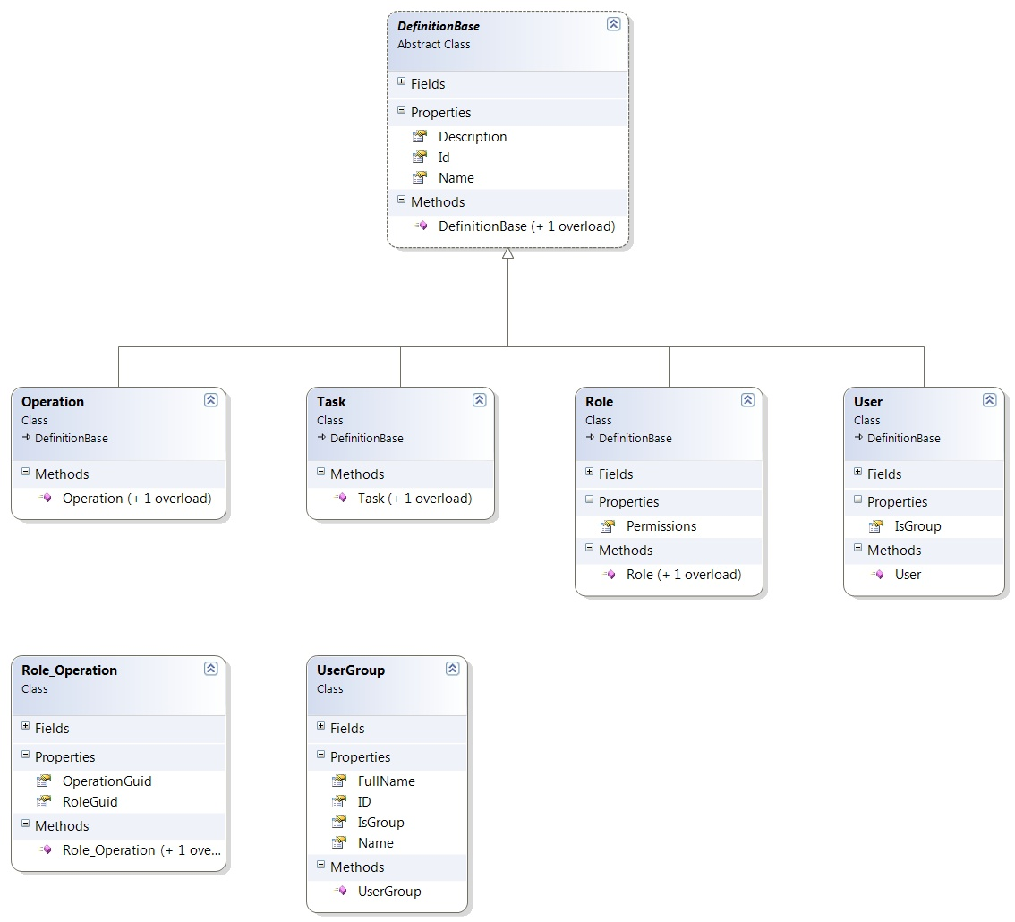

Figure 67 – Class diagram for data contracts in PAP and PDP

## BMS Roles

BMS users fall under the following categories:

**Administrators**: This type of user will customize the BMS settings according to the needs of a facility. They will have access to the Site Options pages. This role refers to a group of users whose members are the person(s) responsible for setting up BMS options for the current facility.

**AuditLogUsers:** This type of user will have access to Audit Log Report. This role cannot be used alone, only together with another role.

**EmsStaff**: The EMS group of users will be allowed to edit and update the bed cleaning process but not the other parts of the bed board. Any member of your EMS staff that will be interacting with BMS must be in this group.

**EMSSupervisorUsers:** The EMS supervisor group of users will be allowed to view the requests for bed clean operations, to filter existing requests by different criteria and to select requests in order to assign them to EMS staff. This role cannot be used alone, only together with EmsStaff role.

**Guests**: The guest user will be allowed to generate the National Bed Availability report from National/Regional page.

**National Users/Regional Users**: This type of user will have access to the National/Regional page only.

**Site Users**: This type of user only has access to the BMS facility page.

**Support Users**: This type of user will have access to the Administrative page of the BMS solution. They configure the sites for the BMS facilities and grant access and read/write rights to the users.

**VISN Users**: This type of user will have access to the pages of different facilities within the VISN where they have been granted access.

# Troubleshooting

This section contains information on common issues with using BMS solution and how those may be resolved.

###### Symptom 1

When you try to load the BMS application, one of the following error messages appear:

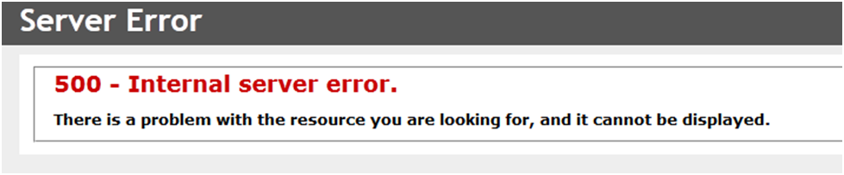

**Problem**

IIS is not started/running.

**Diagnoses and Solutions**

Figure 68: 500 Internal Server Error

Start the IIS Manager and check if the Application Pool Identity is set to the correct service account. (). Verify the BMS pool is started, If stopped right click on the BMS, Select ‘Start’.

Verify the Site ‘BMS’ is started. If not select ‘BMS’ under the Site folder in IIS Manager, select ‘Start’ from the ‘Manage Web Site’ panel on the right side of the IIS Manager.

###### Symptom 2

When trying to load the BMS application, one of the following error messages appears:

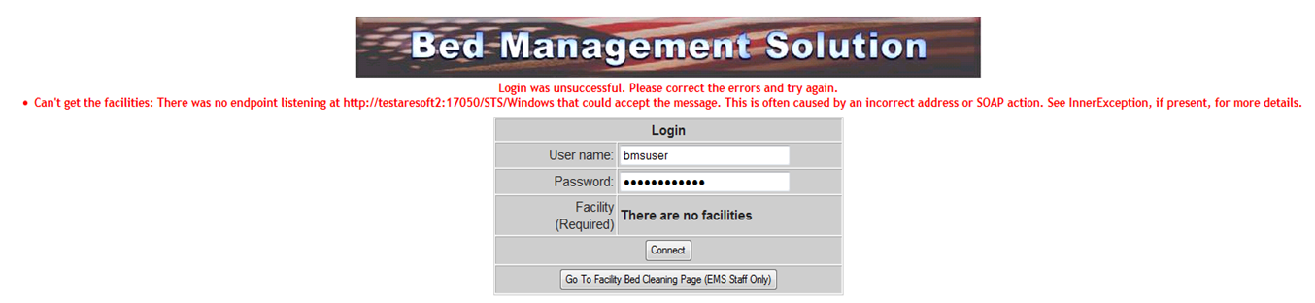

Figure 69: There are no Facilities

###### Diagnoses and Solutions

Go to the MULx5 machine and check if the BMS.ServiceHost service is stopped. Start the services.msc console and start the service.

Verify the service started.

###### Symptom 3

When trying to load the BMS application, one of the following error messages appears:

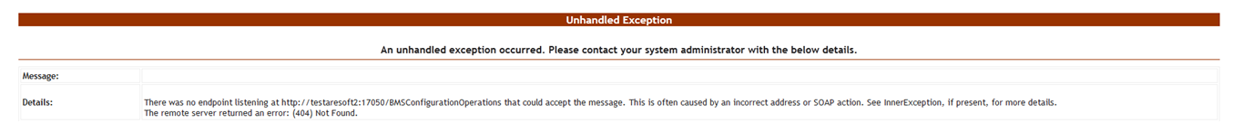

###### Diagnoses and Solutions

Figure 70: Unhandled Exception

* Check if BMS.BMService service is stopped or SQL Server might also have stopped.
* Go to the SQL Server machine and start the SQL Server from the SQL Server Configuration Manager. Verify if the connection string to the database server is set properly.
* Then go to the services’ machine, start the services.msc console and start the BMS.BMService service.

###### Symptom 4

When trying to log-in to the BMS application, the following error is displayed:

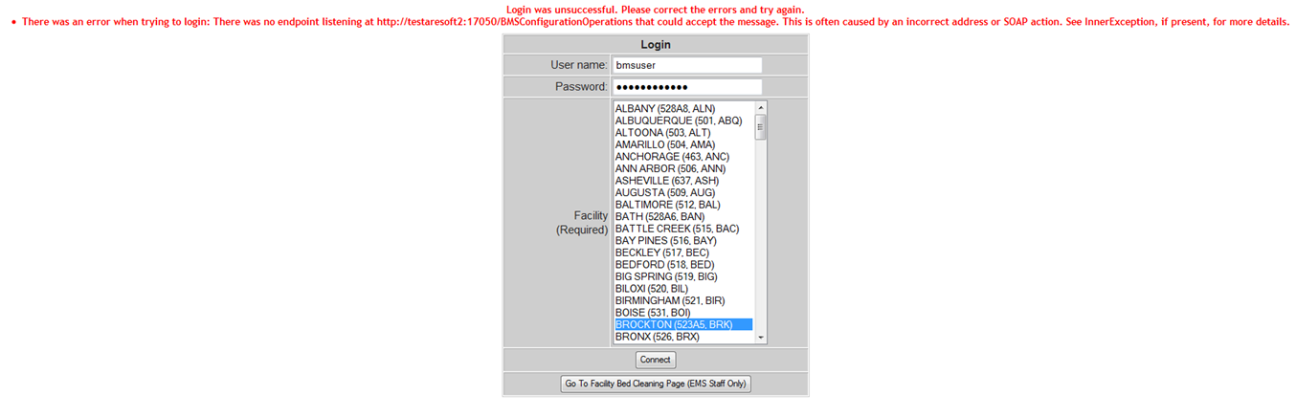

###### Diagnoses and Solutions

Figure 71: Login Unsuccessful

Check if BMS.BMService service is stopped. Go to the services’ machine, start the services.msc console and start the service.

###### Symptom 5

Data does not appear in the reports. Data does not get refreshed in the reports.

###### Diagnoses and Solutions

In SQL Configuration Manager, check if the SQL Server Agent is started, and if it isn’t start it; then, in the SQL Server Management Studio, check if the *BMS - Reports Full* and *BMS - Reports Incremental* are deployed and run without errors. If the jobs are not deployed, install them.

###### Symptom 6

A report is missing from Other Reports section on the Facility Home Page (e.g. *EMS Bed Status Report (Admin)*).

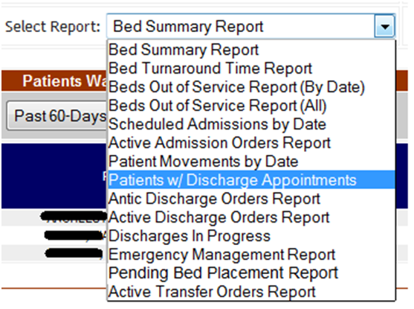

###### Diagnoses and Solutions

Figure 72: EMS Bed Status Report is Missing

Check if the report is missing from the SQL Server Reporting Services. Go to the management web page and add the missing report (Upload File).

###### Symptom 7

When trying to view one of the reports (other than the *Other Reports*) the following error appears:

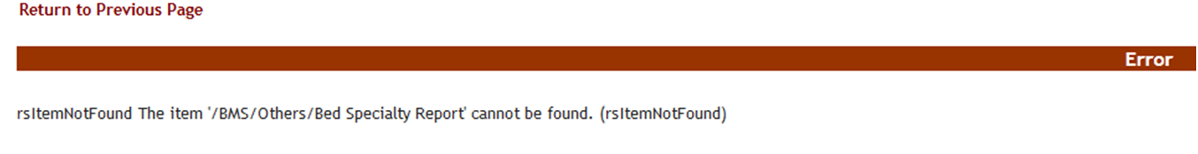

###### Diagnoses and Solutions

Figure 73: Report Cannot be Found

Check if the mentioned report is missing from the Reporting Services. Go to the management web page and add the specified report.

###### BMS Log Files

There are five log files available to anyone supporting the BMS system, the **WinServiceHost**, the **SecurityHost**, the **BMS.ServiceHost**, the

**BMS.VI.ServiceHost** and the **WebTrace log**.

* The WinServiceHost log file is named BMS-Services.log and its location is on the application server (vaausbmsmulx5) D:\BMS\Bin.
* The SecurityHost log file is named BMS-Security.log and its location is on the application server (vaausbmsmulx5) D:\BMS\Bin.
* The BMS.ServiceHost logfile is named BMS.trace.log and its location is on the application server (vaausbmsmulx5) at D:\BMS\Bin\BMS.
* The BMS.VI.ServiceHost logfile is named BMS.VI.trace.log and its location is on the application server (vaausbmsmulx6) at D:\BMS\Bin\BMS.
* The Web trace log is named WebTrace.log and its location is on the web server (vaausbmswebx5) at D:\BMS\BMS.Web.

These logs contain various types of information (informational, warnings, and errors) with the exception of the web trace log, which only contains error messages.

There is no log file for MDWS, those errors are captured through our integration calls and posted in the BMS.ServiceHost log file (Trace.log). These are bit more tricky to debug as in any attempt requires the exact parameters to be passed to MDWS.

# Appendix A – BMS Diagrams

## Business Process Diagrams

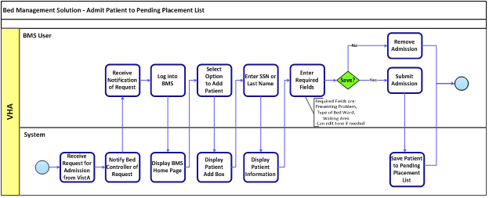

Figure 74: Admit Patient to Patients Pending Bed Placement Business Process

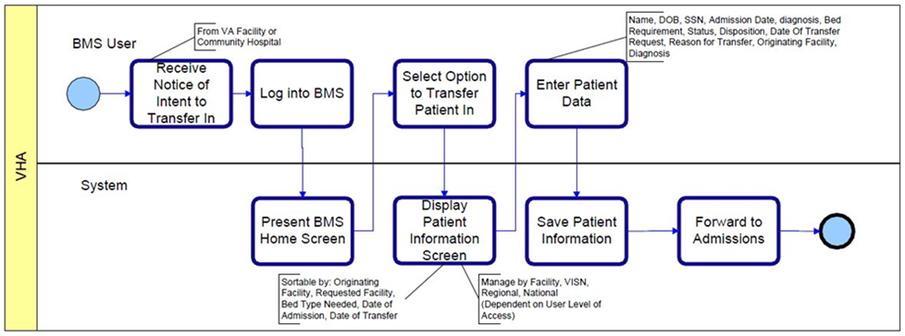

Figure 75: Transfer Patients Pending Bed Placement Business Process

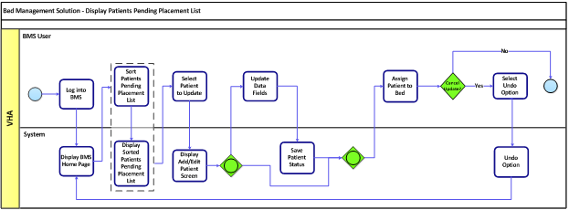

Figure 76: Display and Update Patients Pending Bed Placement Business Process

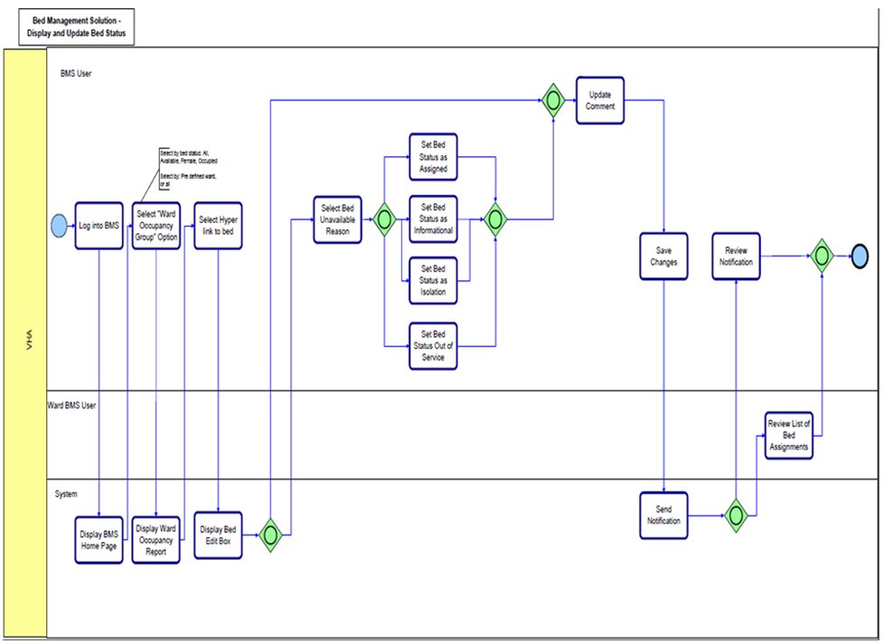

Figure 77: Display and Update Bed Status Business Process

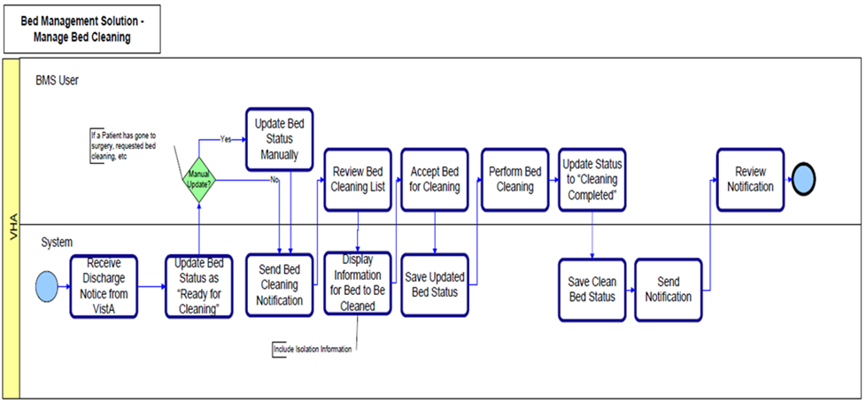

Figure 78: Manage Bed Cleaning Business Process

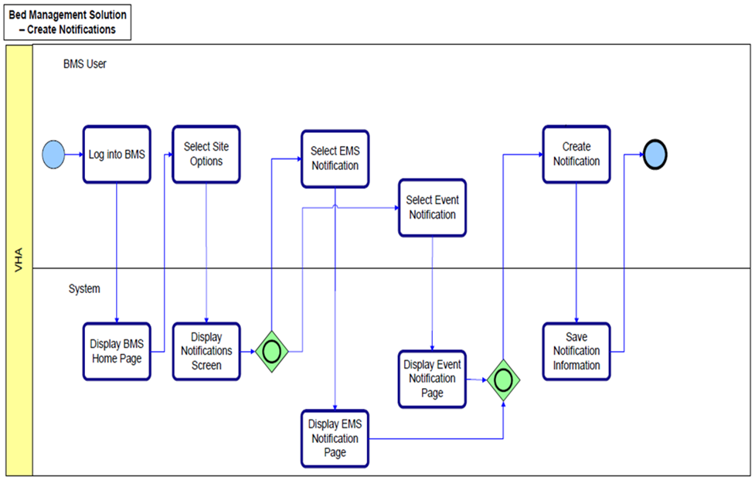

Figure 79: Create Notification Business Process

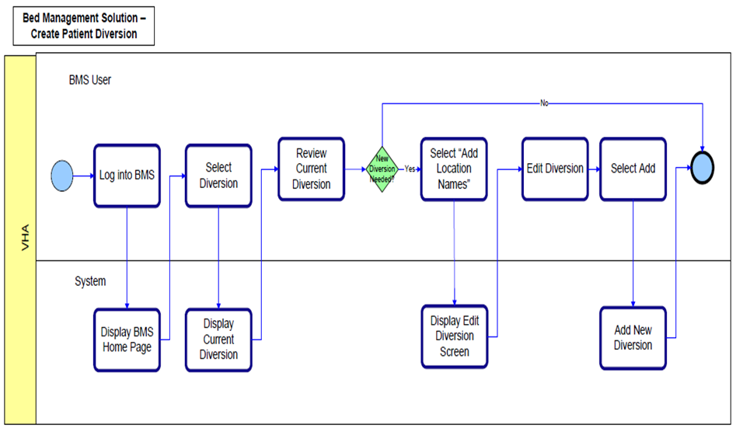

Figure 80: Create Facility Diversion Business Process

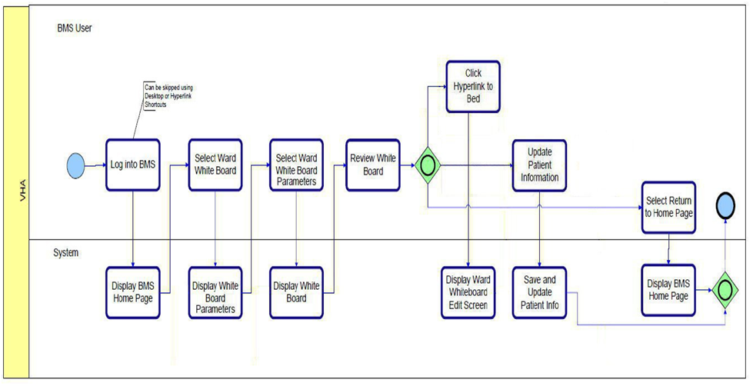

Figure 81: Manage Whiteboard Business Process

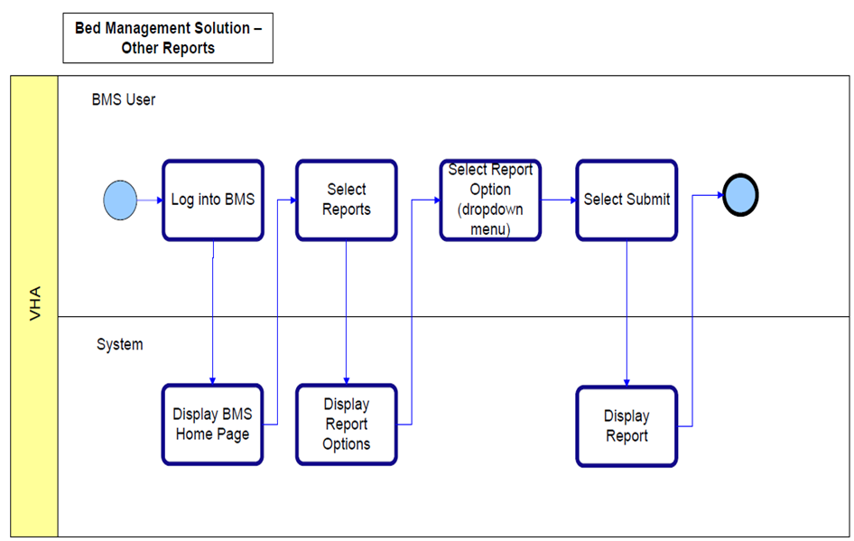

Figure 82: Reports Business Process

## Activity Diagram

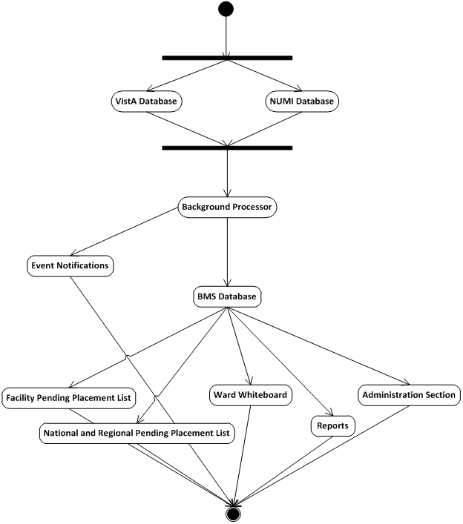

Figure 83: BMS Overview Activity Diagram

## Functional Flow Diagram

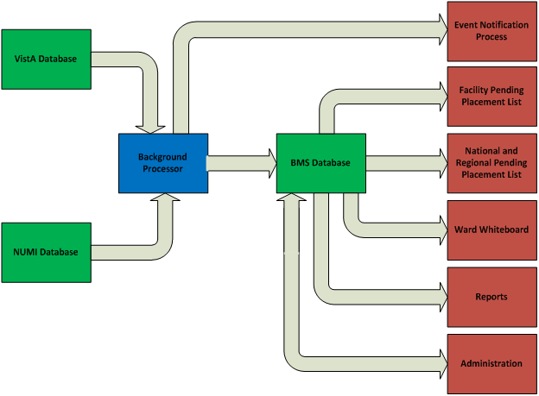

Figure 84: BMS Overview Functional Flow Diagram

**9.4 Data Flow Diagram**

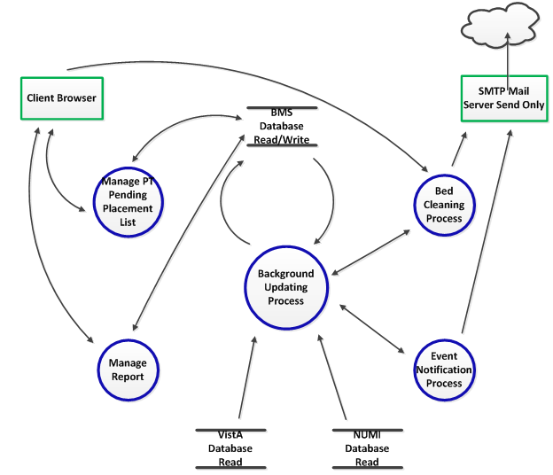

Figure 85: BMS Overview Data Flow Diagram

**9.5 Application Flow Map from APPDYNAMICS**

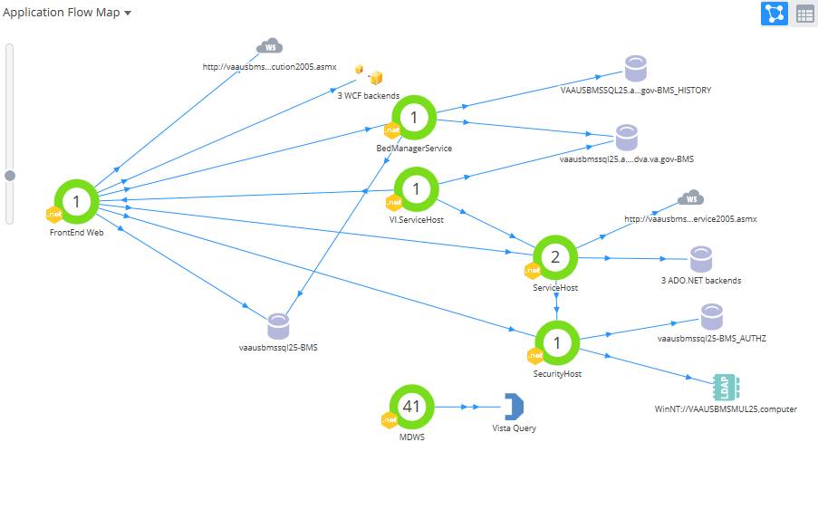

# 10 Appendix B - Terms, Acronyms, and Abbreviations

Table 29: Terms, Acronyms, and Abbreviations

|  |  |
| --- | --- |
| **Terms, Acronyms, Abbreviations** | **Definitions** |
| ASP | Active Server Pages |
| BMS | Bed Management Solution |
| CRUD | Create, Read, Update, Delete |
| EIS | Entity Identification Service |
| EMS | Environmental Management Service |
| ETL | Extract Transform Load |
| EVS | Enterprise Vocabulary Service |
| IE | Internet Explorer |
| IIS | Internet Information Services |
| IRM | Information Resources Management |
| MDO | Medical Domain Objects |
| MDWS | Medical Domain Web Services |
| MVC | Model-View-Controller |
| NUMI | National Utilization Management Integration |
| ODBC | Open Database Connectivity |
| PAP | Policy Administration Point |
| PPBPL | Patients Pending Bed Placement List . A queue of patients in need of beds at VA facilities |
| PDP | Policy Decision Point |
| RS | Reporting Services |
| SOA | Service Oriented Architecture |
| SQL | Structured Query Language |
| STS | Secure Token Service |
| URI | Uniform Resource Identifier |
| URL | Uniform Resource Locator |
| VA | Department of Veterans Affairs |
| VAMC | VA Medical Center |
| VISN | Veterans Integrated Service Network |
| VistA | Veterans Health Information Systems and Technology Architecture |
| WCF | Windows Communication Foundation |
| XAML | Extensible Application Markup Language |
| XML | eXtensible Markup Language |
| WMI | Windows Management Instrumentation |